Test Center- 51411

Computer Science NEA AQA

School Name: Langley Grammar School

Candidate Name: Shrey Patel

Candidate Number- 9417

Shrey PATEL

2023

Table of Contents

Analysis: Background 6

Problem Identification 6

Interview 6

Analysis: User Identification 8

Children: 9

Adult fans of LEGO (AFoL): 9

Analysis: Proposed Solution 10

Benefits of the proposed solution 10

Analysis: Research 12

Similar Solutions: 12

Brickit: 12

RebrickNet 14

Possible programming languages for the solution: 16

Python: 16

C++: 16

Decision: 17

Possible frameworks for the solution (GUI): 17

Dear PyGUI: 17

PyQt5: 17

Kivy: 18

Decision: 18

Analysis: Hash table with chaining collision handling 18

What is a hash table and why should I use it? 18

Analysis: Convolutional Neural Network 19

What is a Convolutional Neural Network, how and why will it be used? 20

Kernels 20

The layers 21

Activation functions 22

Analysis: Camera Input 22

Analysis: Modelling the Problem 23

Analysis: User Requirements 24

Analysis: Objectives 25

Design: Design Overview 28

Design: Convolutional Neural Network 29

Model design: 29

Model pseudocode 29

Compiling the model: 30

Training data 30

Design: Camera Input 31

Design: Image Segmentation 33

Steps to thresholding 33

Design: Stacks and Redos 35

Potential issues with our solution 35

Stacks 36

What is a Stack and how does it help? 36

Design: Hash table with chaining collision handling 38

How will it be implemented? 38

Hash table classes: 39

Get a List of all the Nodes: 39

PAGEREF _Toc159431343 \h Design: Optimization Algorithm- Dimensions and purpose explained 42

Foreword on brick dimensions 42

What is being optimized? 44

Merge Sort 44

Design: Optimization algorithm explained 45

Resolving horizontally and vertically 48

Substituting bricks with plates 50

Design: Files 51

Saving and loading inventory 51

Save 52

Load 52

Saving and loading sets 52

Save 53

Load 53

Delete Set 54

Loading dimensions information 55

File Structure 55

Design: Scraping Rebrickable 57

Foreword on rebrickable data sets 57

Design: Hardware Requirements 60

Design: Hierarchy chart 65

Design: System flowchart 65

Design: Class Diagram 67

Design: Data Flow Diagram 68

Technical Solution- Overview 70

Technical solution- Quality of your programming techniques 70

Technical Solution- Scraping rebrickable 72

Technical Solution- Scraping Rebrickable script 83

Technical Solution- Scraping rebrickable summary 89

Technical Solution- Cleaning part data 89

Clean part data – Main code 91

Clean Part Data Full script 93

Result: 96

Technical Solution- Cleaning part data summary 96

Technical Solution- The Convolutional Neural Network 97

The convolutional neural network – Create the model 97

The convolutional neural network – main code 99

The convolutional neural network – Script 102

The convolutional neural network – Results 105

Technical Solution- The Convolutional Neural Network summary 108

Technical Solution: Hash Table 108

Inventory Class- Inherited from Hash_Table 116

Dimensions Class- Inherited from Hash_Table 120

Technical Solution: Hash Table summary 125

Technical Solution: Stack class 126

Technical Solution: Stacks summary 128

Technical Solution- Sets class 129

MOC_Sets- inherited from Sets class 132

Official_Sets- inherited from Sets Class 133

Technical Solution: Sets summary 136

Technical Solution- Defining global variables and methods outside GUI 137

Searching on behalf of the set – Setting set attribute code 137

Save and Load Inventory 142

Merge Sort Code 143

Defining global variables and filling the Dimensions tables code 147

Technical Solution: Defining global variables and methods outside GUI summary 149

Technical Solution- ClassandGlobalVariabledefinitions.py script 149

Technical Solution- Optimization algorithm 162

Technical Solution- Optimize script 188

Technical Solution: Optimize.py summary 199

Technical Solution- Segment images 200

Technical Solution- Segment_Images.py Script 206

Technical Solution: Segment Images summary 209

Technical Solution: GUI- Initial windows, aesthetics and the render loop 209

Creating dearpygui context (to place GUI code within) 210

Render Loop code 210

Initializing image texture data 212

Initial instance of the main window 213

The menu bar 214

Set colors and font (theming) 215

Main window, deletion callbacks, and setting properties. 216

Technical Solution: GUI- Initial windows, aesthetics and the render loop summary 218

Technical Solution- GUI- Scanning Bricks 219

Technical Solution: GUI- Scanning Bricks summary 234

Technical Solution- GUI- Type Inventory and Add Inventory windows 235

Stack operations 242

Calling the AI model 245

Technical Solution: GUI- Type, View and Add Inventory windows summary 248

Technical Solution- GUI- Build Widgets 249

Optimization subroutines- GUI side 261

Technical Solution: GUI- Build Widgets summary 267

Technical Solution- GUI – User preferences 267

Technical Solution: GUI- User Preferences summary 271

Technical Solution- GUI.py script 272

Technical Solution: GUI.py summary 296

Testing- Overview 297

Evaluation- Evaluation of Objectives 306

Evaluation- Difficulties and challenges overcome. 311

Evaluation- Client Feedback and possible improvements 312

Evaluation- General Evaluation/ Conclusion 314

References 315

# Analysis: Background

The client, Marcel Bonnici, is an automation engineer and LEGO enthusiast. In 2011, he founded AstonishingStudios – a YouTube channel where he showcases his impressive Lego builds, ranging from an automated burger cooking machines to vending machines that dispense M&Ms. For some of Marcel’s LEGO machines, video tutorials are provided for fans to build along to at home.

## Problem Identification

It is difficult for Marcel’s fans to recreate his machines; the process of searching for all the required pieces- pieces his fans may not even have- within their collections of random bricks is currently incredibly time-consuming. It is also needlessly expensive: his fans may order extra pieces the set requires when they could have easily substituted the required bricks with a combination of pieces they already have.

Marcel himself does not struggle with finding the correct bricks when creating his machines- he stores his bricks in a highly compartmentalized way, sorted by color and type. However, he finds it difficult to conceptualize new machines and build other LEGO enthusiasts’ custom machines from his vast collection of bricks. Moreover, it is challenging to adapt his existing machine designs to minimize both the cost and number of parts.

Marcel wishes there was software which could help his fans easily identify bricks from their LEGO collection and simultaneously inform them if they can create one of Marcel’s machines (or other unofficial and official LEGO sets) with the bricks they currently have. The software would also demonstrate how to create these sets (which have been personalized to his fans’ preferences/ bricks they already have).

### Interview

I sat down with Marcus to discuss any problems he- and his fans- have faced when creating LEGO builds. The interview was imperative in identifying how Marcus would like his problems to be solved.

**Q: What are the biggest issues fans have when creating your machines?**

A: Honestly, it can take as long to find the right pieces as it does to actually make my LEGO machines. Most of my fans have their LEGO jumbled in a big container. Whilst following along to my tutorials they have to sort through all the random pieces to find the right part. Not efficient at all! What’s worse is that it puts a lot of fans off making my machines and watching my other tutorials. They think it’ll be a waste of time as they can’t (or it takes too long) to make my LEGO machines.

**Q: What are the biggest issues you have when creating your machines?**

A: Especially in the past few years, I really struggle making sure the cost of the project doesn’t balloon out of control. LEGO is getting more and more expensive, so keeping an eye on how to reduce costs at every stage without compromising function is a real challenge.

**Q: How does cost factor into the creation of LEGO machines?**

A: I try to design sets using just the pieces I have, and only buying extra pieces when I have exhausted my LEGO collection. It is obvious this method is very time consuming: I need to cross-check what I’m designing with what pieces I have. After countless hours of designing, I eventually design a LEGO machine that I can actually create using the bricks I have. However, there is a serious problem if I try to sell the designs to my fans: they don’t have nearly the same number of bricks as I do and end up buying extra pieces that they could’ve just substituted.

**Q: Could you elaborate on brick substitutions and their importance?**

A: Well one of my favorite features of LEGO is that, as a modular building system, you could replace one brick with a combination of two or more bricks. It’s sort of like mixing paint in the sense that if you don’t have a certain color, like orange paint for example, you could combine other paints to create orange, yellow and red. In our example you don’t have to go out of your buy orange paint, a LEGO enthusiast can substitute the parts they don’t have of a LEGO set with ones they do. As part of my design process, brick substitution is heavily used if I don’t have a brick that is vital to the function of my LEGO machines. For my fans, brick substitution is an excellent way to create my LEGO machines at home without buying extra pieces. They could even create LEGO sets at home with the bricks they have at home with the correct substitutions: the official LEGO manuals are freely available as PDFs online.

**Q: What would help the process of creating your own LEGO sets?**

A: What would help is some kind of application that can automatically recommend sets a person could make with the parts they have, whilst simultaneously substituting bricks. A solution should handle the long decision-making process of ‘oh I should replace this part with another’ or ‘it would be a bad idea to replace this part’.

**Q: How do you keep inventory of your bricks?**

A: I basically dump my pieces out onto a table and count them individually. Of course, some of my bricks are already sorted by type and color, but not all. I keep this information on an excel spreadsheet with the name of each of my bricks and its corresponding quantity in my collection. When I finally finish planning a machine, I check the spreadsheet to ensure I have enough pieces. If I don’t, I order them on Bricklink.

**Q: How could LEGO identification/ counting be easier?**

A: For me, I would love to just scan the LEGO using my phone’s camera and some software would tell me the type and amount of each brick I have. It would make the whole building and design process so much more convenient. I know that such an app can’t recognize all the bricks in the world, so if it could just recognize the most common bricks and allow me to enter the rest manually, I would be satisfied.

**Q: How else could such a solution help Astonishing Studios and its fans?**

A: Already overworked as an engineering student, I’d have a lot more free time and it’ll make running my LEGO channel feel less tiring. I could create far more interesting LEGO machines and upload videos more consistently, whilst my fans won’t have to deal with the most boring part of building with LEGO. My vision for AstonishingStudios is to open a gateway for my viewers into the wider world of STEM. The engineer inside of me would feel proud if I can get at least a couple of LEGO fans to end up as fascinated with engineering as me. Essentially, if the software can help people build as much as possible with what they already have, I’d be a happy man.

# Analysis: User Identification

Marcel’s audience (and LEGO fans in general) fall into two key demographics: Children (who often treat LEGO more like a toy) and Adult Fans of LEGO (who often treat LEGO more like a construction material). These groups will naturally form the bulk of the userbase.

#### Potential Users:

Children and Adult Fans of Lego have their separate (but intrinsically linked) experiences and motivations when building with LEGO:

### Children:

* To children, LEGO’s major draw is the ability to create their own ‘toys’ that they can play with. Children prefer smaller, play-oriented sets.
* Due to the fundamental nature of how children play with their toys, the vast majority of LEGO sets created by children end up breaking apart, with the pieces being thrown into a container alongside other random pieces.
* Recreating a set can prove time-consuming and frustrating if sorting pieces by hand. Furthermore, it can be difficult for children to create the sets they imagine from their loose parts; a child may want to create a spaceship for example, but their final build may not look anything like one.
* More often than not, it is a failure to visualize how to combine the pieces in an efficient and polished manner, rather than possessing an insufficient number of pieces, that inhibits a child’s Lego creation.

### Adult fans of LEGO (AFoL):

* Adult fans of LEGO usually build larger, more ambitious models. Similar to a child’s loose brick container, they often own a substantial number of LEGO bins, each containing an assortment of LEGO pieces.
* Unlike children, the LEGO bins AFoL own consist of frequently used bricks rather than a mash up of broken LEGO sets. Moreover, AFoL often own multiple LEGO boxes consisting of just one type of brick of the same color to aid them in construction. In addition, AFoL can spend weeks (sometimes months and even years) on a single project.
* AFoL suffer from issues of managing the large number of bricks they own. Their planning and building techniques are often quite complex, yet they struggle with minimizing the costs of their grand projects.
* There are no publicly available solutions that can help minimize the costs/time of a large-scale LEGO project, which takes into account: the price per part (PPP); the ability to substitute bricks in a set (i.e., a 6x1 brick can be substituted for two 3x1 bricks); the effect on structural integrity when bricks are substituted; the willingness of a builder to ‘compromise’ (i.e. getting rid of certain parts/features of a build, using different- but similar- colored bricks).

[Note that adults may suffer from the same issues as children and vice versa]

Other potential users include thrift/charity shops who receive large donations of loose LEGO pieces, independent LEGO vendors who sell on a piece-by-piece basis (such as those who operate on Bricklink), and budding LEGO entrepreneurs wishing to monetize their creations across a wide market (for example, LEGO Ideas contributors).

# Analysis: Proposed Solution

Users will first view a main menu, consisting of the options to view their inventory, build or customize their experience.

Users can enter their parts into the system inventory in two ways. They can scan new parts in, the user will use a camera (peripheral or embedded into device) to take a photo of their LEGO bricks. An AI model will recognize the individual parts and display to the user: the official part name/number and the quantity of the part the user possess. Otherwise, users can simply type in parts with a keyboard and mouse.

With an inventory, the users can view all the different sets (from both LEGO and independent creators) they can create. Based on user preferences, an algorithm will minimize the total parts needed to create that set by substituting bricks from the original set. They will return to the user an optimized LEGO set. The user can view the parts they require, and the parts possessed.

### Benefits of the proposed solution

#### For Adult Fans of Lego (AFoL)…

* AFoL can save hours usually spent on inventory checks by simply scanning their bricks and -within a few seconds- being informed of the bricks they currently possess.
* The unique brick replacement algorithm can minimize the total number of extra bricks/ minimize price needed to complete a build, saving AFoL money and time.

#### Inspiring Creativity

* Users will be able to access MoCs (My Own Creations), a diverse catalogue of potential builds that can (potentially) far exceed what is offered by The LEGO Group.
* By demonstrating how a stable, aesthetically pleasing model can be created from ‘junk’ bricks, users can learn ingenious techniques and move past crude freestyle builds (applicable most to small children).

#### Sustainability

* Within a new LEGO set, pieces come packaged in single-use plastic bags.
* The plastic LEGO uses (acrylonitrile butadiene styrene) is not biodegradable; it takes (at least) 1300 years to break down.
* By offering the ability to create sets from bricks users already have, plastic wastage is cut drastically.

# Analysis: Research

## Similar Solutions:

### Brickit:

The closest existing solution on the market is Brickit, which promises to ‘come up with hundreds of ideas’ if one just scatters their bricks on a table and takes a photo.

#### Pros:

* Can (allegedly) identify 1600 different types of bricks.
* Displays models users can make with their bricks and provides instructions.
* The design looks crisp, modern, and attractive.
* Can accurately identify bricks even if they are positioned sideways at an angle or even on top of other (larger and flat) bricks with a 75% accuracy.
* Can tell users the location within the pile of the bricks required.
* Users can share pictures of the creation within a safe environment.
* Ability to repurpose all the pieces of an official LEGO set into new, smaller builds without scanning bricks.

#### Cons:

* The perquisite steps (such as removing all large bricks) before actually taking a photo can be long and tedious.
* Most brick types are hidden behind a paywall (Brickit Pro). Moreover, non-pro users can only generate ideas for builds a finite number of times.
* Most suggested ideas are quite small and lack complexity or ingenuity.
* Suggested ideas are only user submitted- no official LEGO sets.
* Ideas cannot provide suitable substitutions and maintain a sensible color pallet.
* Fails to remember previously scanned pieces after a new batch is scanned.
* Inability to provide suitable substitutions for some builds.
* UI may be oversimplified; It proved a challenge to find certain options/pages with the absence of clear menus and submenus.

#### What features should be incorporated into the proposed solution?

* To accurately identify bricks even if they are positioned sideways at an angle with a 75% accuracy.
* Tell users the location within the pile of the bricks required.
* The ability for users to make unofficial LEGO sets

#### What features should not be incorporated into the proposed solution?

* An obtrusive paywall that severely diminishes a user’s experience.
* The removal of larger bricks before scanning the pile (users will be unable to make larger, more impressive MOCs and many official LEGO sets).
* Whilst the feature turning fully intact LEGO sets into smaller separate builds is interesting, it fails to solve the original problem(s); Users want to create larger sets from (random broken up collections of) smaller sets/ brick collections – not smaller sets from larger ones.

#### Overall thoughts on Brickit

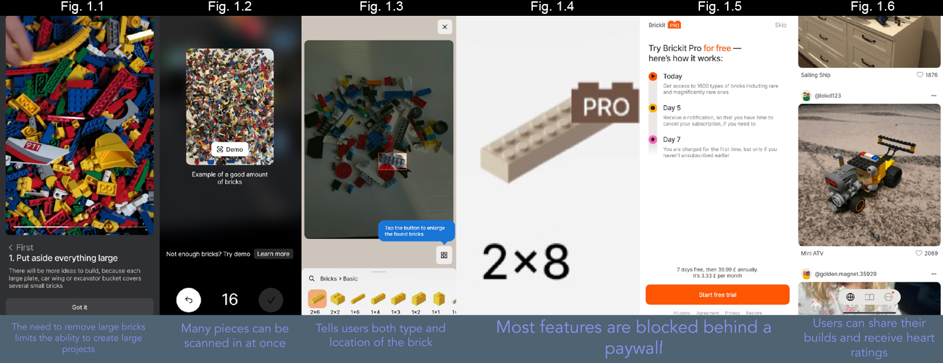Brickit is an impressive – yet flawed- solution that offers a captivating glimpse into the potential power of CNNs (Convolutional Neural Networks). However, Brickit serves a different purpose and different audience compared to the proposed solution. Brickit is geared towards young children, whilst the proposed solution will appeal to adults and children alike. The problem Brickit solves is limited to simply generating build ideas: quite rudimentary compared to the comprehensive, multifaceted problems the proposed solution will solve.

### RebrickNet

A frequently updated subsection of the Rebrickable website, RebrickNet detects LEGO pieces from photos using an AI model.

#### Pros:

* Mostly free to use (only a free account is needed to use most of the features)
* Clear and precise instructions on how to lay bricks out, lighting etc.
* An impressive 91% accuracy at identifying pieces (even on their sides and with slight overlap between pieces).
* Displays where the bricks are in the pile.
* Recognizes both the type and color of a brick.
* Users can submit training data (videos/photos of blocks they currently have at home) to improve the AI model.
* Upon clicking a part, further descriptions appear consisting of how frequently used the part is and alternative colors.

#### Cons:

* Basic UI (could be seen a positive for some users).
* Information overload
* Limited link to set creation.

#### What features should be incorporated into the proposed solution?

* The ability to access most features without having to buy into a subscription model.
* The ability to view further detail about a set when prompted.
* Displays where the bricks are in the pile.

#### What features should not be incorporated into the proposed solution?

* Large blocks of text, that are very technical.
* Information overload
* Limited link to set creation.

#### Overall thoughts on RebrickNet

For a small-scale collaborative project, RebrickNet serves its purpose well and is far superior to Brickit using metrics of accuracy and useability. However, RebrickNet is targeted towards AFoL and as such leaves out quite a few desirable features to widen its userbase (a child would struggle to navigate the website). The crux of RebrickNet’s problems is that it is too technical for all. My proposed solution should use links to the rebrickable site to get the advanced information (part usage frequency/ alternate names colors etc..), but this is only on demand: only the core information necessary to recreate the sets should be available within the actual program.

## 

## Possible programming languages for the solution:

### Python:

#### Pros:

* Holds an extensive collection of libraries relating to data science (Pandas, NumPy. Matplotlib etc.) and, more specifically, machine learning (such as TensorFlow 2 and Keras).
* Highly portable (WORA- Write Once Read Anywhere). This is useful due to the gamut of devices the userbase may have access to (as a result of the large age range)
* As python is embeddable, scripting capabilities can be added.

#### Cons:

* Python is dynamically typed and interpreted. This makes its quite slow to execute, which can put off younger users of the solution (with low attention spans).
* Python is notorious for leading to high memory usage, which will need to be tackled carefully during the project.
* Harder to develop applications using python. Most frameworks and supportability for apps are for Java/C#. The solution will not be a website, so implementing an effective GUI may be an issue.

### C++:

#### Pros:

* Has many of the same data science libraries as Python (such as TensorFlow, NumPy, and PyTorch) but also C++ exclusive libraries (mlpack/Armadillo, OpenNN etc…)
* Much faster than other High-Level General-Purpose programming languages.
* C++ is an OOP (Object Orientated Programming) language. The type-based categorization of LEGO can be implemented uncomplicatedly using classes, inheritance, and polymorphism.

#### Cons:

* Offers complete control over memory management. No garbage collection support could lead to data redundancy and excessive memory usage (if improperly managed).
* C++ is usually classified as a portable language, but the complexity of the proposed solution (which needs to interface with graphical displays) may result in the use of platform-specific libraries.

### Decision:

After initially thinking of developing the solution using C++, I have instead decided to code in python, due to both portability and my familiarity with the language. Before going any further, it is imperative I research good GUI frameworks for python as the solution will not be accessible to the client and users with a command line interface.

## Possible frameworks for the solution (GUI):

There were numerous Python frameworks that could have been used for the GUI. Some were ruled out early: PySimpleGUI was -as the name suggests- too simple and disliked by its own creator; Tkinter GUI’s often looked tacky. I have narrowed down three possible python frameworks.

### Dear PyGUI:

#### Pros:

* Extensive and well written documentation
* Support for other Python extensions like OpenGL and GTK
* Cross-platform
* Open Source

#### Cons:

* Not pre-installed with Python

### PyQt5:

#### Pros:

* Drag and drop functionality for implementing visual elements.
* Add code to visual elements enabling the creation of small- and large-scale apps.
* Cross-platform support for Windows, Mac, Android and Raspberry Pi.
* The process can be made even simpler using QT designer.

#### Cons:

* Requires you to purchase a commercial license.
* Not pre-installed with Python

### Kivy:

#### Pros:

* Open source with MIT license (100% free).
* Cross-platform support (even for IOS and Android)
* Built-in widgets

#### Cons:

* (Reported) Poor performance- users can sometimes find the widgets unresponsive.
* Outdated look

### Decision:

I have decided to use DearPyGUI as it is the most modern and well-documented out of the three candidates.

# Analysis: Hash table with chaining collision handling

## What is a hash table and why should I use it?

Whilst researching ways to store user inventory, one structure stood out to me, hash tables: a data structure that maps keys to a value, where the key is generated using a hash function. The pros of storing the data in a hash table are:

* It takes a constant amount of time to search for parts- Θ(1 + α).
* It can be more memory-efficient than other data structures, as it avoids the need to allocate memory for many slots beforehand.

The first pro in particular meets the objective of quick searching. The speed of searching is crucial when dealing with thousands of sets, which makes other searching methods highly unattractive.

#### Chaining

Collisions refer to when two keys hash to the same slot in memory. This is a common issue within hashing but can be easily resolved by chaining.

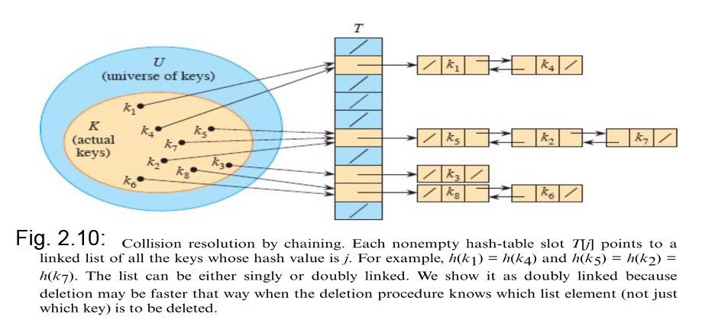Each non-empty slot points to a linked list. Therefore, it is possible to store many values under one slot. I should implement this as some part IDs/ dimensions can hash to the same location within the table



[1]

# Analysis: Convolutional Neural Network

## What is a Convolutional Neural Network, how and why will it be used?

Convolutional Neural Network (or CNNs for short) are a class of neural networks that specializes with grid-like data, mainly images. This type of deep learning network is great for image recognition; hence, the solution will use a CNN to identify LEGO parts.

### Kernels

An image kernel is a small matrix used to apply effects. It is also known as a filter. Filters are crucial to the operation of the network, as it is the filter weights, we adjust to recognize certain features.

Applying a filter (the ‘convolution’ in the context of CNNs):

* A filter (convolution kernels) will ‘occupy’ a sub grid of an image.
* Multiply the original pixels by the filter’s weights.
* Sum the result. The resolution decreases as multiple pixels collapse into one.
* Stride over (often one pixel) and repeat.

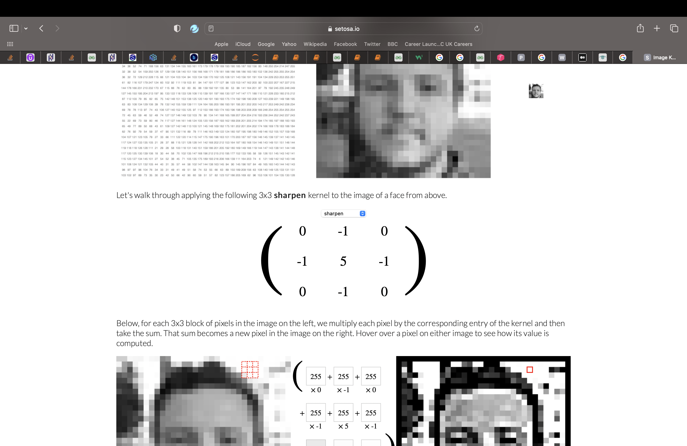

[2]

Fig. 1.13: A sharpen filter

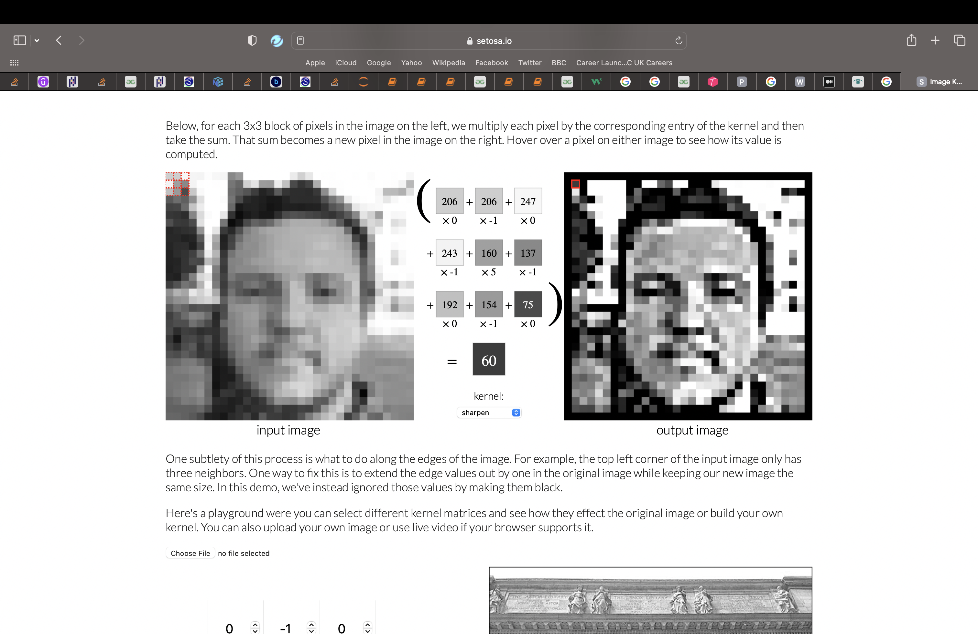

Fig. 1.14: A visual demonstration of how the sharpen filter is applied. [3]

### The layers

CNNs consist of three main types of layers: a convolutional layer, a pooling layer and a fully connected layer.

* A convolutional layer is created when we apply multiple image filters to the input images. This layer performs a dot product between two matrices, where one matrix is the kernel, and the other matrix is the restricted portion of the receptive field. The layer will then be trained to figure out the best filter weights.

A CNN reduces parameters by focusing on local connectivity. Not all neurons will be fully connected. Instead, neurons are only connected to a subset of local neurons in the next layer (these end up being the filters).

* Pooling layers are used to greatly reduce the number of parameters. These accept convolutional layers as input. The pooling layer replaces the output of the network at certain locations by deriving a summary statistic of the nearby outputs.
* A fully connected layer should be the last layer of a CNN. This helps to map the representation between the input and the output.

An additional important layer is the Dropout layer. A dropout layer can be applied to the input vector, in which case it nullifies some of its features; but we can also apply it to a hidden layer, in which case it nullifies some hidden neurons.

Dropout layers are important in training CNNs because they prevent overfitting on the training data.

### Activation functions

These refer to functions that decide whether a neuron should be activated or not: whether or not the neuron’s input to the network is important to the process of prediction. As the network has to predict whether a brick belongs to one category out of several dozen, two activation functions are usually used:

ReLu- The rectified linear activation function or ReLU is a non-linear function hat will output the input directly if it is positive, otherwise, it will output zero.

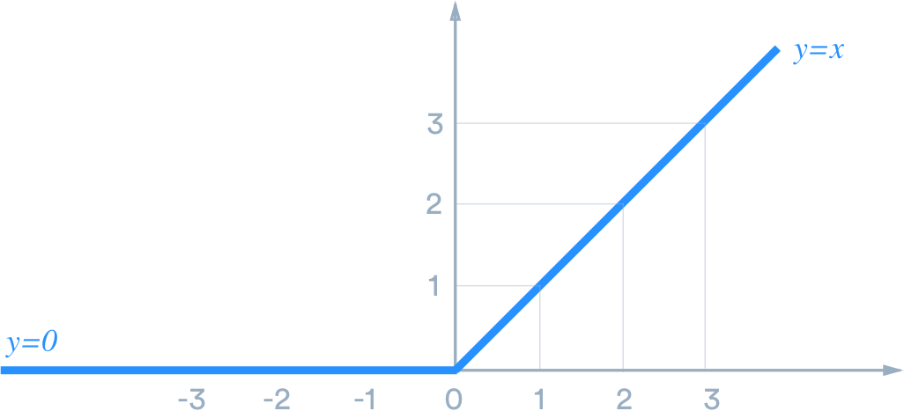

Fig. 1.15: A graphical representation of ReLu [4]

# Analysis: Camera Input

Identifying our bricks through computer vision works in three basic steps:

1- Acquiring an image

Images can be acquired in real-time through photos of bricks taken by the user.

2- Processing the image

My deep learning model is trained by first being fed thousands of labeled or pre-identified images. It can then be deployed to make classification predictions for user part.

3- Understanding the image

The final step is the interpretative step, where the LEGO part is classified.

Open CV

OpenCV (Open Source Computer Vision) is a free cross-platform computer vision library for real-time image processing., OpenCV is the de facto standard tool for image processing and can be used with DearPyGUI. Thus it will be used to get user webcam (or inbuilt camera) input.

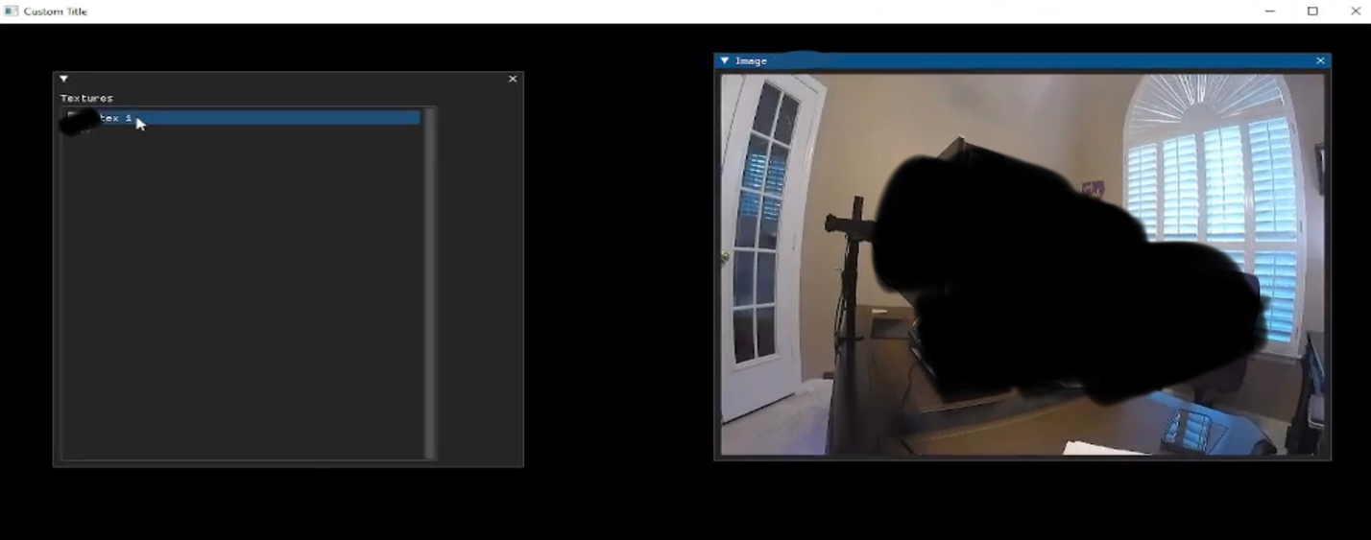[5]

Fig. 1.16 : An example of OpenCV being utilized with DearPyGUI to get user camera input. There is a sketch of how camera input will look like in the solution in the ‘Graphical user interface’ subsection of the design section.

# Analysis: Modelling the Problem

The proposed solution will be coded in python and can be built off the dearpygui framework. Users can enter parts into inventory through a keyboard and mouse, or through scanning bricks using the camera. In the second case, a convolutional neural network will take the bricks in as input and return a part ID prediction. User Inventory will be stored in a hash table, with Part IDs as the key and the quantity as the value. Dimensions for the Lego bricks will be stored in two hash tables, one with the Part ID as the key and other with the Dimension as the key. Users can save their inventory to a file, so that it does not disappear once the program is closed. The user can view their inventory in a table, showing the Part IDs and quantities of each brick they have. Users can also remove parts from inventory they no longer possess.

The solution will display all the sets users can create in two separate tables (sorted in descending order of the percentage of the set they can build). The tables are separated based on whether the user wants to create a MOC, or an official Lego set. The data for these sets will be scraped from rebrickable. Upon clicking on a set, they want to build, the user can view the parts they need and possess in tables, alongside calculations for the total projected cost to build the set and a link to the instructions. The user will also be able to save the sets they want to build later to a file, for quick future reference.

If the user does not possess all the parts they need for a set, an algorithm will minimize the total parts needed to create that set by substituting bricks from the original set with parts they have, referencing the dimensions and inventory tables. There is no current equivalent of the optimization algorithm, so I will have to design the entire algorithm myself- most likely using a greedy recursive approach. Users can view these substitutions in a table.

The user will be able to reach the two main aspects of the solution (inventory and building sets) through a main menu and a menu bar. The user also has the ability to change the color scheme and substitution preferences in an options window.

# Analysis: User Requirements

Based on research into clients and existing solutions, the following requirements have been formulated:

* The ability to scan pieces into the system through the camera of an electronic device.
* To correctly identify each exact part in the pile.
* An accurate brick identifier/counter of bricks in a pile.
* The ability for users to correct the AI if a piece is misidentified.
* The ability to type parts into inventory instead.
* A simple GUI that both children and adults can easily navigate with minimal instructions.
* The ability to create both official and unofficial LEGO sets from pieces the user already owns.
* Tailoring the project to minimize costs/bricks (based on user preferences)
* The tailored project has to be both structurally sound and visually pleasing.
* A straightforward way to know which pieces the user does not currently own, so that they can purchase them from brick vendors.

Limitations

* There are a total of about 3764 unique LEGO Elements, available in a plethora of colors. It is impossible to train a model to recognize all these parts. However, it would be a resounding success if the model can recognize the most frequently used bricks. This is because some pieces are used for very specific purposes within a small handful of sets.
* The user would have to spread-out a pile and have good lighting conditions before scanning bricks. The bricks need to be in good condition (clean, minimal scratches and no significant damage).
* The program suggested alterations may not appear as visually pleasing/ practical as the original set (this depends on a user-by-user basis, it is as equally likely the alterations improve the set’s aesthetics).
* The program will not be able to find substitutions of all the LEGO parts that currently exist.

# Analysis: Objectives

1. Create a convolutional neural network which can identify LEGO bricks.
2. I will create my own sequential TensorFlow deep learning model.
3. The model should be able to recognize at least 50 different types of bricks.
4. The model should recognize bricks with a minimum accuracy of 75%.
5. When the model is called, it should return a part ID prediction for each brick.
6. Create a data set of custom MOCs and official LEGO sets,
7. Webscrape the data from Rebrickable’s existing set data
8. Process data to ensure:
9. Each required part id is in a general format (not color, modification specific)
10. There is only one instance of each set.
11. Each set only contains one instance of the part information.
12. Ensure set data contains the quantity and type of all required bricks.
13. Store user brick inventory
14. Implement a hash table to store all the bricks the user has.
15. Include a function to search for and insert parts.
16. Linked lists will be implemented to resolve collisions through chaining.
17. Allow users to see their inventory within the program.

i) Users can view their full inventory in a table

ii) Users can save the current state of their inventory for future use (to a csv)

1. Create an algorithm to substitute bricks.
2. I should design my own greedy optimization algorithm.
3. Resolve dimensions horizontally as well as vertically.
4. Resolve dimensions with largest horizontal piece first principle.
5. Ensure the algorithm is heuristic (will trial all possibilities)
6. Allow users to optimize sets as they see fit (they choose which sets to optimize)
7. Ensure the algorithm can substitute both bricks (3 studs tall) and plates (1 stud tall)
8. Users can choose whether to enable this feature.
9. Allow combinations of plates to substitute one brick.
10. Store general brick data alongside user-specific information.
11. Process and save rebrickable data to extract the essential part information (dimensions and names)
12. Store the dimensions of certain parts and types in a hash table for reference.
13. Store set data.
14. Allows users to view the sets they can build.
15. Find the parts the user does, and does not, have and display them.
16. Provide a hypertext link to the set instruction manual.
17. Calculate the percentage of the set they can build and (using merge sort) show them the highest.
18. Calculate total parts required and the estimated cost to build the set they want.
19. Display the (feasible) substitution for applicable bricks.
20. Recalculate percentages, totals, and possession lists after substitution.

b) Users can save the sets they want to build for future reference (to a csv)

1. Develop a GUI for the solution.
2. Develop a menu bar, so users can navigate to the main sections easily.
3. Allow users to adjust color scheme.
4. Users can adjust window, border, text, button, and title colors.
5. Users can default to original color settings.
6. Data entry is limited to inventory management (security)
7. Data can be entered through keyboard and mouse.
8. Users can type a PartID in alongside its Quantity.
9. Users can ‘redo’ accidental typos when typing parts through the use of stacks.
10. Users can remove parts from inventory by specifying their PartID
11. Users can scan bricks in through a camera.
12. The user can take photos of parts using their mobile device or webcam,
13. Users can verify which photos they want to use.
14. Display the segmented parts from the main image, alongside the prediction.
15. Give users the ability to verify the predictions (correct Part ID and quantity) before placing them in inventory.

# Design: Design Overview

The solution will be comprised of five main sections.

Firstly, we discuss what the AI model should do/consist of, and the training. Then we discuss the camera input of the system- how we can get the user to submit images to the system, within the context of the dearpygui framework. Afterwards, we need to discuss the processing of the user images. This allows one image of multiple bricks to be converted into multiple brick predictions, for the user to verify. Then we can discuss how changes to inventory can be handled (both typing and scanning) through stacks.

Later, we discuss the merits of hash tables and how they will be used to store the user inventory and dimensions while the program is running. Then we discuss the optimization algorithm in depth. We go over how recursion and resolving in three dimensions allows us to ensure the algorithm is heuristic and efficient by taking a greedy approach. Afterwards, we discuss the csv files used in the solution, and the file structure in general.

Finally, we end on various diagrams and sketches. These include a structure/hierarchy chart, system flowchart, class diagram, system flowchart, data flow diagram and a Human Computer Interface. These will hopefully deliver a comprehensive visual explanation into how all the components of the solution work together.

# Design: Convolutional Neural Network

## Model design:

I first based my models on Resnet and Deepnet models, though I carefully removed some layers to reduce training times. By training prototypes of the model on the MNIST dataset, I was able to adapt and gauge the accuracy of potential models if trained on the Kaggle LEGO dataset. Below are the accuracies of each model trained on the MNIST dataset, with the final design’s statistics shown at the bottom.



Fig. 2.1: Each successive prototype for the model. Accuracy increases with every new prototype.

OBJECTIVES MET: 1A

### Model pseudocode

Below is Pseudocode of the final model design:

**Define Model -> A Sequential Model**

**ADD 2 Convolutional Layers TO Model**

**ADD Max Pooling Layer TO Model**

**ADD 2 Convolutional Layers TO Model**

**ADD Max Pooling Layer TO Model**

**ADD 2 Convolutional Layers TO Model**

**ADD Max Pooling Layer TO Model**

**Flatten Model**

**ADD Dense Layer TO Model**

**ADD Dropout Layer TO Model**

**ADD Dense Layer TO Model**

**ADD Dropout Layer TO Model**

**ADD Dense Layer TO Model**

1

## Compiling the model:

* The model will recognize images split into 50 distinct categories: hence the loss function will be ‘categorical cross entropy’. The role of the loss function is to quantify the difference between predicted and actual values.
* The model will use the Adam optimizer. It is a fairly new extended version of stochastic gradient descent. The role of an optimizer is to update the weights of a neural network during training.
* During training, we will measure categorical accuracy, as we are dealing with categorical data.

## Training data

Suitable training data for the model came from a Kaggle dataset.

<https://www.kaggle.com/datasets/joosthazelzet/lego-brick-images>

The provided dataset contains 40,000 renderings at different angles of 50 different bricks (800 renderings per brick).

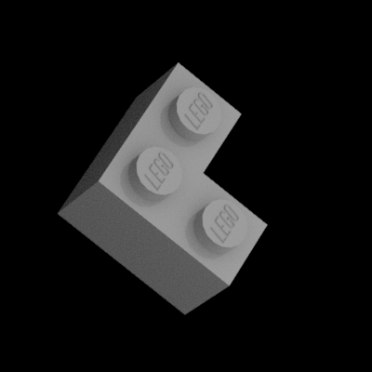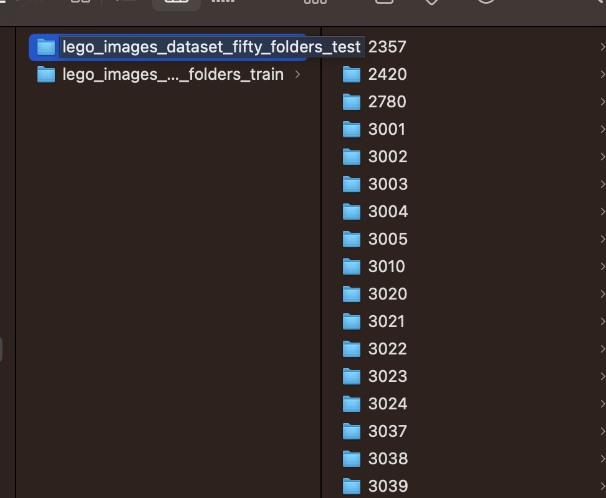

Figure 2.2: An example of the LEGO renders. Figure 2.3: How the renders are stored for the model to access

To use this data to train the model, the images had to first be grouped into folders based on their part ID, and then separated into training and test data. Above is the new file directory

OBJECTIVES MET: 1B

# Design: Camera Input

When using DearPyGUI for image display, it is imperative to remember that when using the framework, widgets are created at runtime, utilizing the user’s GPU. Likewise, so image data needs to feed into the GPU as textures.

As the solution requires Real time image data, we need to constantly update the texture. To achieve this, my code has to be incorporated within the render loop, which allows data aspects need to code a system within the render loop.

Raw textures are used for small to medium sized textures that can change per frame. These can be updated with set_value but the width and height must be the same as when the texture was first created. This texture will be used for all the images.

To control when to start video capture and when to take pictures, there will be a series of Boolean flags, each controlled by a button. Firstly, there will eb a flag to signal the start of video capture, then one to take snapshots of the current video capture, and finally, one flag to save the image. In the render loop, there will be conditionals that control the capture of images. Below is some pseudocode demonstrating how this will be achieved.

OBJECTIVES MET: 7Cii)A , 7Cii)B

**START🡪False,** **CAPTURING🡪False, TAKE_CAPTURE 🡪False**

**VID 🡪 Camera**

**PHOTO 🡪 ___**

**BUTTON GO TO CAPTURE MENU- TOGGLE START**

**BUTTON TAKE SNAPSHOT- TOGGLE TAKE_CAPTURE**

**BUTTON SAVE – SAVE PHOTO AND MOVE ONTO NEXT**

**RENDER LOOP:**

**IF START True:**

**SHOW WINDOW SCREEN**

**CAPTURING 🡪 True**

**IF CAPTURING True:**

**PROCESS camera input INTO data**

**UPDATE Camera Value WITH data**

**IF TAKE_CAPTURE True:**

**UPDATE PHOTO WITH data**

**TAKE_CAPTURE 🡪 False**

# Design: Image Segmentation

Before the machine learning model can predict our taken photos, the actual parts need to be separated in order to return predictions for each part. We can use OpenCV to help us implement the image segmentation algorithm.

The best way to segment different LEGO parts from each other is to use their pixel values. This is because the pixel values will be different for the parts and the image’s background if there’s a sharp contrast between them. Pixel values falling below or above a threshold can be classified accordingly (as an object or the background) - Threshold Segmentation.

## Steps to thresholding

First, we need the user to submit a background and foreground image, both of which can be achieved the camera input described above. Then, we convert both images to grayscale and calculate the difference between the pixel values to get a rough idea of where the parts are. We save the resulting image and move onto the next step.

To reduce the amount of noise, smooth edges and remove speckles within the image, we apply a Gaussian blur to the image from the previous step. The resulting image is now ready for thresholding,

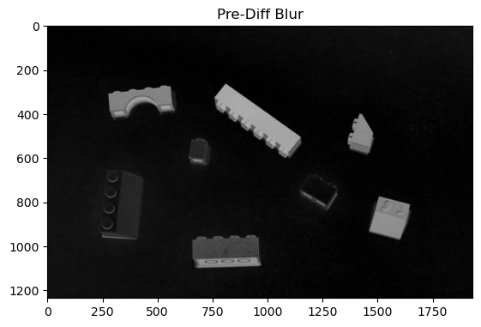

Figure 2.4: The parts, after converted into grayscale and Gaussian blur is applied

Based on the grayscale intensity values of its pixels, we use Otsu’s method, which uses the grayscale histogram of an image, to detect an optimal threshold value that separates two regions with maximum inter-class variance. This will return an image with the parts in white and background in black.

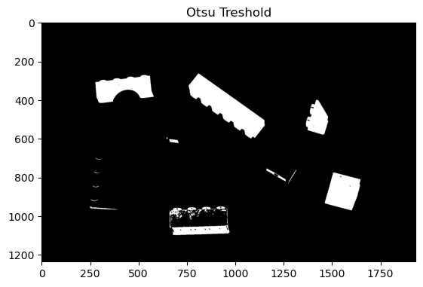

Figure 2.5: The parts, after thresholding

We can use this information to plot contours around the suspected parts. We disregard any contour areas below a certain value, as they are likely to just be random noise and not a part. We iterate through all the parts, and on each part apply a mask and a bitwise and operation to isolate the individual part. We then center this in on a black background.

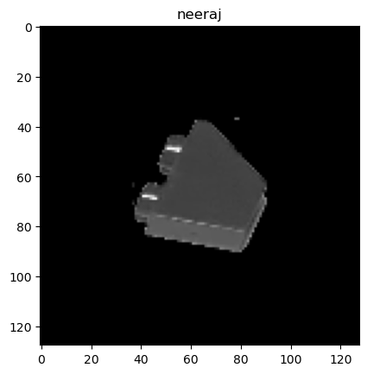

Figure 2.6: The centered parts, what actually is fed into the model for predictions

Finally, after we save these images, we have data that can be passed into the CNN to return PartID predictions.

OBJECTIVES MET: 1C, 1D. [6]

# Design: Stacks and Redos

### Potential issues with our solution

If the user accidentally mistypes a part ID, they will normally have to go to the remove part section, remember the mistype and remove the part. This is quite a long process, which is why a redo button is needed to make it easier to prevent mistakes when entering parts into the inventory.

Additionally, when scanned parts are identified, they will all have quantity of 1 even if there is more than one of the part, i.e. ([2034,1], [2034,1], [1102,1]) - we can see there is two 2034’s, but inventory will display two separate instances of a 2034 with quantity 1. The same issue will occur if a user enters the same part ID into inventory twice in one session. This may mean that there will be data redundancy and inconsistency if entering the part into inventory as is. We need a way to dynamically add parts to inventory, updating existing quantities, without implemented it into the existing INSERT method (as we want duplicate dimensions in the Dimension tables).

In both cases, stacks can be used to solve the respective problems.

## Stacks

### What is a Stack and how does it help?

A stack is an abstract data type that serves as a collection of elements. The order in which elements come off a stack is LIFO (last in, first out). When typing/scanning bricks into inventory, they will actually be stored in a stack first, before being added to inventory, which allows us to combine quantities when we finally add the parts to the actual inventory, as well as allowing us to remove the last added part with ease.

There are four main stack operations we need to implement:

* Peek- returns the element at the top of the list without modifying the stack.
* Push- adds an element to the top of the stack.
* Pop- which removes the most recently added element that was not yet removed.

Below are how these operations will be used:

To redo (when typing into inventory):

-Peek, to show user the part they want to remove, so they can confirm they do want to remove the specific part (and did not accidentally press the redo button)

-Pop, when the user confirms they want to remove the last added part

Empty Stack (finalizing inventory additions/ removals):

-Pop, until peek returns a nonvalue (remove elements until the stack is empty)

We can insert the first instance of a part into inventory table normally. When we get a repeat part ID, we adjust quantities, incrementing the original part ID’s quantity in the table by the amount specified in the repeat part ID quantity field.

To add (when typing into inventory):

-Push, add part ID and corresponding quantity

When scanning bricks into inventory:

* Pop, until peek returns a nonvalue (remove elements until the stack is empty)
* We can insert the first instance of a part into an intermediary inventory table normally. When we get a repeat part ID, we adjust quantities, incrementing the original part ID’s quantity in the intermediary table by the amount specified in the repeat part ID quantity field.

Below is some pseudocode which demonstrates how the stack could be implemented, using an array and pointer.

**STACK DEFINITION 🡪 PARAMETER = CAPACITY**

**STACK 🡪 ARRAY * CAPACITTY**

**POINTER 🡪0**

**SUBROUTINE PEEK()**

**RETURN STACK[POINTER]**

**SUBROUTINE POP()**

**STACK[POINTER] 🡪 NULL**

**POINTER -=1**

**SUBROUTINE POP (VALUE)**

**POINTER +=1**

**STACK[POINTER] 🡪 VALUE**

OBJECTIVES MET: 7CiB

# Design: Hash table with chaining collision handling

### How will it be implemented?

#### The key and slots:

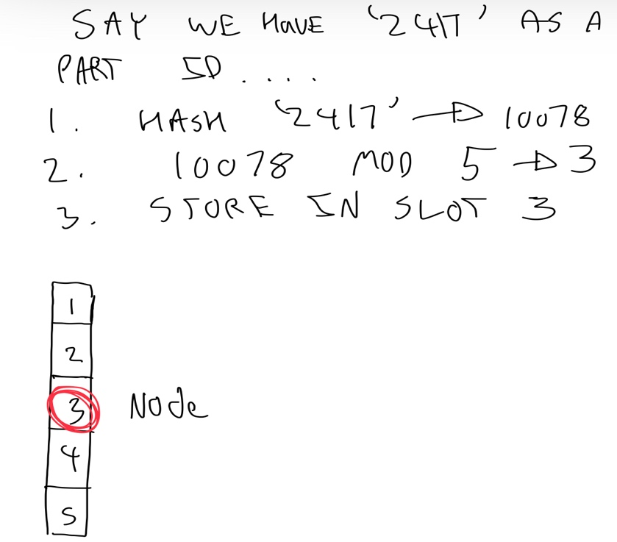We already have a unique identifier for every part: the part ID. We can simply hash this and perform a modulus operation with the capacity of the table to allocate a slot.

Fig. 2.7: An example of the steps needed to store/chain.

#### The Linked-Lists:

A class named, ‘ListNodes’ will be created, with each object possessing three attributes:

1. Their Key
2. Their Value
3. A pointer to the next node

## Hash table classes:

There will be a generic hash table class, and two inherited hash table classes dealing with the user inventory and stored dimensions respectively

Below are some of the key methods of the hash tables within the context of our solution.

#### Inserting:

1. Apply the hashing steps described in ‘the key and slots’ section to the current part ID.
2. If there is no list currently in the slot, create a new node representing the part which will serve as the head of a new linked list. Repeat step 1 onwards for next part.
3. If a list exists, iterate to the end of the list (the last element will have no pointer)
4. Create a new node representing the part at the end of the list.
5. Repeat step 1 onwards.

#### Removing:

1. Declare two variables which hold current and previous nodes, the current node being the location in the table the element should be in (dependent on key)
2. If there is something at the memory location of current node, continue. Else, Finish
3. If current node has the same key as one, we want to remove, look at step 4, else step 5
4. if there is a previous node, update its 'next' pointer. Else just update the node directly. Finish
5. Else, move to the next node and repeat step 2.

#### Copy:

1. Initialize a new table with the same capacity.
2. For all nodes in the original table, insert key-value pairs into the new table.
3. Return the new table.

## Get a List of all the Nodes:

1. Initialize an empty list.
2. For all nodes in the original table, insert key-value pairs into the new list.
3. Return the new list.

**Inherited Inventory class FROM parent hash table class**

#### Searching for parts:

The algorithm will search the Inventory for the required parts.

1. Find the slot that would contain the part we are searching for
2. If the slot contains nothing, return NULL
3. Else, compare the set’s key to the node’s keys.
4. If the keys match, return the NODE
5. If the keys do not match, go to the next node and repeat steps 3 and 4. If the pointer to next node does not exist, return NULL

#### Checking quantities:

The algorithm will go through each set, searching the user’s hash table for the required parts and quantities. Below are the main steps on how a set will be processed:

1. Get the node from SearchForParts
2. If the node is NULL, return ‘NO_PART’.
3. Else, subtract how much of the part we need from how much we actually have and return the value. If the value is negative, the absolute value represents the quantity of parts needed. Otherwise, we have enough of that part

#### Changing quantities:

1. Find the slot that would contain the part we are searching for
2. If the slot contains nothing, return NULL
3. Else, compare the set’s key to the node’s keys.
4. If the keys match, add the given value to the existing node value, and return both the node and new node value
5. If the keys do not match, go to the next node and repeat steps 3 and 4. If the pointer to next node does not exist, return NULL

**INHERITED Dimensions class FROM parent hash table class**

It is easier to understand this methods in pseudocode

#### Dimensions to Matrix:

## 

**DimensionLength 🡪 COUNT ‘x’ in Dimensions**

**DimensionsNew 🡪 [] * DimensionLength**

**DimensionsNew[0] 🡪 Dimensions[0 TO INDEX OF FIRST ‘x’]**

**DimensionsNew[1] 🡪 Dimensions[INDEX OF FIRST ‘x’ TO INDEX OF SECOND ‘x’]**

**IF DimensionLength ==3:**

**DimensionsNew[2] 🡪 Dimensions[NDEX OF SECOND ‘x’ TO INDEX OF THRID ‘x’]**

**RETURN DimensionsNew**

#### Matrix to Dimensions:

**IF len(Dimensions) ==2:**

**RETURN Dimensions[0] + ‘ x ‘ + Dimensions[1]**

**ELSE:**

**RETURN Dimensions[0] + ‘ x ‘ + Dimensions[1] + ‘ x ‘ + Dimensions[2]**

OBJECTIVES MET: 3A, 5B,

# Design: Optimization Algorithm- Dimensions and purpose explained

## Foreword on brick dimensions

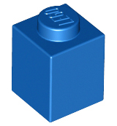Whilst each LEGO brick has an official part id, it is commonplace for people to label bricks by their dimensions. For example, part ‘3005’ is referred to as 1x1; From a birds-eye viewpoint, the brick is one stud wide and one stud long.

Fig. 2.8: Part ‘3005’, i.e., 1x1

For the optimization algorithm, these labels can be thought of as matrixes, of which we only consider the dimensions and not the contents.

We label dimensions by format, Rows x Columns, as illustrated below.

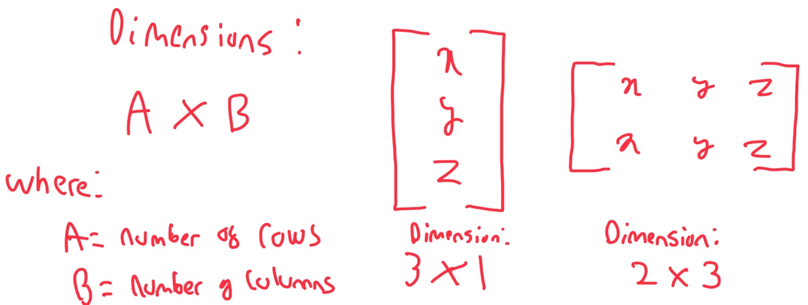

Fig. 2.9: The format for defining brick dimensions.

Rows and column usually cannot be swapped in a matrix. However, as a LEGO brick can be viewed from a number of different angles, thereby rendering the process of defining a brick’s row and column redundant. Hence, a brick’s dimensions can further be simplified to (smaller stud length) x (larger stud length).

A visual example, part ‘3010’ (see below) could have dimensions ‘4x1’ or ‘1x4’ depending on its positioning. Labelling with regards to stud length, part ‘3010’ is commonly known as ‘1x4’. However, if we were to refer to part ‘3010’ as ‘4x1’, it would not be inconsistent with the actual shape of the part.

## A white lego block with four round holes Description automatically generatedA white lego block with black background Description automatically generatedLego Plate 1 x 3Lego Brick 1 x 2 x 5 - Blocked Open Studs or Hollow Studs

Fig. 2.10: Part ‘3010’ viewed from different angles.

Fig. 2.11: Part ‘2454’, dimensions 1 x 2 x 5

Fig.2.12: Part ‘3623’, dimensions 1 x 3 x (0.3)

Bricks can also be more than one stud high, such as part ‘2454’ which is 5 studs high. Plates refer to bricks less than 1 stud tall. The dimensions of such bricks can be expressed as A x B x C, where A and B are interchangeable. C refers to the height of brick in studs. For plates, C will take value 0.3.

We will consider such bricks only after ‘normal’ bricks of height one stud are optimized, with plates being prioritized next.

## What is being optimized?

Picture the likely scenario that a user does not possess enough bricks to create a certain set. The algorithm will processes sets by ascending percentage value, with priority values being calculated with the below formula:

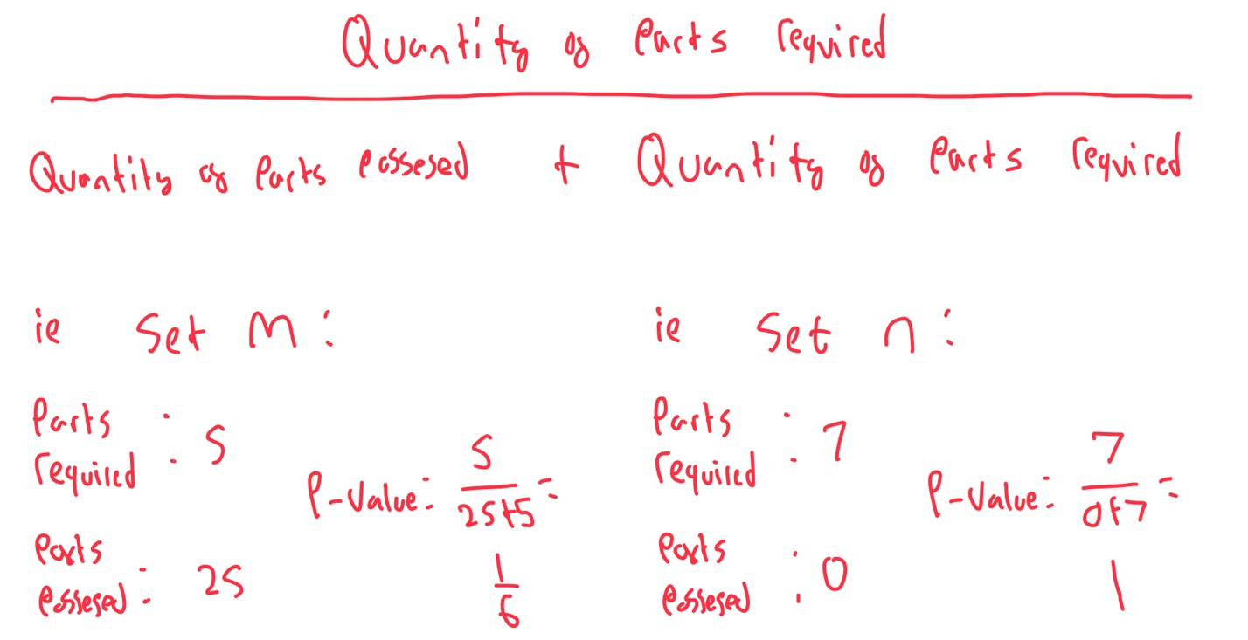

Fig. 2.13: The formula for calculating priority values.

Any sets of percentage value ‘1’ not being considered. This is because it would be more suitable for a user to just buy the exact required parts rather than substitute so heavily.

## Merge Sort

A merge sort algorithm will be used to sort the parts by ascending priority value. There are three steps to the algorithm:

1. Divide the unsorted list into sublists, each containing a single element.
2. Take adjacent pairs of two single-element lists and merge them to form a list of 2 elements.
3. Repeat the process till a single sorted list is obtained.

Merge sort is an ideal algorithm for searching a list consisting of thousands of sets, as it only has a time complexity of o(n*logn).

OBJECTIVES MET: 6Aiii

# Design: Optimization algorithm explained

All the possible combinations of parts that can be used to substitute a brick can be represented using a tree. Take this simple example of possible options when substituting a 1 x 5 with whole bricks (no third dimension). There are already quite a few possibilities, even though this example is limited to whole bricks.

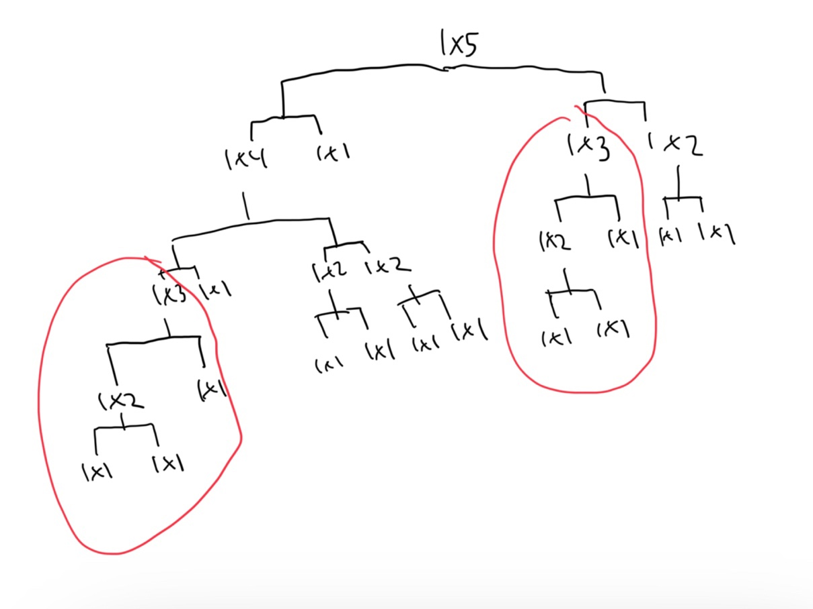

Figure 2.14: The conceptual tree of substitutions

Some interesting things to note: Every brick can be made up of 1x1’s, every tree has maximum depth of (n-1), and there are repeating patterns of substitution (ie the red circles).

These combinations on a layer-by-layer basis can be found using the following algorithm:

1. Target brick matrix dimension will be defined by (smaller stud length) x (larger stud length): hence to be known as A x B.
2. Replacement brick matrix dimensions will be defined by C x D and E x F.
3. Let G take the value of A.
4. Let C, F take the value of G.
5. Let H take the value of B.
6. H-=1
7. Let D take the value of H.
8. E= B-D
9. The two target bricks’ dimensions are now in form (smaller stud length) x (larger stud length)
10. If H is less than or equal to B/2, the process has finished finding all replacement bricks
11. If replacement bricks not found, move onto a new target brick and restart algorithm.

For 1 x 5, this will return [1 x 4, 1 x 1] and [1 x 3, 1 x 2]. Likewise for 1 x 4, the above algorithm will return [1 x 3, 1 x 1] and [1 x 2, 1 x 2]. This is a Greedy Algorithm: it attempts to find the largest replacements bricks first.

We still need to compare the output of the combination’s algorithm with the parts the user has. Now take a look at the following examples:

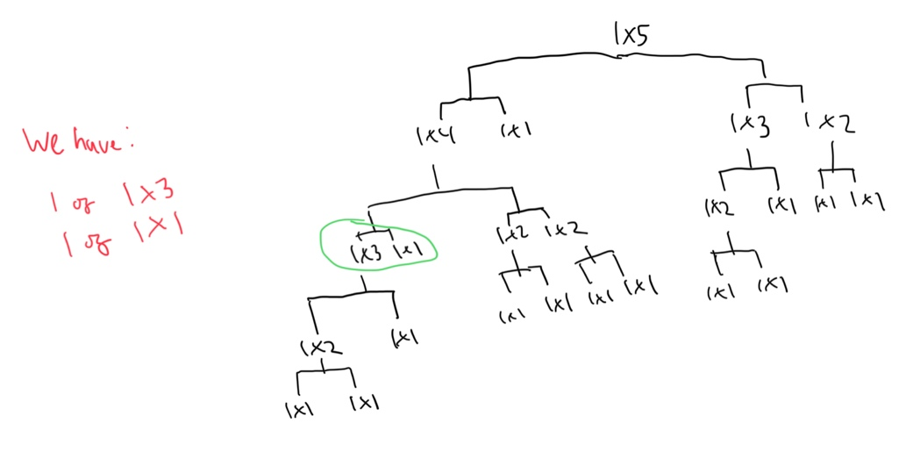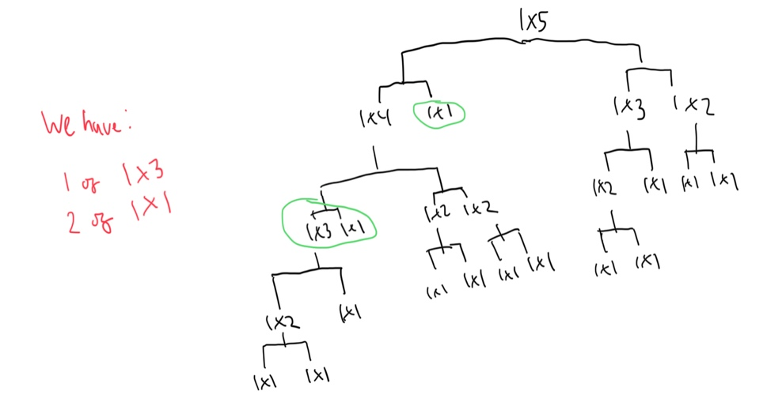

Figure 2.14: Left, A tree displaying how we cannot substitute a 1 x 5. Right, A tree displaying how we can substitute a 1 x 5.

In example 1, we can build a 1 x 4, as circled in green, but we do not have enough parts to create a 1 x 5. This is because we are missing the extra 1 x 1. In example 2, we possess the extra 1 x1, hence we can make the 1 x 5.

These two examples display how we can determine feasible substitutions. If a parent node can be substituted, at least one of the groups of children (two children per group) should consist of parts the user possesses or previous substitutions. In example 1, node 1 x 4 does have a group of child nodes (1 x 3 and 1 x1) that the user possesses the parts to. In example 2, the node 1x5 does have a group of child nodes (1 x 4 and 1 x1) that has already been substituted and possesses the parts to, respectively.

Therefore, the optimization algorithm should traverse the tree in pre-order style, stopping and returning to the previous layer of nodes when the conditions in the above paragraph are met. This can be done using a recursive method.

**SUBROUTINE Optimize PARAMETERS: Brick**

**//// VARIABLE INITIALIZTION WOULD GO HERE ///**

**BRICK_1, BRICK_2🡪 COMBINATIONS()**

**Found 🡪 FindSubstituteParts(Brick_1,Brick_2)**

**RETURN Found**

**SUBROUTINE FindSubstituteParts PARAMETERS: Brick_1,Brick_2**

**///Traverse left child before right child/////**

**Found_1 🡪 NextTwoSubstitutions(Brick_1)**

**Found_2🡪 NextTwoSubstitutions(Brick_2)**

**RETURN Found_1 and Found_2**

**SUBROUTINE NextTwoSubstitutions PARAMETERS: Brick**

**////Lowest possible depth///**

**IF ( Brick NOT IN Inventory ) AND Brick == [1,1]:**

**RETURN False**

**ELIF ( Brick NOT IN Inventory ) AND Brick != [1,1]:**

**Found 🡪 Optimize(Brick)**

**RETURN Found**

**ELSE:**

**RETURN True**

### Resolving horizontally and vertically

When dealing with bricks of dimensions 2 x b x c (whereby by b is any positive natural umber and c is 1/3 or 1), an issue arises. The code to finding bricks combinations for one layer will only resolve horizontally. See below:

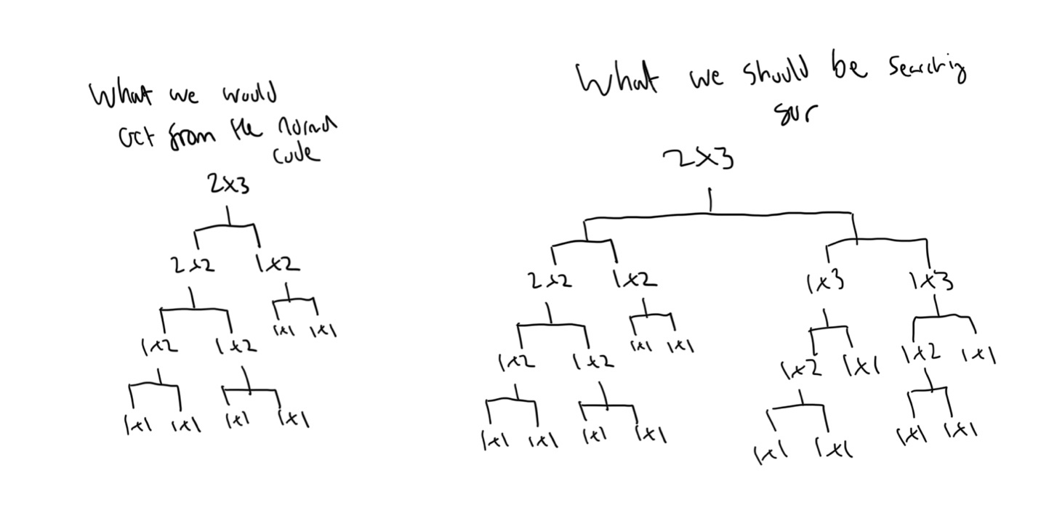  
Figure 2.15: Left, the current tree we can build. Right, the tree we need to build.

The recursive and combinations algorithm together would still miss a possible substitution of a [1 x 3] and [1 x 3]. The best way to solve the problem is to, for every 2 x B node we arrive at, split the node into two 1 x B nodes and optimize these bricks separately as normal – resolving vertically.

Below is how we can do this:

**/// new code/ modifications are in green**

**SUBROUTINE NextTwoSubstitutions PARAMETERS: Brick**

**////Lowest possible depth///**

**IF ( Brick NOT IN Inventory ) AND Brick = [1,1]:**

**RETURN False**

**ELIF ( Brick NOT IN Inventory ) AND Brick != [1,1] and Brick[0] = 2:**

**Found 🡪 Split2xB(Brick)**

**RETURN Found**

**ELIF ( Brick NOT IN Inventory ) AND Brick != [1,1] and Brick[0] = 1:**

**Found 🡪 Optimize(Brick)**

**RETURN Found**

**ELSE:**

**RETURN True**

**SUBROUTINE Split2xB PARAMETERS: Brick**

**Found_1 🡪 Optimize ( [Brick[0]-1, Brick[1]] )**

**Found_2🡪 Optimize ( [Brick[0]-1, Brick[1]] )**

**RETURN Found_1 and Found_2**

### Substituting bricks with plates

A user may want to substitute a brick with the plates they have. After all, any brick can be substituted with three layers of plates in any suitable combination. Therefore, we can adjust the previous algorithms to meet this objective, by optimizing the same brick three times, but this time looking for plates instead of bricks. We can also substitute plates with plates similarly too. Below is a demonstration of how this can be done.

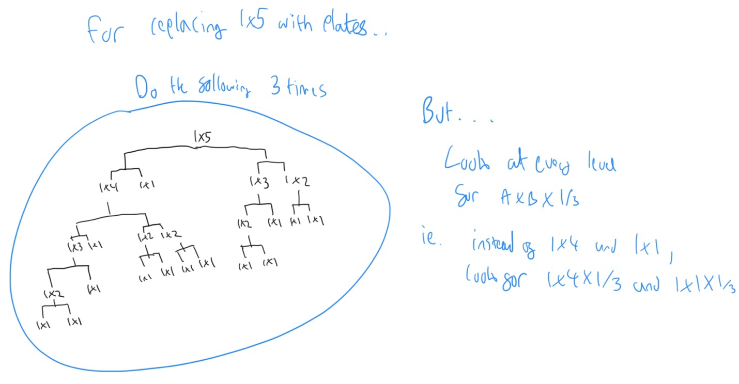

Figure 2.16: How iterations of the core algorithm can be exploited to allow for conceptual dimension expansion

**PLEASE NOTE: FOR ALL THE ABOVE OPTIMIATIONS ALGORITHIMS, THE PSUEDOCODE REPRESENTS THE MOST CORE BASIS OF THE ACTUAL ALGORITHM. AS ONE CAN SEE IN THE TECHNICAL SOLUTION, FAR MORE CONDITIONS AND POSSIBILTIES ARE DEALT WITH. THE PSEUDOCODE WILL MEAN LITTLE FOR THE OTHER SECTIONS AS IT IS DEPENDENT ON THE ACTUAL IMPLEMENTATION OF THE PSEDUOCODE IN PYTHON.**

**OBJECTIVES MET: 4A, 4Cii**

# Design: Files

## Saving and loading inventory

The solution needs to access a stored inventory when the program begins, as well as giving the users the ability to save the current state of their inventory at any point.

We will use a csv file labelled InventoryCSV to store all the relevant information of a saved inventory. File construct is given below.

|  |  |  |
| --- | --- | --- |
| ***Field Name*** | Quantities | PartID |
| ***Data Type*** | String | String |

File save/ load method pseudocode is given below:

### Save

PARTS 🡪INVENTORY.GetListOfAllNodes()

DICTIONARY= 'Quantities' 🡪 quantities in PARTS , 'PartID' 🡪 partID in PARTS

DATAFRAME = DataFrame(DICTIONARY)

# Save the updated inventory

DATAFRAME = DataFrame(DICTIONARY)

DATAFRAME_TO_CSV ("CSV's/InventoryCSV.csv", DATAFRAME)

### Load

DATAFRAME 🡪 CSV_TO_DATAFRAME ("CSV's/InventoryCSV.csv")

For PARTID and Quantities in DATAFRAME:

INVENTORY.INSERT( PARTID, Quantities)

## Saving and loading sets

When a user wants to save the parts required, possessed and substituted of a set at any time, without having to search the set lists and recalculating the values, they should be able to save a set’s information for future use (and override any previous saved instances of the set). They should hence also be able to view these saved sets, and delete any instances of the saved sets.

We will use a csv file labelled SavedSets to store all the relevant information of a saved set. File construct is given below.

|  |  |  |  |  |  |  |  |  |  |
| --- | --- | --- | --- | --- | --- | --- | --- | --- | --- |
| ***Field Name*** | Set Type | Set Name | Set URL, | Total Needed | Cost | PValue | Parts Possessed | Parts Required | Substitutions |
| ***Data Type*** | String | String | String | String | String | String | String | String | String |

File save/ load/ delete method pseudocode is given below:

### Save

DATAFRAME 🡪 CSV_TO_DATAFRAME ("CSV's/SavedSets.csv")

# Remove any old versions of the set

FOR names IN DATAFRAME['Set Name']:

if names = CURRENT_SET.Name:

DATAFRAME = DATAFRAME [DATAFRAME ['Set Name'] != names]

### Load

Saved sets information should be displayed in a table. Some of the set information is too big to be viewed within a table, so some fields within the table should just link to a separate window displaying the information (denoted by ViewAll function).

DATAFRAME 🡪 CSV_TO_DATAFRAME("CSV's/SavedSets.csv")

FOR i IN range(0, ROWS):

FOR k in range(0,columns):

switch k:

case 0|1|3|4|5:

BUTTON(Set_name, press_to = ViewAll)

case 2|6|7|8:

BUTTON(‘Click to view more’, press_to = ViewAll)

case 9:

BUTTON(Set_name, press_to = DeleteSet)

### Delete Set

DATAFRAME 🡪 CSV_TO_DATAFRAME("CSV's/SavedSets.csv")

FOR names in DATAFRAME['Set Name']:

IF names = name:

DATAFRAME 🡪 DATAFRAME[DATAFRAME ['Set Name'] != name]

**OBJECTIVES MET: 3Bii, 6B**

## Loading dimensions information

We need dimension information for as many parts as possible. Part data is available on rebrickable at <https://rebrickable.com/downloads/> . Unfortunately, this does not include dimensions. Therefore, we need to extract the dimensions from the part description (detailed in technical solution).

The resulting file should look like this:

|  |  |  |  |
| --- | --- | --- | --- |
| ***Field Name*** | part_num | name | dimensions |
| ***Data Type*** | String | String | String |

The process which requires dimensions (optimization, viewing parts, etc.…) can simply look up the part dimensions from the csv when needed.

## File Structure

Other noteworthy files/images:

* Arial Black: the font used in the GUI
* Contours_Individual folder: hold the processed image parts (segmenting)
* Contours_Individual folder: hold the foreground image with contours (segmenting)
* Scanned Images folder- holds the user taken background and foreground images
* Black img: used when processing the parts, a background for the individual parts
* CNN_Model: the actual artificial intelligence model that will predict parts

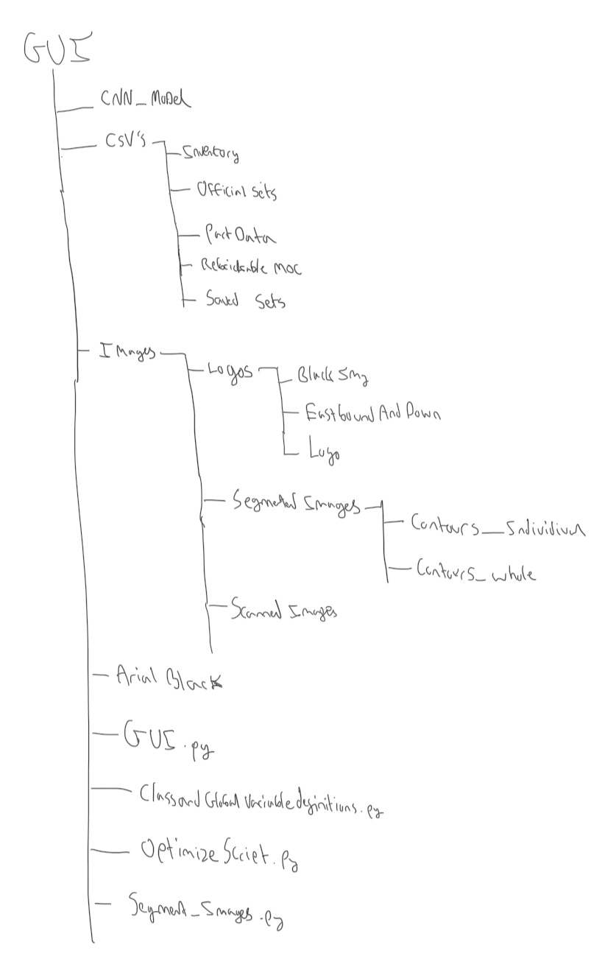

Figure 2.17: File structure of solution

OBJECTIVES MET: 3Bii, 5A, 6B, 7Ciii)C

# Design: Scraping Rebrickable

## Foreword on rebrickable data sets

A full data set for Rebrickable sets is unavailable through the site’s API. The most feasible way to obtain this crucial data was through web scraping.

#### Selenium Driver

I opted to use this web framework that permits you to execute cross-browser tests. Essentially, this framework handles the automation aspect of web scraping.

It was possible to use either a Chrome, Safari or Firefox driver. I opted for chrome as it was the most stable though time outs became an issue (see code on how time outs are dealt with).

#### Beautiful Soup

This Python library was used to pull data out of the HTML of a webpage. This was essential in only extracting the part ID and quantities of the MOCs.

#### Step-by-step explanation of how data can be scraped

The basic process of scraping is illustrated below

1. First, the page containing the most recent MOCs is loaded. A data consent button will need to be bypassed before proceeding.

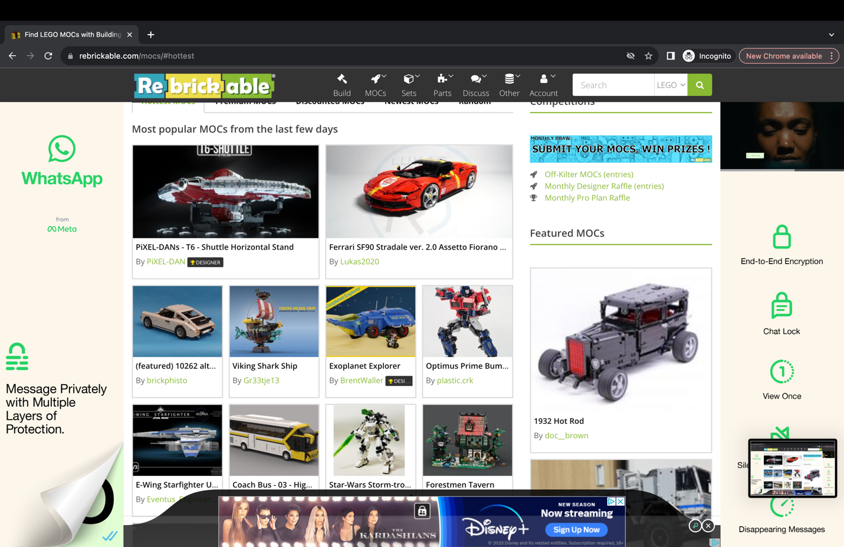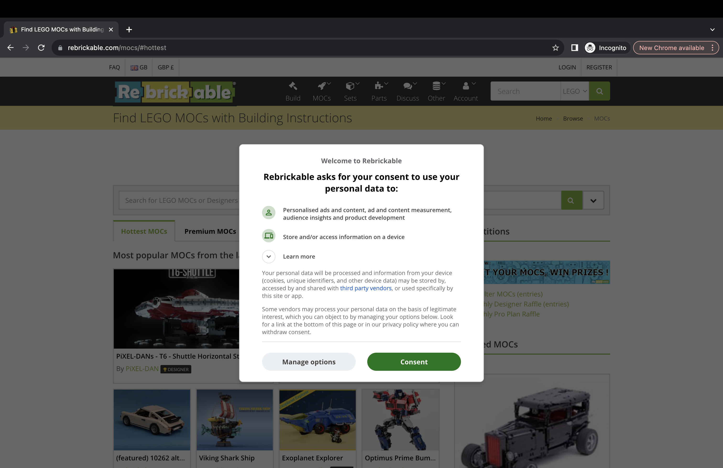 2. Then, select the first MOC on the page

3. After opening the MOC page, take the relevant data (part ID and quantity) from the HTML of the page. Go back to step 2, this time selecting the next MOC.

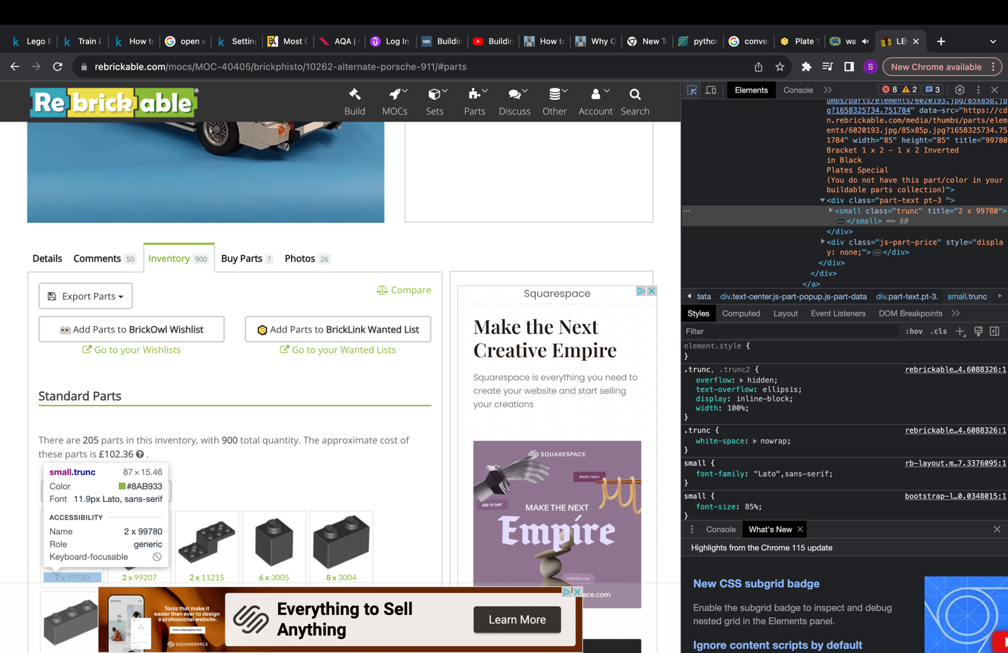

4. After scraping every MOC on the current recent MOCs page, go to the next page of recent MOCs

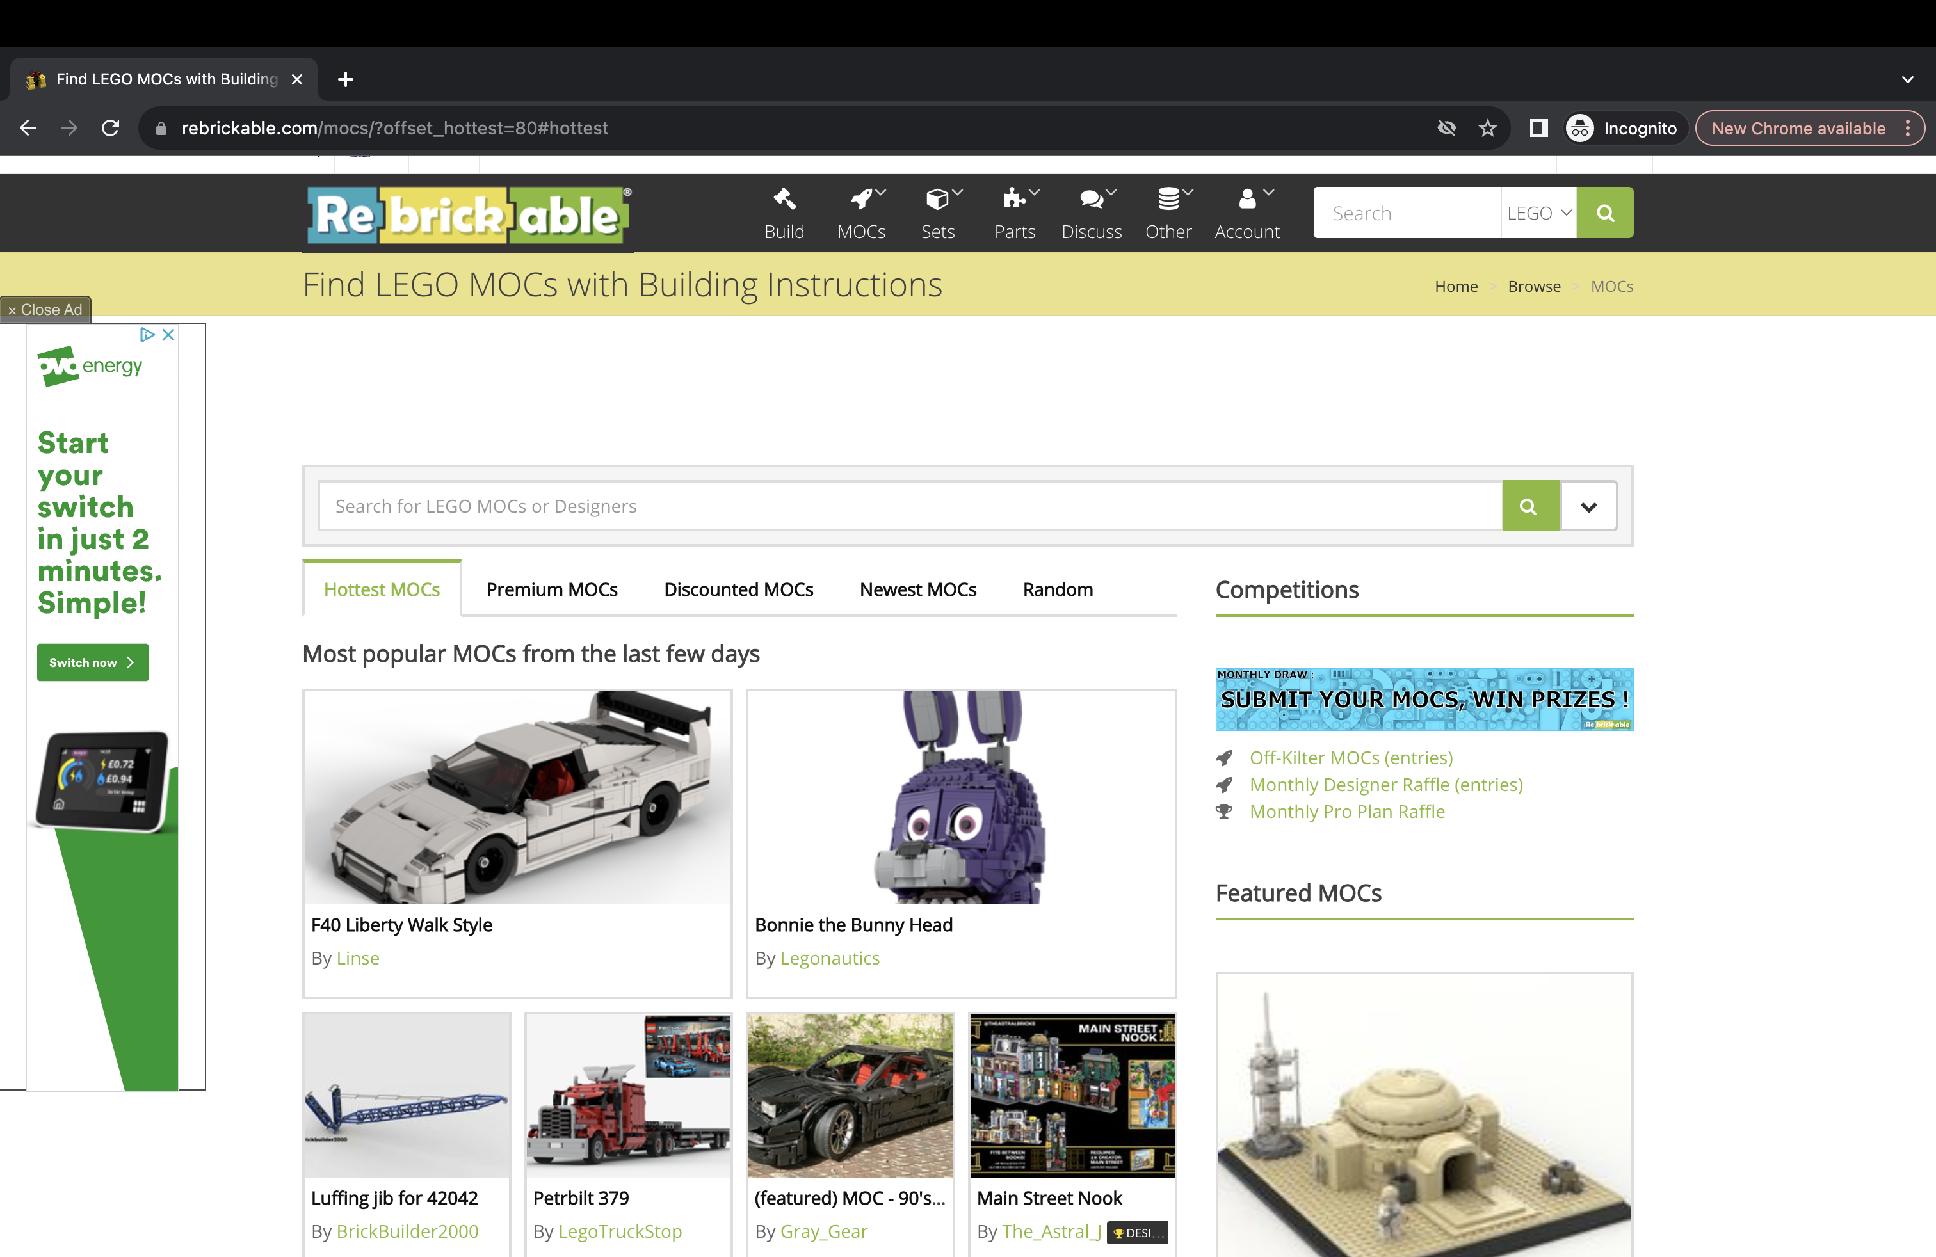

**Objectives Met: 2A, 2C**

# Design: Hardware Requirements

Users will need a personal computer with python installed, with the ability to connect to a camera (to scan bricks) . The solution was created on a Mac, and this is the preferred device to use the solution. This is because apple have a continuity camera feature, allowing users to use their iPhone camera to transmit data to their Mac – perfect for users wanting to scan bricks.



Figure 2.18: A man using the continuity camera feature on his Mac

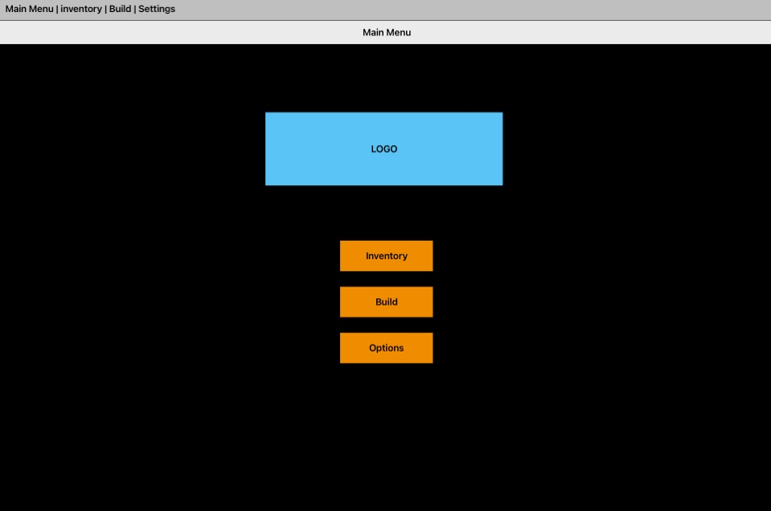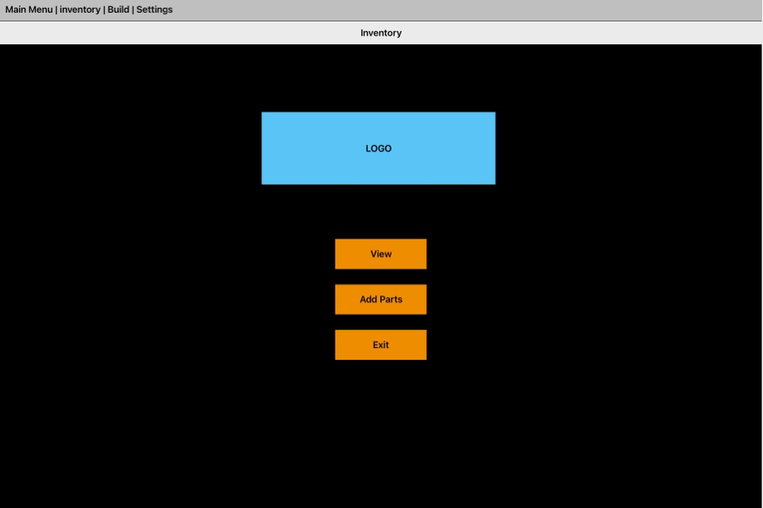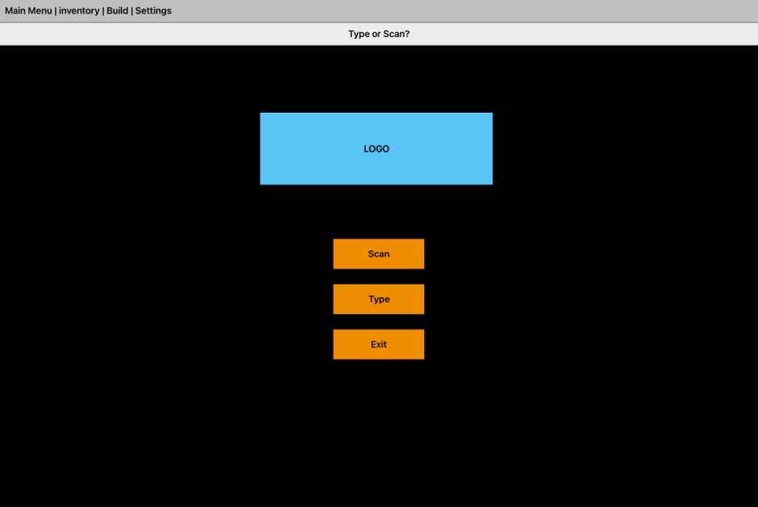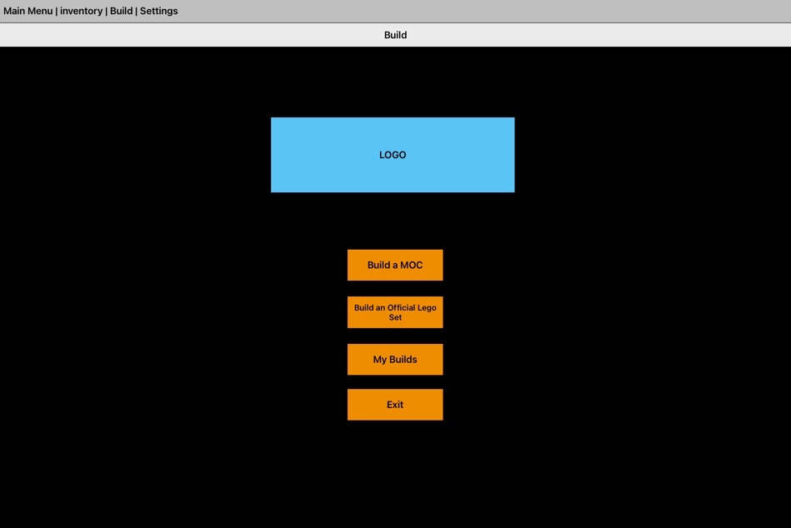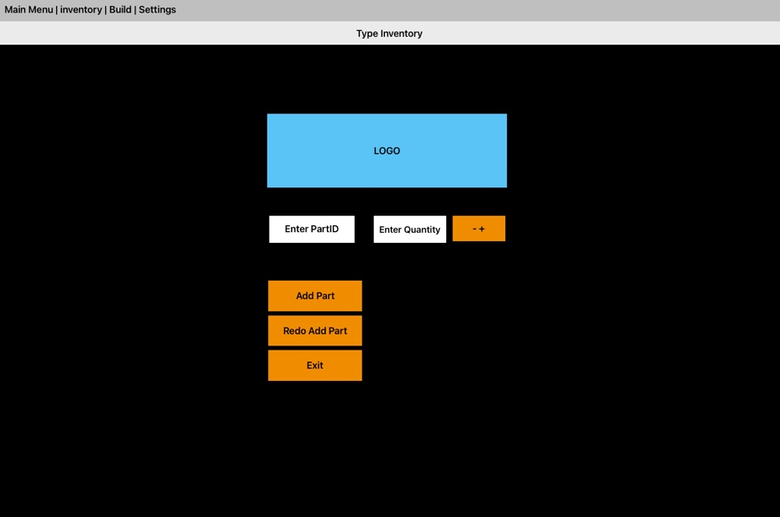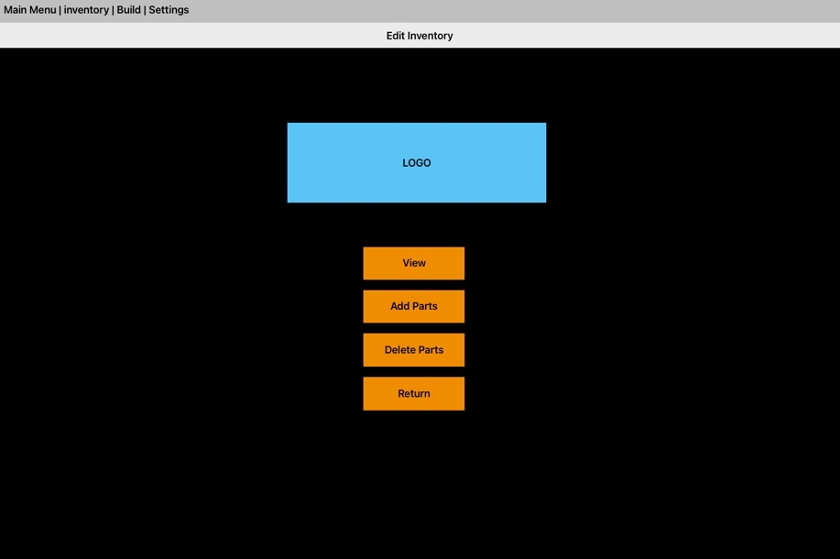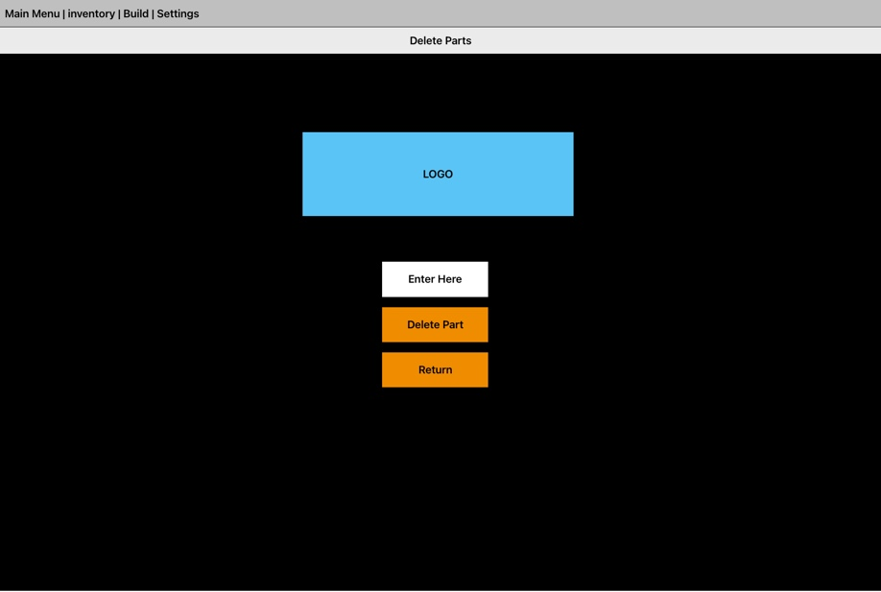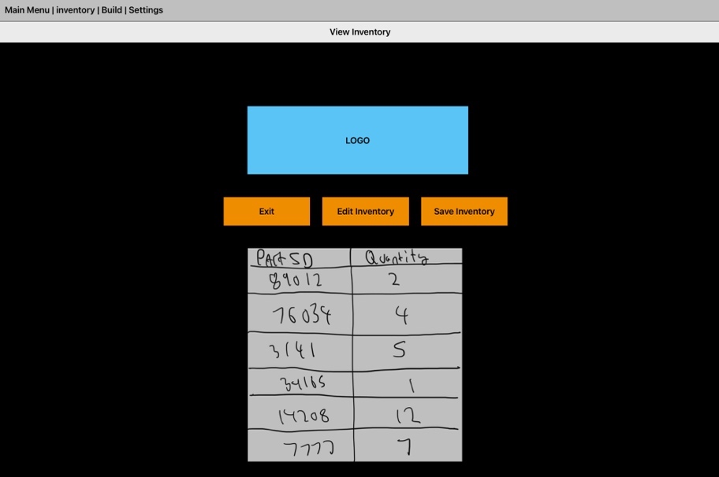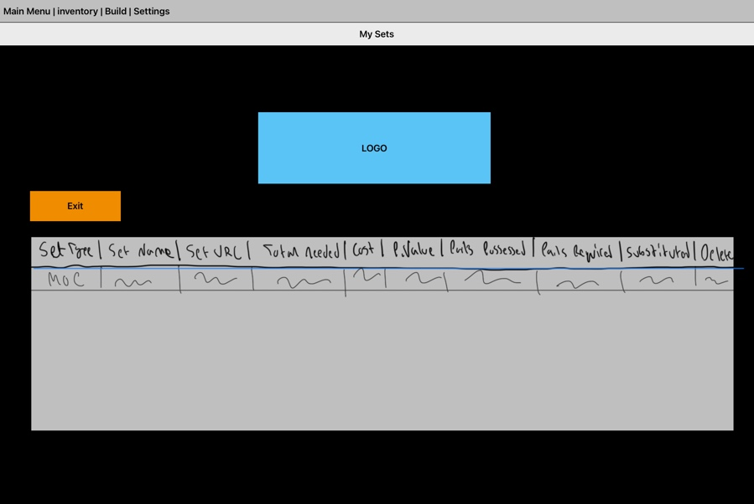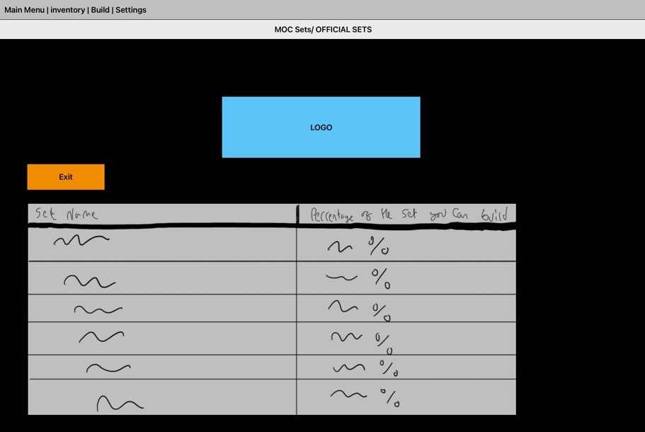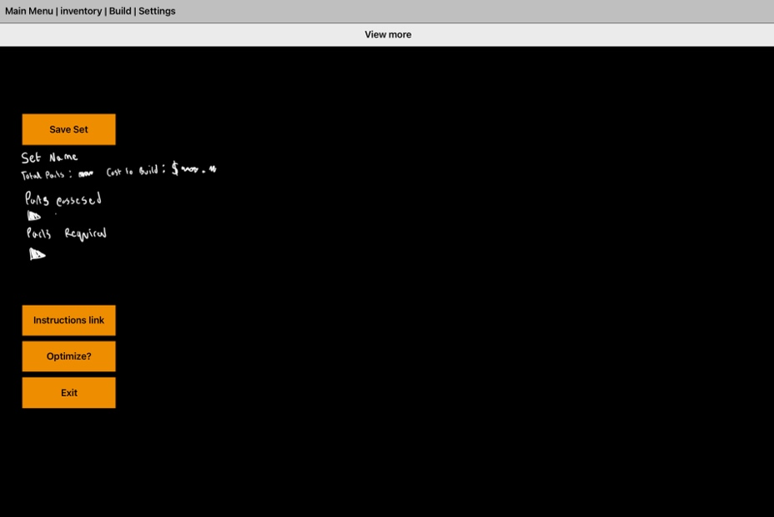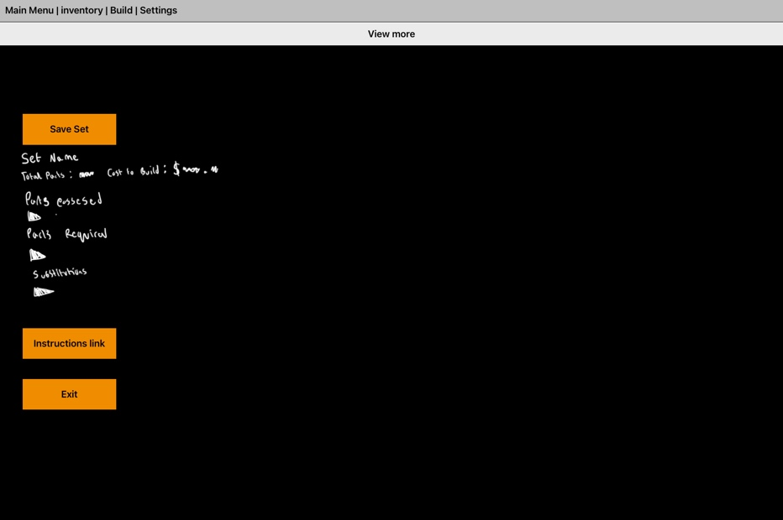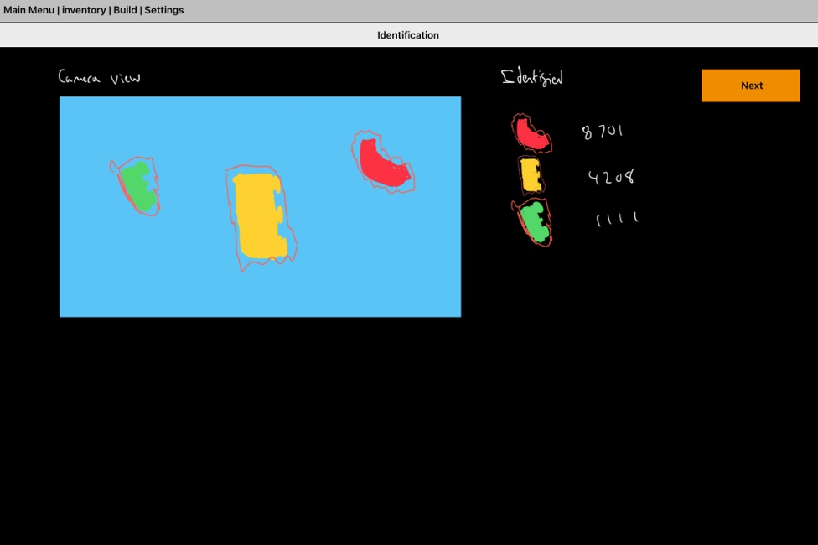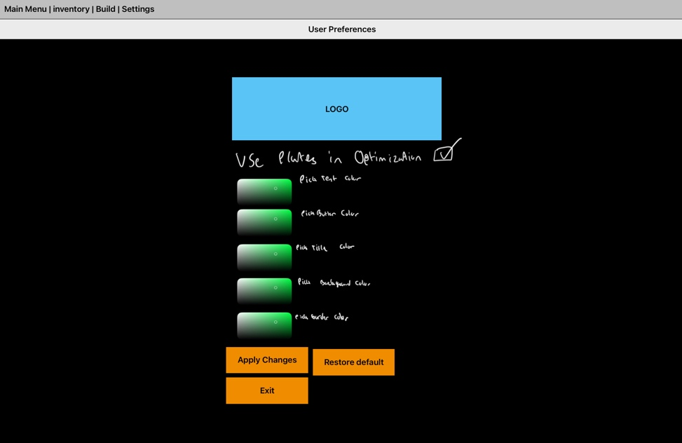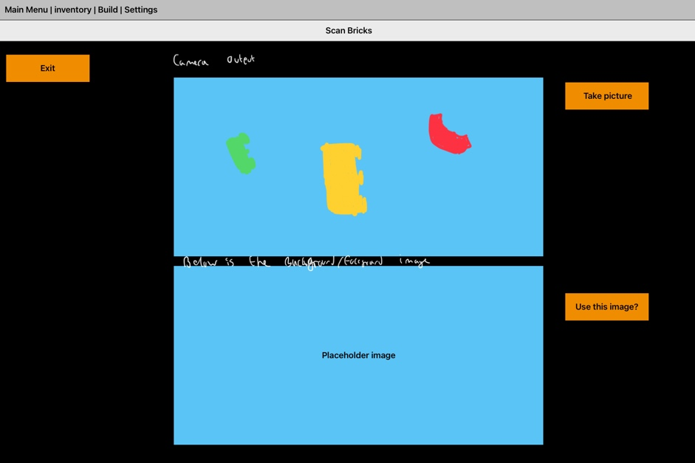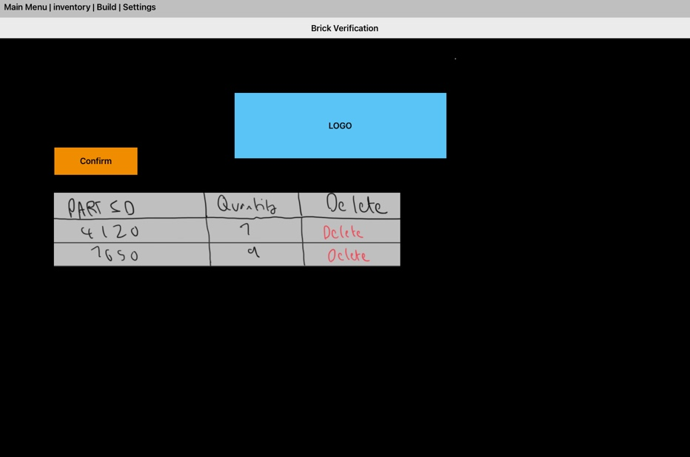

Above: Build Screen

Below: Add Inventory Screen

Above: Inventory Screen

Below: Main Menu Screen

Above: Edit Inventory Screen

Below: Type Inventory Screen

Above: View Inventory Screen

Below: Delete parts Screen

Above: Set view Screen

Below: My Sets Screen

Above: Set information Screen

Below: Set information (after optimization) Screen

Above: Settings Screen

Below: Brick Identification Screen

Above: Brick Verification Screen

Below: can bricks Screen

OBJECTIVES MET: 3B, 4Ci, 4B, 6 (each window will allow users to accomplish what is laid out in objective 6), 7

# Design: Hierarchy chart

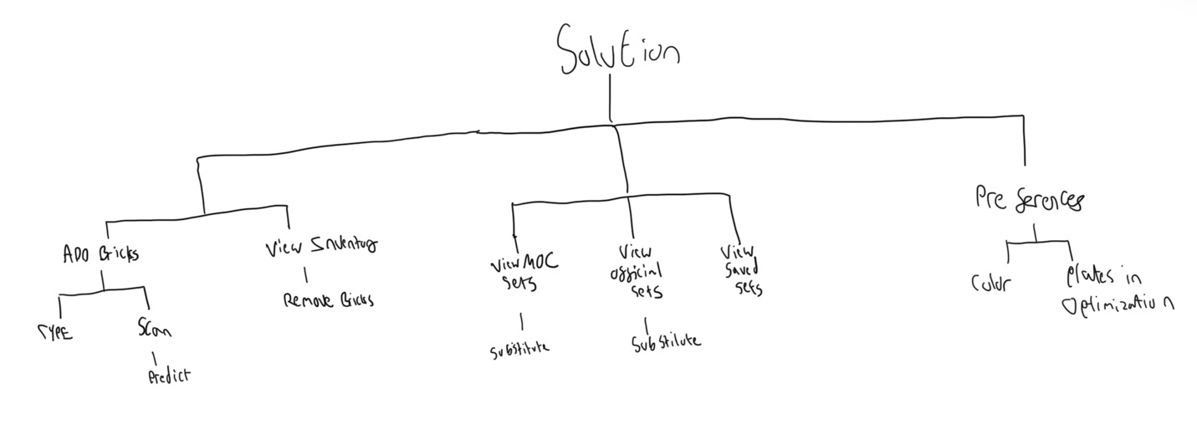

Figure 2.19: A hierarchy chart of all the key modules

# Design: System flowchart

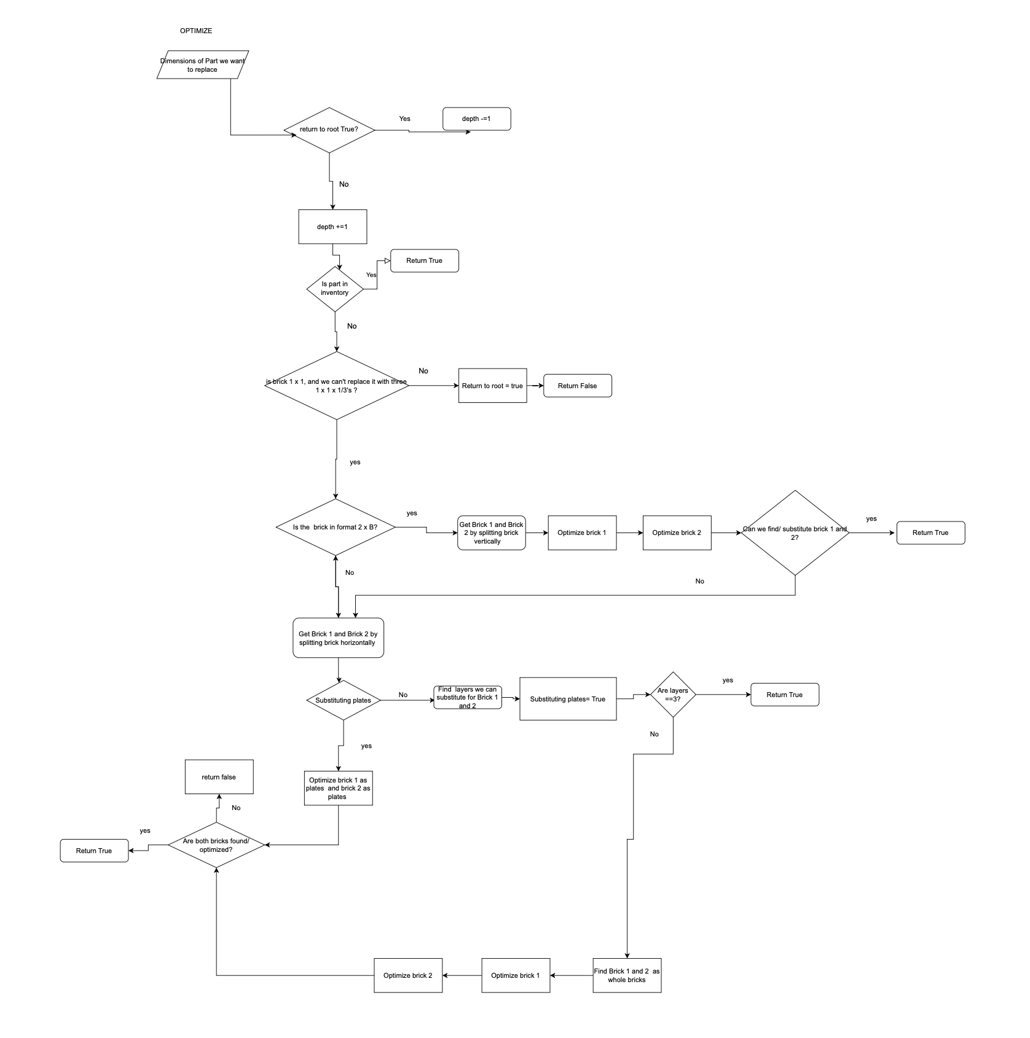

Figure 2.20: A system flowchart, demonstrating logic flow within optimization algorithm

Figure 2.21: A system flowchart, demonstrating logic flow excluding the optimization algorithm

# Design: Class Diagram

How the classes interact with each other. Note: inherited classes inherit all of their parent’s attributes/methods

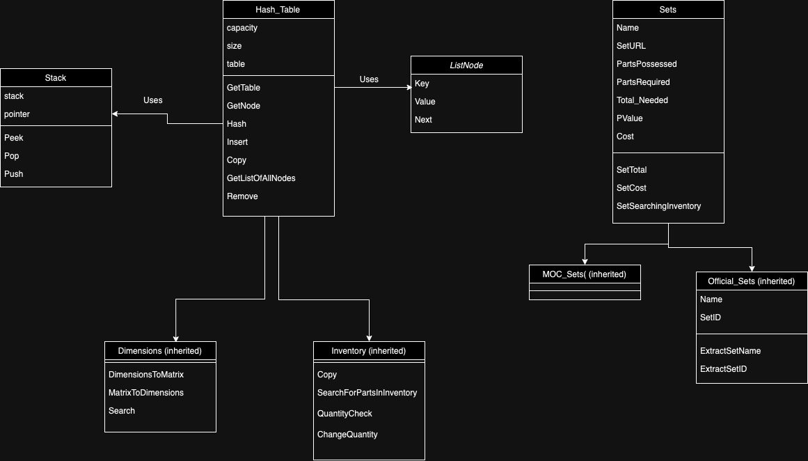

Fig. 2.22: The class diagram

# Design: Data Flow Diagram

Note: The optimize/plate substitution modules are not included in full as it would complicate the diagram and flow. Data is in orange boxes

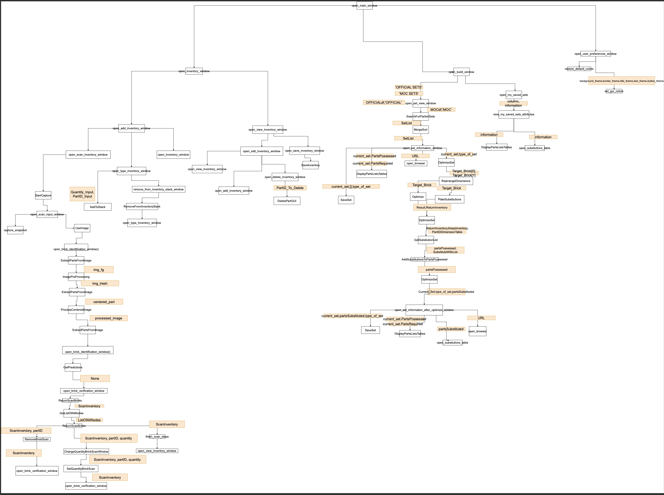

Figure 2.23: A data flow diagram, demonstrating how data flows between each subroutine

# Technical Solution- Overview

The user will NOT use the first three scripts. They have been used for data collection and creating the AI model. The program relies heavily on the output of these scripts, however.

The next three scripts will be run when the user starts the program. GUI is the file that is run to start the UI, and without it, the program is not functional as it ties all the individual modules together.

Every subroutine and block of code has been thoroughly commented, alongside an overview of its purpose, parameters/variables and any additional information that will help ones understanding of the code.

# Technical solution- Quality of your programming techniques

PLEASE NOTE: I have added all the techniques used underneath every function/ block of code etc. The numbers shown are only the first instance of the techniques being used.

|  |  |  |  |  |
| --- | --- | --- | --- | --- |
| Instruction | Page Number | Instruction | Page Number | |
| OOP (Ignore page number) | Yes | OOP get/set | 129 | |
| Classes – (class structure diagram) | 68 | Feature extraction | 134 | |
| OOP Inheritance | 131 | Lambda function | 136 | |
| OOP Polymorphism | 116 | Array division | 143 | |
| Procedures and Functions - used extensively to simplify the organisation and structure of your program (Ignore page number) | Yes | Recursive merge sort | 143 | |
| Dictionaries | 142 | Boolean flags | 147 | |
| Read/write to file | 79 | User defined greedy optimization algorithm. | 164 | |
| Exception handling | 74 | Trees | 164 | |
| HTML parsing | 78 | Pre-order tree traversal | 164 | |
| Browser automation | 73 | Iterative permutation checking | 164 | |
| Cookie handling | 75 | Recursion | 165 | |
| XPath and CSS Selectors | 78 | Dynamic variable assignments | 169 | |
| String handling | 75 | Conceptual dimension expansion | 178 | |
| 2D array subscripting | 89 | Hash table manipulation | 186 | |
| Regular expressions | 89 | Dimension translation | 187 | |
| Function application for feature engineering | 92 | Image processing | 202 | |
| Boolean indexing and exclusion | 92 | Numpy array manipulation | 203 | |
| CNN architecture | 97 | Image segmentation | 206 | |
| Max Pooling | 97 | Contour detection | 206 | |
| Dropout regularizations | 97 | Bounding box extraction | 206 | |
| Implicit one-hot encoding | 97 | Real time image display | 213 | |
| AI Model training | 100 | Snapshot capture | 213 | |
| Early stopping | 100 | Texture loading and registration | 214 | |
| Lined list node design | 108 | Window creation | 215 | |
| OOP class initialization with constructor | 108 | Grouping widgets | 216 | |
| Hash table (table implementation with arrays) | 108 | Menu creation | 216 | |
| Hash table (node retrieval) | 109 | Application state handling | 219 | |
| OOP abstraction | 109 | Resource cleanup strategy | 219 | |
| Modulo operation to hash value | 110 | Flag based control flow | 222 | |
| Linked list traversal | 111 | Global state management | 222 | |
| Linked list node addition | 111 | Input data sanitisation | 230 | |
| Hash table with collision handling through linked lists | 111 | Class handling | 233 | |
| OOP encapsulation | 113 | Stack management | 234 | |
| Hash table node addition | 113 | CNN model inference | 248 | |
| Iteration over hash table | 113 | List comprehension | 265 | |
| Linked list modification | 114 | 4D array subscripting | 266 | |
| Parsing in the second and third dimensions | 122 | Pointer management | | 126 |
| Stacks | 125 | Bounds checking | | 126 |

# Technical Solution- Scraping rebrickable

PLEASE NOTE:

The following code run to scrape Official Lego Sets: with only two minor adjustents

1. The set URL was changed to be:

URL= "https://rebrickable.com/sets/?get_drill_downs=&min_year=2013&max_year=2023&min_parts=0&max_parts=5000&q=&top_theme=&parts_in_set=&sort_sets_by=0&sort_sets_dir=D&page="+ str(startIndex) +"#sets"

1. The StartIndex no longer needed to be in multiples of 80

|  |
| --- |
| Subroutine name: **LoopThroughRecentMOCs()** |
| Subroutine Purpose:  The main subroutine for this script. Inside, I can set the number of pages I would like to scrape from the Rebrickable website. The subroutine contains further methods to open the relevant MOC pages, scrape the brick data, and also bypass a data collection pop-up. |
| Variables:     * PageToStart * startIndex * TimeOut * URL * chrome_options (to set options for the selenium driver) * Driver (the selenium driver) * Button * Scraping * NumberOfPagesToScrape |
| Code:  def LoopThroughRecentMOCs():    #The program will loop 'backswards in time', taking the inventories of all recent MOCs  PageToStart=20  startIndex= PageToStart*80    # Will be true when a timeout occurs  TimeOut= False    # URL of most recent MOCs  URL= "https://rebrickable.com/mocs/newest/?offset_newest="+str(startIndex)+"#newest"      # New web session created  chrome_options = Options()  chrome_options.add_argument("--dns-prefetch-disable")  driver= webdriver.Chrome(chrome_options)    # This webpage contains the most recent MOCs.  driver.get(URL)    CloseConsentButton(driver)    # Variable changes depending on how many pages I want to scrape  NumberOfPagesToScrape= 20    Scraping= True    # Each Most Recent Page has a multiple of 80 in its URL  while Scraping:      SetPageScrape(driver, TimeOut, quantity, partID, URL)  if startIndex==80*(PageToStart + NumberOfPagesToScrape):  Scraping = False    #increments index by 80 (Each Most Recent Page has a multiple of 80 in its URL)  startIndex+=80  URL= "https://rebrickable.com/mocs/newest/?offset_newest="+str(startIndex)+"#newest"    Refresh(driver)    TimeOut= False    CloseConsentButton(driver) |
| Extra Notes: TimeOut exceptions are common when webs scraping using chrome driver. We can work around this error by reloading the page when an exception is thrown.  **Techniques Used- Browser automation, exception handling** |

|  |
| --- |
| Subroutine name: **GetBricksFromPage()** |
| Subroutine Purpose:  The subroutine will use the html content of the website to extract the brick types and quantities from the cells of the ‘inventory’ table. |
| Parameters:   * Soup (the HTML content of the webage) * quantity, partID (both lists with the combined purpose of storing the quantity of each brick type) |
| Variables:   * parts (local variable within the ‘for each’ loop) * fullID |
| Code:  def GetBricksFromPage(soup, quantity, partID):  # finds the table contatining the bricks  for parts in soup.findAll('div', class_='pull-left inv_img'):  # fullID includes quantity and type of each brick. The program needs to separate both  fullID= parts.find('small',class_= 'trunc')  # Only the bold text contains quantity so it can be extracted and removed from fullID  quantity.append(fullID.find('b').text.replace(' x',''))  fullID.b.decompose()  # Adds to the list what remains of FullID  partID.append(fullID.text) |
| Extra Notes:  **Techniques used- XPath and CSS Selectors, string handling** |

|  |
| --- |
| Subroutine name: **CloseConsentButton()** |
| Subroutine Purpose:  There is a pop-up which appears on the most recent MOCs page which asks users to consent to Rebrickable collecting their data.  This pop-up hinders the ability to web scrape, so this subroutine deals with closing this pop-up. |
| Parameters:   * driver (the selenium driver) |
| Code:  def CloseConsentButton(driver):  try:  Button = driver.find_element(By.CLASS_NAME, 'fc-cta-consent')  Button.click()  except:  pass |
| Extra notes:  **Tehcniques used- Cookie handling** |

|  |
| --- |
| Subroutine name: **Refresh()** |
| Subroutine purpose:  Will open the page specified by the URL.  Will refresh the webpage if a timeout exception occurs. |
| Parameters:   * driver (the selenium driver) * TimeOut (a Boolean that is used to record if a timeout exception has occurred) |
| Code:  def Refresh(driver, TimeOut, URL):    # Will repeat every time time out exception occurs  while TimeOut== False:  try:  driver.get(URL)  TimeOut= True  except TimeoutException as e:  # Refresh webpage if taking too long  driver.refresh()    # Time out exception dealt with  TimeOut= False |
| Extra notes:  **Techniques used- Exception handling** |

|  |
| --- |
| Subroutine name: **SetPageScrape()** |
| Subroutine purpose:  This subroutine will access all the MOCs on the current ‘most recent MOCs page’ and then use beautiful soup to extract the data by finding the relevant HTML tags on the webpage. |
| Parameters:   * driver (the selenium driver) * TimeOut (a Boolean that is used to record if a timeout exception has occurred) * quantity, partID (both lists with the combined purpose of storing the quantity of each brick type) * URL ( the URL of the most recent MOCs page) |
| Variables:   * MOCLinkText * content * soup |
| def SetPageScrape(driver, TimeOut, quantity, partID, URL):  # Creates a list of all the MOC link texts on the page  MOCLinkText = driver.find_elements(By.CLASS_NAME, 'js-set-name')  # Will iterate for all links in the page  for i in range(0,len(MOCLinkText)):  # gets the html content from the most recent MOC page  content = driver.page_source  soup = BeautifulSoup(content)    # Will repeat every time time out exception occurs  while TimeOut== False:  try:  # Finds the current MOC link  MOCLink = "https://rebrickable.com"+soup.find_all('h5',class_='trunc mb-0 js-set-name')[i].find('a',href=True)['href']  driver.get(MOCLink.replace('?spot=newest' , '#parts'))  TimeOut=True  except TimeoutException as e:  # Refresh webpage if taking too long  driver.refresh()    # Time out exception dealt with  TimeOut= False  ## gets the html content from the specific MOC page  content = driver.page_source  soup = BeautifulSoup(content)  title=soup.find('h3',class_="text-center").text  # Adds information about the set and Rebrickable URL to the lists  quantity.append(title)  partID.append(MOCLink)  GetBricksFromPage(soup, quantity, partID)  # Closes browser window (to prevent crashing)  driver.quit()  # Returns back to the page of all recent MOCs  driver= webdriver.Chrome(chrome_options)  Refresh(driver, TimeOut, URL)  CloseConsentButton(driver) |
| Extra Notes:  **Techniques Used- HTML Parsing, XPath and CSS Selectors, string handling** |

|  |
| --- |
| Subroutine name: **SaveToDataFrame()** |
| Function Purpose:  Will store the quantities and part IDs into a pandas data frame for future reference. |
| Parameters:   * quantity, partID (both lists with the combined purpose of storing the quantity of each brick type) |
| Variables:   * df |
| Code:  def SaveToDataFrame(quantity,partID):  # Places the two lists into a pandas dataframe  df = pd.DataFrame({'Quantities':quantity,'PartID':partID})    return df |
| Extra notes:  Returns the data frame  **Techniques used- Writing and reading from files** |

|  |
| --- |
| Subroutine name: **get_main_partID()** |
| Function purpose:  Will be applied to a pandas data frame, reducing the part id to a 3-5 digit number |
| Parameters:   * parts (the data in the data frame column, ‘partID’) |
| Code:  def get_main_partID(parts):    # If a part and not a URL (which will always be longer than 13 charcters)  if len(parts)<20:  return parts[:6].replace('a','').replace('b','').replace('c','').replace('pr','').replace('pat', '').replace(' ','')    else:  # Return the URL  return parts |
| Extra notes:  Some bricks can have the same physical dimensions and serve the same function, but have odd part IDs – often containing letters. These are usually to represented printed pieces or slightly modified bricks.  We need to only consider the basic part ID. Otherwise there will be hundreds of other special cases that both the user and solution would need to consider.  We must not remove any text data from a URL, hence the filtering by length  **Techniques used- String handling** |

|  |
| --- |
| Subroutine name: **CleanData()** |
| Subroutine purpose:  Will remove MOC entries which are empty (an issue when web scraping the site). It will also remove any special brick types. |
| Parameters:   * df (the pandas data frame containing the MOC data) |
| Variables:   * allURL * indexDiff |
| Code:  def CleanData(df):    # Gets all URl through filtering by length  allURL= df[df['PartID'].str.len()>13].copy()    # finding the difference in index between two sets  indexDiff=allURL.iloc[0:len(allURL)-1].index-allURL.iloc[1:].index  # Where difference is of 1 (ie no parts)  indexDiff=np.array(indexDiff)== -1  # Insert a False at end to match lengths between allURL and indexDiff  indexDiff = np.insert(indexDiff, len(indexDiff), False, axis=0)  # Remove rows  df.drop(allURL[indexDiff==True].index, axis=0, inplace=True)    # Applies the filtering function to column PartID  df['PartID']= df['PartID'].apply(get_main_partID)    # Save the cleaned data  df.to_csv('RebrickableMOCsClean.csv', index=False, encoding='utf-8') |
| Extra notes:  The data frame is organized as such:    Figure 3.1: The clean sets data frame  There should be at least one row separating any two MOC entries. Hence, we can remove ‘empty’ MOC entries by checking the index differences of two consecutive MOCs (by locating the rows storing the URL and Names) |

# Technical Solution- Scraping Rebrickable script

|  |
| --- |
| Code:  # Import the necessary libraries  from selenium import webdriver  from selenium.common.exceptions import TimeoutException  from selenium.webdriver.chrome.options import Options  import time  from bs4 import BeautifulSoup  import pandas as pd  # two lists holding the type and amount of each part required for each MOC  quantity=[]  partID=[]  LoopThroughRecentMOCs()  df= SaveToDataFrame(quantity,partID)  CleanData(df)  def LoopThroughRecentMOCs():    #The program will loop 'backswards in time', taking the inventories of all recent MOCs  PageToStart=20  startIndex= PageToStart*80    # Will be true when a timeout occurs  TimeOut= False    # URL of most recent MOCs  URL= "https://rebrickable.com/mocs/newest/?offset_newest="+str(startIndex)+"#newest"      # New web session created  chrome_options = Options()  chrome_options.add_argument("--dns-prefetch-disable")  driver= webdriver.Chrome(chrome_options)    # This webpage contains the most recent MOCs.  driver.get(URL)    CloseConsentButton(driver)    # Variable changes depending on how many pages I want to scrape  NumberOfPagesToScrape= 20    Scraping= True    # Each Most Recent Page has a multiple of 80 in its URL  while Scraping:      SetPageScrape(driver, TimeOut, quantity, partID, URL)  if startIndex==80*(PageToStart + NumberOfPagesToScrape):  Scraping = False    #increments index by 80 (Each Most Recent Page has a multiple of 80 in its URL)  startIndex+=80  URL= "https://rebrickable.com/mocs/newest/?offset_newest="+str(startIndex)+"#newest"    Refresh(driver)    TimeOut= False      def CloseConsentButton(driver):  try:  Button = driver.find_element(By.CLASS_NAME, 'fc-cta-consent')  Button.click()  except:  pass  def GetBricksFromPage(soup, quantity, partID):  # finds the table contatining the bricks  for parts in soup.findAll('div', class_='pull-left inv_img'):  # fullID includes quantity and type of each brick. The program needs to separate both  fullID= parts.find('small',class_= 'trunc')  # Only the bold text contains quantity so it can be extracted and removed from fullID  quantity.append(fullID.find('b').text.replace(' x',''))  fullID.b.decompose()  # Adds to the list what remains of FullID  partID.append(fullID.text)  def SaveToDataFrame(quantity,partID):  # Places the two lists into a pandas dataframe  df = pd.DataFrame({'Quantities':quantity,'PartID':partID})    return df  def SetPageScrape(driver, TimeOut, quantity, partID, URL):  # Creates a list of all the MOC link texts on the page  MOCLinkText = driver.find_elements(By.CLASS_NAME, 'js-set-name')  # Will iterate for all links in the page  for i in range(0,len(MOCLinkText)):  # gets the html content from the most recent MOC page  content = driver.page_source  soup = BeautifulSoup(content)    # Will repeat every time time out exception occurs  while TimeOut== False:  try:  # Finds the current MOC link  MOCLink = "https://rebrickable.com"+soup.find_all('h5',class_='trunc mb-0 js-set-name')[i].find('a',href=True)['href']  driver.get(MOCLink.replace('?spot=newest' , '#parts'))  TimeOut=True  except TimeoutException as e:  # Refresh webpage if taking too long  driver.refresh()    # Time out exception dealt with  TimeOut= False  ## gets the html content from the specific MOC page  content = driver.page_source  soup = BeautifulSoup(content)  title=soup.find('h3',class_="text-center").text  # Adds information about the set and Rebrickable URL to the lists  quantity.append(title)  partID.append(MOCLink)  GetBricksFromPage(soup, quantity, partID)  # Closes browser window (to prevent crashing)  driver.quit()  # Returns back to the page of all recent MOCs  driver= webdriver.Chrome(chrome_options)  Refresh(driver, TimeOut, URL)  CloseConsentButton(driver):  def Refresh(driver, TimeOut, URL):    # Will repeat every time time out exception occurs  while TimeOut== False:  try:  driver.get(URL)  TimeOut= True  except TimeoutException as e:  # Refresh webpage if taking too long  driver.refresh()    # Time out exception dealt with  TimeOut= False  def CleanData(df):    # Gets all URl through filtering by length  allURL= df[df['PartID'].str.len()>13].copy()    # finding the difference in index between two sets  indexDiff=allURL.iloc[0:len(allURL)-1].index-allURL.iloc[1:].index  # Where difference is of 1 (ie no parts)  indexDiff=np.array(indexDiff)== -1  # Insert a False at end to match lengths between allURL and indexDiff  indexDiff = np.insert(indexDiff, len(indexDiff), False, axis=0)  # Remove rows  df.drop(allURL[indexDiff==True].index, axis=0, inplace=True)    # Applies the filtering function to column PartID  df['PartID']= df['PartID'].apply(get_main_partID)    # Save the cleaned data  df.to_csv('RebrickableMOCsClean.csv', index=False, encoding='utf-8') |
|  |

# Technical Solution- Scraping rebrickable summary

|  |
| --- |
| Objectives met:  **All of objective 2** |

|  |
| --- |
| Techniques used:  **HTML Parsing, Browser automation, Cookie handling XPath and CSS Selectors, string handling, exception handling, Writing and reading from files , exception handling** |

# Technical Solution- Cleaning part data

|  |
| --- |
| Subroutine name: get_dimensions |
| Parameters:  Names- part names (i.e. Brick 2 x 2)  cat_id, what category the part belongs to ( see extra information) |
| Variables:  ExtractedDimensions |
| Purpose:  Using a regular expression, the dimensions can be extracted from the part name. If the part is a tile or plate, we add a 1/3 to its dimensions |
| Code:  def get_dimensions(names,cat_id):    # Dimensions will match the following regex  ExtractedDimensions= re.findall(r'(\d+(?:/\d+)? x \d+(?: x (\d+(?:/\d+)?|\d+))?)', names)  # If dimensions can be found..  if len(ExtractedDimensions)==1:    # For plates and tiles  if (cat_id== 14 or cat_id== 19 or cat_id== 21 or cat_id== 67 or cat_id== 9 or cat_id== 15) and ExtractedDimensions[0][0][-3:] != '2/3':  # A plate/ tile is 1/3 the height of a regular brick  return ExtractedDimensions[0][0] + " x 1/3"    # For bricks  if (cat_id== 5 or cat_id== 3 or cat_id== 6 or cat_id== 8 or cat_id== 11 or cat_id== 20 or cat_id== 37):  return ExtractedDimensions[0][0]    # Else return empty dimensions  else:  return None |
| Extra Information:  **Techniques used- Regular expressions, 2D array subscripting** |

## Clean part data – Main code

|  |
| --- |
| Variables   * df- rebrickable parts data as a pandas data frame * values- part categories we want to drop |
| Purpose:  To remove any parts belonging to undesirable categories, as well as extracting the dimensions and removing any duplicate parts. |
| Code:  df= pd.read_csv("/Users/shrey/Desktop/NEA /Data Sets/Rebrickable Data/parts.csv")  values = [4,17,24,27,41,42,43,45,48,50,56,57,58,59,60,61,62,63,64,65,66]  # Drop rows that contain any value in the list (These parts are useless within the context of optimization)  df = df[df['part_cat_id'].isin(values) == False]  # Drop the part_material category (unnecessary information)  df= df.drop(['part_material'], axis=1)  df['dimensions']=df.apply(lambda x: get_dimensions(x['name'], x['part_cat_id']),axis=1)  # drop all rows with empty dimensions  df = df[df['dimensions'].apply(lambda x: x != None)]  # No need for the cat_id now as approiate filtering has been applied  df= df.drop(['part_cat_id'], axis=1)  df['part_num']= df['part_num'].apply(lambda x: x[:6].replace('a','').replace('b','').replace('c','').replace('pr','').replace('pat', '').replace('p', '').replace('un', '').replace(' ',''))  df = df.drop_duplicates(subset='part_num')  df.to_csv('PartDataClean.csv', index=False, encoding='utf-8') |
| Extra Notes:  Below is a list of all the part categorized by rebrickable. It should make sense as to why some parts were ignored when compiling brick dimension data   |  |  | | --- | --- | | id | name | | 1 | Baseplates | | 3 | Bricks Sloped | | 4 | "Duplo Quatro and Primo" | | 5 | Bricks Special | | 6 | Bricks Wedged | | 7 | Containers | | 8 | Technic Bricks | | 9 | Plates Special | | 11 | Bricks | | 12 | Technic Connectors | | 13 | Minifigs | | 14 | Plates | | 15 | Tiles Special | | 16 | Windows and Doors | | 17 | Non-LEGO | | 18 | "Hinges Arms and Turntables" | | 19 | Tiles | | 20 | Bricks Round and Cones | | 21 | Plates Round Curved and Dishes | | 22 | Pneumatics | | 23 | Panels | | 24 | Other | | 25 | "Technic Steering Suspension and Engine" | | 26 | Technic Special | | 27 | Minifig Accessories | | 28 | Plants and Animals | | 29 | Wheels and Tyres | | 30 | Tubes and Hoses | | 31 | "String Bands and Reels" | | 32 | "Bars Ladders and Fences" | | 33 | Rock | | 34 | "Supports Girders and Cranes" | | 35 | Transportation - Sea and Air | | 36 | Transportation - Land | | 37 | Bricks Curved | | 38 | "Flags Signs, Plastics and Cloth" | | 39 | Magnets and Holders | | 40 | Technic Panels | | 41 | Large Buildable Figures | | 42 | "Belville Scala and Fabuland" | | 43 | Znap | | 44 | Mechanical | | 45 | Electronics | | 46 | Technic Axles | | 47 | Windscreens and Fuselage | | 48 | Clikits | | 49 | Plates Angled | | 50 | HO Scale | | 51 | Technic Beams | | 52 | Technic Gears | | 53 | Technic Pins | | 54 | Technic Bushes | | 55 | Technic Beams Special | | 56 | Tools | | 57 | "Non-Buildable Figures (Duplo Fabuland etc)" | | 58 | Stickers | | 59 | Minifig Heads | | 60 | Minifig Upper Body | | 61 | Minifig Lower Body | | 62 | Minidoll Heads | | 63 | Minidoll Upper Body | | 64 | Minidoll Lower Body | | 65 | Minifig Headwear | | 66 | Modulex | | 67 | Tiles Round and Curved | | 68 | Projectiles / Launchers | | 69 | Energy Effects | |  |  |   **Techniques used- Reading/writing to a file,** **Boolean Indexing and Exclusion, Function Application for Feature Engineering, data wrangling**  [7] |

## Clean Part Data Full script

|  |
| --- |
| Code:  import pandas as pd  import numpy as np  import matplotlib as plt  # For regular expressions  import re  def get_dimensions(names,cat_id):    # Dimensions will match the following regex  ExtractedDimensions= re.findall(r'(\d+(?:/\d+)? x \d+(?: x (\d+(?:/\d+)?|\d+))?)', names)  # If dimensions can be found..  if len(ExtractedDimensions)==1:    # For plates and tiles  if (cat_id== 14 or cat_id== 3 or cat_id== 19 or cat_id== 21 or cat_id== 67 or cat_id== 9 or cat_id== 15 or cat_id== 67) and ExtractedDimensions[0][0][-3:] != '2/3':  # A plate/ tile is 1/3 the height of a regular brick  return ExtractedDimensions[0][0] + " x 1/3"    # For bricks  if (cat_id== 5 or cat_id== 11 or cat_id== 20 or cat_id== 37):  return ExtractedDimensions[0][0]    # Else return empty dimensions  else:  return None    df= pd.read_csv("/Users/shrey/Desktop/NEA /Data Sets/Rebrickable Data/parts.csv")  values = [4,17,24,27,41,42,43,45,48,50,56,57,58,59,60,61,62,63,64,65,66]  # Drop rows that contain any value in the list (These parts are useless within the context of optimization)  df = df[df['part_cat_id'].isin(values) == False]  # Drop the part_material category (unnecessary information)  df= df.drop(['part_material'], axis=1)  df['dimensions']=df.apply(lambda x: get_dimensions(x['name'], x['part_cat_id']),axis=1)  # drop all rows with empty dimensions  df = df[df['dimensions'].apply(lambda x: x != None)]  # No need for the cat_id now as approiate filtering has been applied  df= df.drop(['part_cat_id'], axis=1)  df['part_num']= df['part_num'].apply(lambda x: x[:6].replace('a','').replace('b','').replace('c','').replace('pr','').replace('pat', '').replace('p', '').replace('un', '').replace(' ',''))  df = df.drop_duplicates(subset='part_num')  df.to_csv('PartDataClean.csv', index=False, encoding='utf-8') |

## Result:

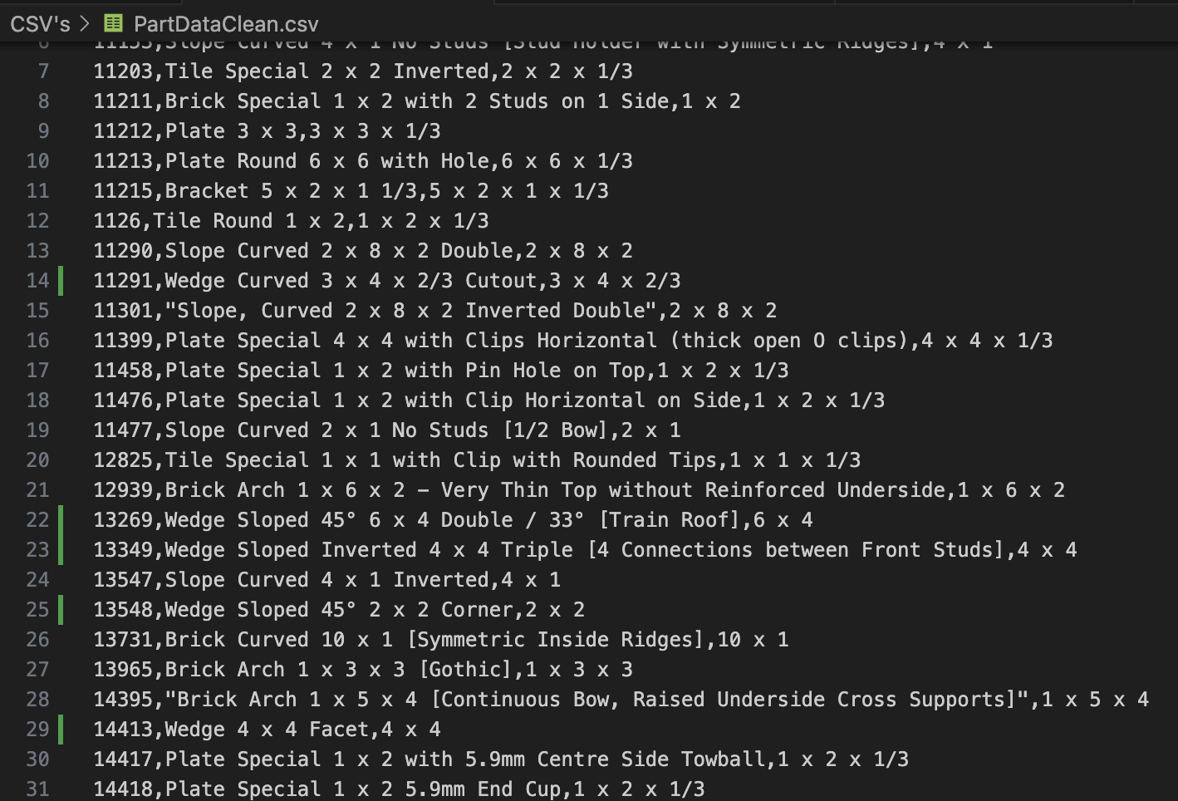

Figure 3.2: We will end up with an easily referenceable CSV, consisting of PartIDs, Names and Dimensions.

# Technical Solution- Cleaning part data summary

|  |
| --- |
| Objectives met:  **5A** |
| Techniques used:   * **Reading/writing to a file** * **2D array subscripting** * **Boolean Indexing and Exclusion** * **Regular Expressions** * **Function Application for Feature Engineering** * **data wrangling** |

# Technical Solution- The Convolutional Neural Network

## The convolutional neural network – Create the model

|  |
| --- |
| Subroutine name: CreateModel |
| Parameters: |
| Variables:  Model- a sequential model  Optimizer- Adam optimizer set to a custom learning rate |
| Purpose:  Creates the AI model |
| Code:  def CreateModel():  model= Sequential()  model.add(Conv2D(filters=64, kernel_size=(3,3), input_shape=(128,128,1),activation='relu'))  model.add(Conv2D(filters=64, kernel_size=(3,3), input_shape=(128,128,1),activation='relu'))  model.add(MaxPool2D((2,2), padding='same'))  model.add(Conv2D(filters=128, kernel_size=(3,3), input_shape=(128,128,1),activation='relu'))  model.add(Conv2D(filters=128, kernel_size=(3,3), input_shape=(128,128,1),activation='relu'))  model.add(MaxPool2D((2,2), padding='same'))  model.add(Conv2D(filters=256, kernel_size=(3,3), input_shape=(128,128,1),activation='relu'))  model.add(Conv2D(filters=256, kernel_size=(3,3), input_shape=(128,128,1),activation='relu'))  model.add(MaxPool2D((2,2), padding='same'))  model.add(Conv2D(filters=512, kernel_size=(3,3), input_shape=(128,128,1),activation='relu'))  model.add(Conv2D(filters=512, kernel_size=(3,3), input_shape=(128,128,1),activation='relu'))  model.add(MaxPool2D(pool_size=(2, 2), padding='same'))  model.add(Flatten())  model.add(Dense(1024,activation='relu'))  model.add(Dropout(0.4))  model.add(Dense(512,activation='relu'))  model.add(Dropout(0.4))  model.add(Dense(50,activation='softmax'))  optimizer = tf.keras.optimizers.legacy.Adam(learning_rate=0.001)  model.compile(loss='categorical_crossentropy', optimizer=optimizer ,metrics=['categorical_accuracy'])  return model |
| Extra Notes:  Please read the design section on the AI model to understand each layer of the model and its purpose  **Techniques used- Convolutional Neural Network (CNN) Architecture, , Max Pooling, Dropout Regularization, Learning Rate adjustment, implicit One-Hot encoding** |

## The convolutional neural network – main code

|  |
| --- |
| Variables:   * earlyStop- an instance of the early stopping module * batch size- the number of samples to go through before updating the internal model parameters. * target_size- image data output/input size * image_gen- an instance of ImageDataGenerator module * train_path- path to train data * test_path- path to test data * checkpoint_filepath where the model will be saved. * model_checkpoint_callback- instance of the model checkpoint module * train_image_gen, test_image_gen both generate new adjusted data from existing data sources every epoch * model- an instance of our AI model (initially untrained) |
| Purpose:  To train the CNN |
| Code:  # Sets the graph settings and clears previous session data (as we are using my device's GPU)  tf.keras.backend.clear_session()  tf.compat.v1.reset_default_graph()  tf.config.optimizer.set_experimental_options({"custom_optimizers": False, "plugin_optimizers": False})  #Ensure we use our GPU  tf.config.experimental.list_physical_devices('GPU')  # Utilize early stopping module to prevent overfitting  earlyStop= EarlyStopping(monitor='val_categorical_accuracy',patience=2)  batch_size= 64  target_size=(128,128)  image_gen= ImageDataGenerator(  zoom_range=0.4,  rotation_range=360,  width_shift_range=0.2,  height_shift_range=0.2,  vertical_flip=True)  checkpoint_filepath = '/Users/shrey/Desktop/NEA /Saved Models/CNN_Model_11'  model_checkpoint_callback = ModelCheckpoint(  filepath=checkpoint_filepath,  save_weights_only=False,  monitor='val_categorical_accuracy',  mode='max',  save_best_only=True)  train_path= '/Users/shrey/Desktop/NEA /Data Sets/Two Datasets/lego_images_dataset_fifty_folders_train'  test_path='/Users/shrey/Desktop/NEA /Data Sets/Two Datasets/lego_images_dataset_fifty_folders_test'  train_image_gen= image_gen.flow_from_directory(train_path,target_size=target_size, color_mode='grayscale', batch_size=batch_size, class_mode='categorical')  test_image_gen= image_gen.flow_from_directory(test_path,target_size=target_size, color_mode='grayscale', batch_size=batch_size, class_mode='categorical')  model= CreateModel()  # needed to use mac GPU effectively  tf.config.optimizer.set_experimental_options({"use_plugin_optimizers": False})  # train the model  model.fit(train_image_gen,  batch_size=batch_size,  epochs= 1000,  validation_data= test_image_gen,  callbacks= [model_checkpoint_callback, earlyStop]) |
| Extra Notes:  Custom graph optimizers are enabled when using mac GPU by default. Users have to adjust this using their API to optimize their training as they see fit. We simply use ADAM optimizer, so we disable this feature.  **Techniques used- GPU Utilization on macOS, Custom Model Creation, model training, Early stopping, ImageDataGenerator**  See the design section for any further clarification. |

# The convolutional neural network – Script

|  |
| --- |
| Code:  import matplotlib  import matplotlib.pyplot as plt  import tensorflow as tf  import numpy as np  from tensorflow.keras.preprocessing import image  from tensorflow.keras.callbacks import EarlyStopping,ModelCheckpoint  from tensorflow.keras.preprocessing.image import ImageDataGenerator  from tensorflow.keras.models import Sequential  from tensorflow.keras.layers import Dense, Conv2D, MaxPool2D, Flatten, Dropout  import os  import cv2  import numpy as np  from tensorflow.keras.preprocessing import image  from keras import backend as K  def CreateModel():  model= Sequential()  model.add(Conv2D(filters=64, kernel_size=(3,3), input_shape=(128,128,1),activation='relu'))  model.add(Conv2D(filters=64, kernel_size=(3,3), input_shape=(128,128,1),activation='relu'))  model.add(MaxPool2D((2,2), padding='same'))  model.add(Conv2D(filters=128, kernel_size=(3,3), input_shape=(128,128,1),activation='relu'))  model.add(Conv2D(filters=128, kernel_size=(3,3), input_shape=(128,128,1),activation='relu'))  model.add(MaxPool2D((2,2), padding='same'))  model.add(Conv2D(filters=256, kernel_size=(3,3), input_shape=(128,128,1),activation='relu'))  model.add(Conv2D(filters=256, kernel_size=(3,3), input_shape=(128,128,1),activation='relu'))  model.add(MaxPool2D((2,2), padding='same'))  model.add(Conv2D(filters=512, kernel_size=(3,3), input_shape=(128,128,1),activation='relu'))  model.add(Conv2D(filters=512, kernel_size=(3,3), input_shape=(128,128,1),activation='relu'))  model.add(MaxPool2D(pool_size=(2, 2), padding='same'))  model.add(Flatten())  model.add(Dense(1024,activation='relu'))  model.add(Dropout(0.4))  model.add(Dense(512,activation='relu'))  model.add(Dropout(0.4))  model.add(Dense(50,activation='softmax'))  optimizer = tf.keras.optimizers.legacy.Adam(learning_rate=0.001)  model.compile(loss='categorical_crossentropy', optimizer=optimizer ,metrics=['categorical_accuracy'])  return model  # Sets the graph settings and clears previous session data (as we are using my device's GPU)  tf.keras.backend.clear_session()  tf.compat.v1.reset_default_graph()  tf.config.optimizer.set_experimental_options({"custom_optimizers": False, "plugin_optimizers": False})  #Ensure we use our GPU  tf.config.experimental.list_physical_devices('GPU')  # Utilize early stopping module to prevent overfitting  earlyStop= EarlyStopping(monitor='val_categorical_accuracy',patience=2)  batch_size= 64  target_size=(128,128)  image_gen= ImageDataGenerator(  zoom_range=0.4,  rotation_range=360,  width_shift_range=0.2,  height_shift_range=0.2,  vertical_flip=True)  checkpoint_filepath = '/Users/shrey/Desktop/NEA /Saved Models/CNN_Model_11'  model_checkpoint_callback = ModelCheckpoint(  filepath=checkpoint_filepath,  save_weights_only=False,  monitor='val_categorical_accuracy',  mode='max',  save_best_only=True)  train_path= '/Users/shrey/Desktop/NEA /Data Sets/Two Datasets/lego_images_dataset_fifty_folders_train'  test_path='/Users/shrey/Desktop/NEA /Data Sets/Two Datasets/lego_images_dataset_fifty_folders_test'  train_image_gen= image_gen.flow_from_directory(train_path,target_size=target_size, color_mode='grayscale', batch_size=batch_size, class_mode='categorical')  test_image_gen= image_gen.flow_from_directory(test_path,target_size=target_size, color_mode='grayscale', batch_size=batch_size, class_mode='categorical')  model= CreateModel()  # needed to use mac GPU effectively  tf.config.optimizer.set_experimental_options({"use_plugin_optimizers": False})  # train the model  model.fit(train_image_gen,  batch_size=batch_size,  epochs= 1000,  validation_data= test_image_gen,  callbacks= [model_checkpoint_callback, earlyStop]) |

## The convolutional neural network – Results

As evident from the figures below we have successfully trained our model to an overall accuracy of 75%. Most of the parts have accuracies well exceeding 75%. Some of the individual parts such as 3004, and 3700 have accuracies considerably lower than the others, however this is often due to the angle the input image was taken at- these parts look very similar to other parts at certain angles (usually studs down). This should not be a problem, as the user will not purposefully position parts in an uncompromising position. Regardless, the user will be able to verify the predictions before they appear in inventory.

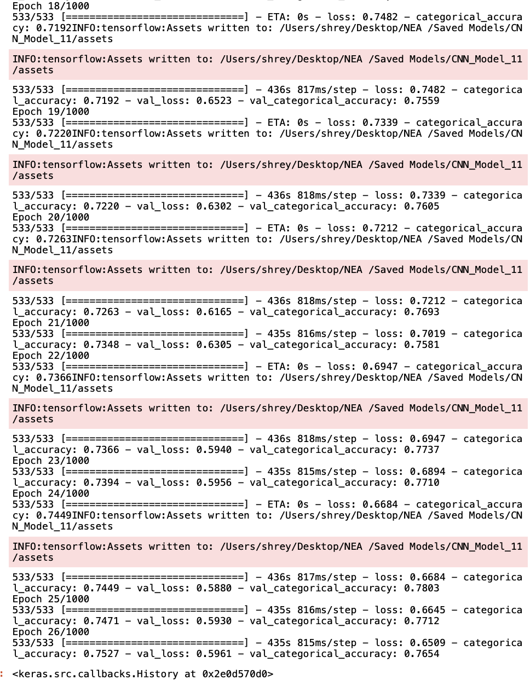

Figure 3.3- Training Results. Training stopped at an accuracy of 75.27%, successfully meeting our objectives

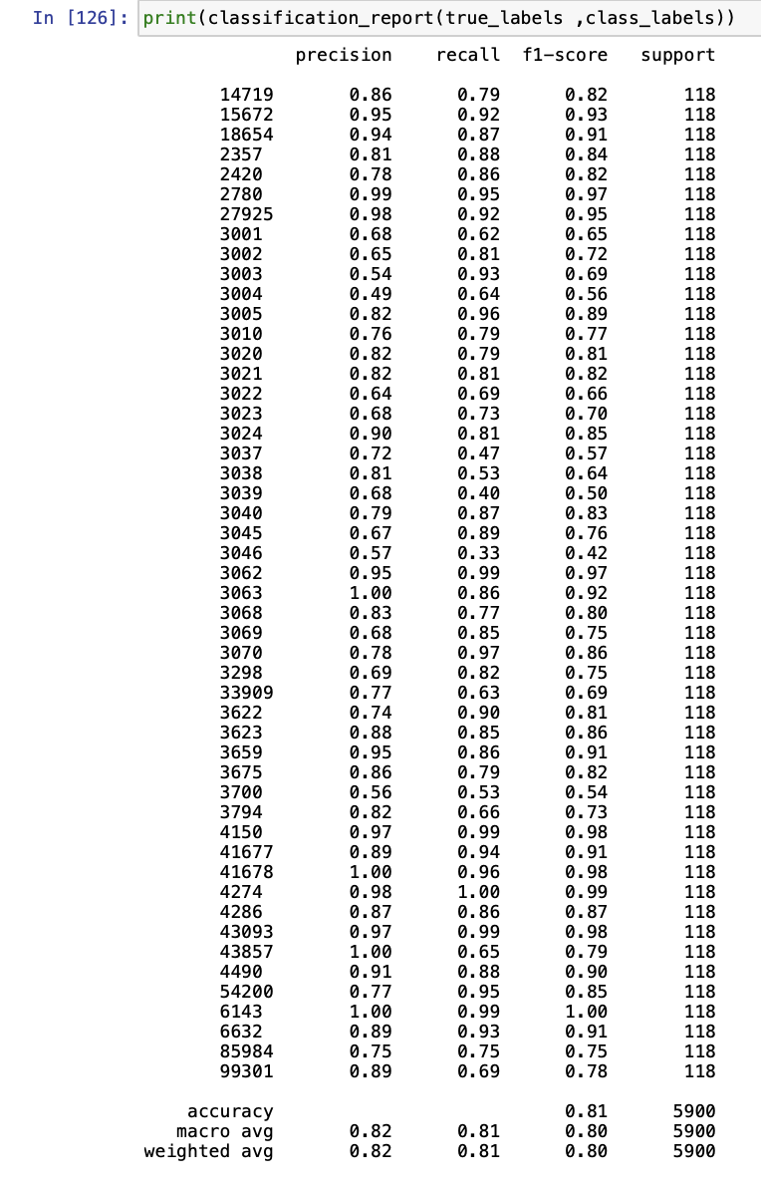

Figure 3.4- Results from utilizing our model on test data. We managed to get a higher accuracy overall than when training

# Technical Solution- The Convolutional Neural Network summary

|  |
| --- |
| Objectives met:  **1A,1B,1C** |
| Techniques used:  **GPU Utilization on macOS, Custom Model Creation, model training, Early stopping, ImageDataGenerator**  **Convolutional Neural Network (CNN) Architecture, , Max Pooling, Dropout Regularization, Learning Rate adjustment, implicit One-Hot encoding** |

# Technical Solution: Hash Table

|  |
| --- |
| Class: ListNode |
| CONSTRUCTOR |
| Code:  class ListNode:    def __init__(self,key,value):  self.key= key  self.value= value  self.next= None |
| Extra Notes:  See the design section for more details  **Techniques Used- Linked Lists (node design), OOP Class Initialization with Constructor** |

|  |
| --- |
| Class: Hash_Table |
| CONSTRUCTOR |
| Code:  def __init__(self, capacity):  self.capacity= capacity  self.size=0  self.table= [None]* capacity |
| Extra Notes:  Capacity is 1.3* number of sets  **Techniques Used- Hash Tables (table implementation with arrays), OOP Class Initialization with Constructor** |

|  |
| --- |
| Class: Hash_Table |
| Function name: GetNode |
| Purpose:  Returns a memory slot |
| Parameters:   * key |
| Variables:  (both local)   * HashedValue * Node (essentially the contents of the memory slot) |
| Code:  def GetNode(self, key):    # Will return an index  HashedValue= self.Hash(key)  # Will return the first element in list- if it exists  Node= self.table[HashedValue]  return Node |
| Extra Notes:  **Techniques Used- Hash Tables (node retrieval), OOP Abstraction** |

|  |
| --- |
| Class: Hash_Table |
| Function name: Hash |
| Parameters:   * key |
| Code:  def Hash(self,key):  # hashes the key and finds the index through a mod operation with the table's capacity  return hash(key) % self.capacity |
| Extra Notes:  Utilizes python’s inbuilt hashing algorithm  **Techniques Used- Modulo Operation, OOP Abstraction** |

|  |
| --- |
| Class: Hash_Table |
| Subroutine name: Insert |
| Parameters:   * key * value |
| Variables:   * Node (the memory slot/ linked list content) |
| Purpose:  This subroutine will insert key-value pairs into their slot’s linked list |
| Code:  def Insert(self,key,value):  Node= self.GetNode(key)    # If there is no list at that index of the table...  if Node == None:    # Create a linked list with the current key/value combination as the head  self.table[self.Hash(key)]= ListNode(key,value)  self.size+=1  return    else:    # Will iterate to the end of the existing linked list  while Node.next != None:  Node= Node.next    # Create a new element of the linked list  Node.next= ListNode(key,value)  self.size+=1 |
| Extra Notes:  See the design section for a text explanation of how the algorithm works  **Techniques Used- Linked List Creation, Linked List Transversal, Linked List Node Addition, OOP Abstraction, Hash Table with collision handling through linked lists** |

|  |
| --- |
| Class: Hash_Table |
| Subroutine name: Copy |
| Parameters:   * Copy_Table – an empty hash table belonging to the same class as the object that calls Copy |
| Variables:   * Node (the memory slot/ linked list content) |
| Purpose:  This function will return a copy of a hashtable |
| Code:  def Copy(self,copy_table):  # initialize a new table with the same capacity    for Node in self.table:  #if a node exists..  while Node != None:    # Insert key-value pairs into the new table  copy_table.Insert(Node.key, Node.value)    # Move onto the next node  Node = Node.next    # Once all data has been copied, return the table  return copy_table |
| Extra Notes:  Will be used primarily within the Optimization algorithm to maintain pervious iterations of the table as substitutions are trialed.  **Techniques Used- Linked List Transversal, Hash Table Node Addition, OOP Abstraction** |

|  |
| --- |
| Class: Hash_Table |
| Subroutine name: GetListOfAllNodes |
| Parameters: |
| Variables:   * ListOfAllNodes- a 2D list of the contents of every node (its key and value stored as an array in form [Key,Value]) |
| Purpose:  This function will return a list of all the nodes stored in the hashtable |
| Code:  def GetListOfAllNodes(self):  ListOfAllNodes=[]  for Node in self.table:  #if a node exists..  while Node != None:  ListOfAllNodes.append([Node.key,Node.value])  # Move onto the next node  Node = Node.next  # Once all data has been copied, return the table  return ListOfAllNodes |
| Extra Notes:  Its primary use will be when the user interacts with the Inventory in the GUI  **Techniques Used- Linked List Transversal,** **Iteration over Hash Table, OOP encapsulation.** |

|  |
| --- |
| Class: Hash_Table |
| Subroutine name: Remove |
| Parameters:   * Key (to remove) |
| Variables:   * previousNode * currentNode |
| Purpose:  Remove a node from the hash table- as specified by the provided key |
| Code:  def Remove(self, key)  location = self.Hash(key)  previousNode = None  currentNode = self.table[location]  # Iterate thorugh the linked list (if it exists)  while currentNode != None:    if currentNode.key == key:  # If there is a previous node, update its 'next' pointer  if previousNode != None:  previousNode.next = currentNode.next  else:  # Otherwise update the node at table[location] directly  self.table[location] = currentNode.next  self.size -= 1  return    # Move to the next node  previousNode = currentNode  currentNode = currentNode.next    # Return if not in table  return |
| Extra Notes:  **Techniques Used- Hashing , Iterative Linked List Transversal,** **Linked List Modification,** **Iteration over Hash Table, OOP abstraction.** |

## Inventory Class- Inherited from Hash_Table

|  |
| --- |
| Class: Inventory |
| Function name: __init__ |
| Parameters:   * capacity- the capacity of the hash table |
| Variables: |
| Purpose:  Constructor method for inventory |
| Code:  def __init__(self, capacity):  Hash_Table.__init__(self,capacity) |
| Extra Notes: Inherits all methods and attributes from hash_table  **Techniques Used- OOP Class Initialization with Constructor, OOP Inheritance** |

|  |
| --- |
| Class: Inventory |
| Function name: Copy |
| Parameters: |
| Variables:   * copy_table: an empty object of Inventory class |
| Purpose  Copy an Inventory table |
| Code:  def Copy(self):  copy_table= Inventory(self.capacity)  # Use the rest of the parent class Copy method  return super().Copy(copy_table) |
| Extra Notes:  **Techniques Used- OOP abstraction, OOP Polymorphism** |

|  |
| --- |
| Class: Inventory |
| Function name: SearchForPartsInInventory |
| Parameters:   * key (node we want to find) |
| Variables:   * Node (possible instance within the linked list of the part) |
| Purpose  Find a part in Inventory |
| Code:  def SearchForPartsInInventory(self, key):      Node= self.GetNode(key)    # Will iterate to the end of the list.  # If key not found, return '0'  while Node != None:      # If not item, go to next node  if Node.key != key:  Node= Node.next  # If found, return value  elif Node.key== key:  return Node    return None |
| Extra Notes:  **Techniques Used- Iterative Linked List Traversal, Node retrieval** |

|  |
| --- |
| Class: Inventory |
| Function name: QuantityCheck |
| Parameters:   * key (instance of the part) * PartsRequired (quantity of a specific part required to build a set) |
| Variables:   * Node (possible instance within the linked list of the part) * Quantity (the remaining quantity of the brick the user will have if the brick is used in the set) |
| Purpose:  To return the amount of that brick remaining if it were to be used in a set |
| Code:  def QuantityCheck(self, key, PartsRequired):  # Find the node  Node= self.SearchForPartsInInventory(key)  if Node != None:  # Subtract parts required from how much the user has  quantity= str(int(Node.value)-int(PartsRequired))  return quantity  else:  return 'NO_PART' |
| Extra Notes:  **Techniques Used- Node Retrieval,, OOP Encapsulation** |

|  |
| --- |
| Class: Inventory |
| Function name: ChangeQuantity |
| Parameters:   * key (instance of the part) * amount (amount we want to change the quantity by) |
| Variables:   * Node (possible instance within the linked list of the part) * Quantity (the remaining quantity of the brick the user will have if the brick is used in the set) |
| Purpose:  Functions modifies the quantity of a certain part stored within an Inventory and returns the new modified quantity |
| Code:  def ChangeQuantity(self, key, amount):    Node= self.GetNode(key)    # Will iterate to the end of the list.  # If key not found, return '0'  while Node != None:      # If not item, go to next node  if Node.key != key:  Node= Node.next  # If found, return value  elif Node.key== key:  Node.value = str(int(Node.value)+amount)  return self, Node.value  return self,Node.value |
| Extra Notes:  **Techniques Used- Node Retrieval,, OOP Abstraction** |

## Dimensions Class- Inherited from Hash_Table

|  |
| --- |
| Class: Dimensions |
| Function name: __init__ |
| Parameters:   * capacity- the capacity of the hash table |
| Variables: |
| Purpose:  Constructor method for Dimensions |
| Code:  def __init__(self, capacity):  Hash_Table.__init__(self,capacity) |
| Extra Notes: Inherits all methods and attributes from hash_table  **Techniques Used- OOP Class Initialization with Constructor, OOP Inheritance** |

|  |
| --- |
| Class: Dimensions |
| Function name: DimensionsToMatrix |
| Parameters:   * dimensions (dimensions of brick in form a x b x c. or. a x b) |
| Variables:   * dimensionLength (how many dimensions we are dealing with- 2 or 3) * returnDimensionsArray (the input dimensions in form [a,b] or [a,b,c]) |
| Purpose:  Converts dimensions of form a x b to [a,b]  Converts dimensions of form a x b x c to [a,b,c] |
| Code:  def DimensionsToMatrix(self,dimensions):  # The dimensions of the matrix are revealed by the number of x's in the string  dimensionLength= dimensions.count('x') +1  # Create a array to hold matrix dimensions  returnDimensionsArray=[None]*dimensionLength  # Find first matrix dimension  returnDimensionsArray[0]= int(dimensions[:dimensions.index('x')])  dimensions= dimensions[(dimensions.index('x')+1):]  # Find second (and possibly third) matrix dimension(s)  if dimensionLength ==2:  returnDimensionsArray[1]= int(dimensions)  return returnDimensionsArray  elif dimensionLength ==3:  returnDimensionsArray[1]= int(dimensions[:dimensions.index('x')])  dimensions= dimensions[(dimensions.index('x')+1):]  # We store a plate as size 1.3 for readability  if dimensions == ' 1/3':  returnDimensionsArray[2]= 1.3  elif dimensions == ' 2/3':  returnDimensionsArray[2]= 2.3  else:  returnDimensionsArray[2]= int(dimensions)  return returnDimensionsArray  # We cannot deal with more than 3 dimensions  else:  return [0,0] |
| Extra Notes:  **Techniques Used- Parsing in the Second and Third Dimensions, OOP Abstraction , String handling** |

|  |
| --- |
| Class: Dimensions |
| Function name: MatrixToDimensions |
| Parameters:   * dimensions (dimensions of brick in form [a,b] or [a,b,c]) |
| Variables:   * dimensionThree _ a possible third dimension of the part |
| Purpose:  Converts dimensions of form [a,b] to a x b  Converts dimensions of form [a,b,c] to a x b x c |
| Code:  def MatrixToDimensions(self,dimensions):  if len(dimensions)== 2:  return str(dimensions[0])+ ' x '+ str(dimensions[1])    elif len(dimensions)== 3:  if dimensions[2] == 1.3:  dimensionThree= '1/3'  elif dimensions[2] == 2.3:  dimensionThree= '2/3'  else:  dimensionThree= str(dimensions[2])  return str(dimensions[0])+ ' x '+ str(dimensions[1])+' x '+ dimensionThree |
| Extra Notes:  **Techniques Used- Parsing in the Second and Third Dimensions, OOP Abstraction , String handling** |

|  |
| --- |
| Class: Dimensions |
| Function name: Search |
| Parameters:   * key – dimensions in form a x b. or a x b x c , or PartID |
| Variables:   * Node (possible instance within the linked list of the part) |
| Purpose:  Function searches inventory for parts/dimesnions with desired dimensions/partID and returns the partID/dimensions node found |
| Code:  def Search(self, key):    Node= self.GetNode(key)    # Will iterate to the end of the list.  # If key not found, return '0'  while Node != None:      # If not item, go to next node  if Node.key != key:  Node= Node.next  # If found, return value  elif Node.key== key:  return Node    return None |
| Extra Notes:  **Techniques Used- Parsing in the Second and Third Dimensions, OOP Abstraction , String handling, Node/ attribute retrieval** |

# Technical Solution: Hash Table summary

|  |
| --- |
| Objectives met:  **All of objective 3A, 5B,** |
| Techniques used:  **Techniques Used-** **Linked Lists (node design), OOP Class Initialization with Constructor ,Hash Tables (table implementation with arrays), OOP Class Initialization with Constructor, Hash Tables (node retrieval), OOP Abstraction, Modulo Operation, Linked List Creation, Linked List Transversal, Linked List Node Addition, Hash Table with collision handling through linked lists, Hash Table Node Addition, Iteration over Hash Table, OOP encapsulation, Hashing, Linked List Modification, OOP Inheritance, OOP Polymorphism, Parsing in the Second and Third Dimensions , String handling** |

# Technical Solution: Stack class

|  |
| --- |
| Class: Stack |
| Function name: __init__ |
| Parameters:   * Capacity- stack capacity |
| Attributes:   * Stack (the array of length Capacity that holds the stack) * Pointer( (last item added in the stack) |
| Purpose:  Constructor method for Stack class |
| Code:  def __init__(self,capacity):  self.stack= [None]* capacity  self.pointer= 0 |
| Extra Notes:  **Techniques Used- OOP Class Initialization with Constructor, Stacks** |

|  |
| --- |
| Class: Stack |
| Function name: Peek |
| Parameters: |
| Variables: |
| Purpose:  Returns the last item added to the stack |
| Code:  def Peek(self):  # returns the last item added to the stack  return self.stack[self.pointer] |
| Extra Notes:  **Techniques Used- OOP abstraction , stack operations (peek)** |

|  |
| --- |
| Class: Stack |
| Function name: Pop |
| Parameters: |
| Variables: |
| Purpose:  Removes the last item added to the stack |
| Code:  def Pop(self):  self.stack[self.pointer]= None  self.pointer-=1  # Ensures we do not go out of index  if self.pointer<0:  self.pointer=0 |
| Extra Notes:  **Techniques Used- OOP abstraction, Bounds Checking, Pointer management, stack operations (pop)** |

|  |
| --- |
| Class: Stack |
| Function name: Push |
| Parameters:  Value – item we want to add to the stack |
| Variables: |
| Purpose:  Removes the last item added to the stack |
| Code:  def Push(self, value):  self.pointer+=1  # Ensures we do not go out of index  if self.pointer == len(self.stack):  self.pointer-=1  pass  else:  # Set value  self.stack[self.pointer]= value |
| Extra Notes:  **Techniques Used- OOP abstraction, Bounds Checking, Pointer management, stack operations (push)** |

# Technical Solution: Stacks summary

|  |
| --- |
| Objectives met:  **7Ci)B** |
| Techniques used:  **OOP abstraction, Bounds Checking, Pointer management, Stacks, stack operations (push, pop, peek), OOP Class Initialization with Constructor** |

# Technical Solution- Sets class

|  |
| --- |
| Class: Sets |
| Function name: __init__ |
| Parameters:  Name  SetURL (link to rebrickable page of the set) |
| Attributes:   * Name * SetURL * PartsPossessed * PartsRequired * Total_Needed * PValue * Cost |
| Purpose:  Constructor method for Sets Class |
| Code:  def __init__(self, Name, SetURL):  self.Name= Name  self.SetURL= SetURL  self.PartsPossessed= []  self.PartsRequired= []  self.Total_Needed=0  self.PValue= 0  self.Cost='' |
| Extra Notes:  **Techniques Used- OOP Class Initialization with Constructor,** |

|  |
| --- |
| Class: Sets |
| Function name: SetTotal |
| Parameters: |
| Variables:   * runningTotal |
| Purpose:  Set the total (of any) parts required to complete the set |
| Code:  def SetTotal(self):  runningTotal=0  # Add all the quantities of parts still needed  for parts in self.PartsRequired:  runningTotal+=int(parts[1])  self.Total_Needed= runningTotal |
| Extra Notes:  **Techniques Used- OOP Get/Set method** |

|  |
| --- |
| Class: Sets |
| Function name: SetCost |
| Parameters: |
| Variables:   * cost |
| Purpose:  Set the cost to complete the set based on Part_Needed |
| Code:  def SetCost(self):  # Multiply total by average price-per-part ($0.19)  cost= str(round(self.Total_Needed * 0.19,2))  # Extend to two decimal places  while len(cost[cost.index('.')+1:]) <2:  cost+='0'  self.Cost= "$"+cost |
| Extra Notes:  Money data type does not exist in python so I had to use strings with a leading ‘$’ and trailing ‘0’ to imitate standard money notation  **Techniques Used- OOP Get/Set method** |

|  |
| --- |
| Class: Sets |
| Function name: SetSearchingInventory |
| Parameters:   * Quantity- How much of the part we need. * PartID- The actual part. * Inventory – Inventory where part is stored. |
| Variables:   * ResultOfSearch – How much of the part the user would have left over. |
| Purpose:  Adds quantities/partIDs to the Set’s PartsPossessed and PartsRequired lists |
| Code:  def SetSearchingInventory(self, Quantity, PartID, inventory):  # Will store either 'NO_PART' or the quantity of parts left over  ResultOfSearch= inventory.QuantityCheck(PartID, Quantity)    # The user needs full quantity of the part (they have none)  if ResultOfSearch == 'NO_PART':    self.PartsRequired.append([PartID,Quantity])    # If the user does not have enough parts  elif int(ResultOfSearch)< 0 :    # As ResultOfSearch would be negative in this case,  # The absolute value represents the extra parts required  self.PartsRequired.append([PartID,str(abs(int(ResultOfSearch)))])    # User already has some of this part - but not enough.  self.PartsPossessed.append([PartID,str(int(Quantity)+  int(ResultOfSearch))])  elif int(ResultOfSearch)>= 0 :  # The user has both the type of brick and enough of it  self.PartsPossessed.append([PartID,str(Quantity)]) |
| Extra Notes:  **Techniques Used-Handling Cases** |

## MOC_Sets- inherited from Sets class

|  |
| --- |
| Class: MOC_Sets |
| Function name: __init__ |
| Parameters:  Name  SetURL (link to rebrickable page of the set) |
| Attributes:   * Name * SetURL * PartsPossessed * PartsRequired * Total_Needed * PValue * Cost |
| Purpose:  Constructor method for MOC_Sets Class |
| Code:  def __init__(self, Name, SetURL):  Sets.__init__(self, Name, SetURL) |
| Extra Notes:  **Techniques Used- OOP Class Initialization with Constructor, OOP Inheritance** |

## Official_Sets- inherited from Sets Class

|  |
| --- |
| Class: Official_Sets |
| Function name: __init__ |
| Parameters:  Name  SetURL (link to rebrickable page of the set) |
| Attributes:   * Name * SetID * SetURL * PartsPossessed * PartsRequired * Total_Needed * PValue * Cost |
| Purpose:  Constructor method for Official_Sets Class |
| Code:  def __init__(self, Name, SetURL):  Sets.__init__(self, Name, SetURL)  self.Name= self.ExtractSetName()  self.SetID= self.ExtractSetID() |
| Extra Notes:  **Techniques Used- OOP Class Initialization with Constructor, OOP Inheritance** |

|  |
| --- |
| Class: Official_Sets |
| Function name: ExtractSetName |
| Parameters: |
| Variables:   * URL- set URL * start_of_set_name. (index of where in the URL the set name starts) * end_of_set_name (index of where in the URL the set name ends) * set_name_unclean. (the set name but with hyphens in between each word) * set_name |
| Purpose:  Returns the set name (extracted from the set URL) |
| Code:  def ExtractSetName(self):  try:  # First 29 charcters are same for all URLs. Find the fourth and fifth instance of '/'  URL= self.SetURL    start_of_set_name=URL[30+URL[29:].index('/'):]  end_of_set_name=start_of_set_name.index('/')  # Then slice that section out of URL and replace dashes with spaces  set_name_unclean= start_of_set_name[:end_of_set_name]  set_name= set_name_unclean.replace('-',' ')    return set_name  except:  return self.Name |
| Extra Notes:  **Techniques Used- String handling, Exception handing , Feature extraction** |

|  |
| --- |
| Class: Official_Sets |
| Function name: ExtractSetID |
| Parameters: |
| Variables:   * loc1. (index of where in the URL the set ID starts) * loc2 (index of where in the URL the set ID ends) |
| Purpose:  Returns the set ID (extracted from the set URL) |
| Code:  def ExtractSetID(self):    # Locate where the setID will begin  loc1= 6+ self.SetURL.find('/sets/')  # The next '/' after '/sets' is where the setID ends  loc2= loc1 + self.SetURL[loc1:].find('/')  # The setID is between the two locations  return self.SetURL[loc1:loc2] |
| Extra Notes:  **Techniques Used- String handling, Feature extraction** |

# Technical Solution: Sets summary

|  |
| --- |
| Objectives met:  **6Aiii, 6Aiv** |
| Techniques used:  **OOP Class Initialization with Constructor,  OOP Get/Set method, Handling Cases, OOP Inheritance, String handling, Exception handing , Feature extraction** |

# Technical Solution- Defining global variables and methods outside GUI

## Searching on behalf of the set – Setting set attribute code

|  |
| --- |
| Subroutine name: SearchForPartsInSets |
| Parameters:   * df (the pandas data frame containing all the sets) * MOC_or_OFFICIAL (flag identifying wether the set is a MOC or an official LEGO set) |
| Variables:   * SetList (a list containing all the processed sets) * Index (position in list) * Set (instance of a set object stored within the setlist) |
| Purpose:  Will apply a function to the pandas data frame that will process all the sets and returns them all in a list |
| Code:  def SearchForPartsInSets(df,MOC_or_OFFICIAL):  SetList=[]  index=-1  # Apply the function to the dataframe to add sets and search for parts  df.apply(lambda x: GoThroughParts(x['Quantities'],x['PartID'],SetList,MOC_or_OFFICIAL, index, UserInventory),axis=1)  # Find priority values once all sets have been accounted for  for Set in SetList:  CalculatePValues(Set)  return SetList |
| Extra notes:  **Techniques Used- Lambda Function** |

|  |
| --- |
| Subroutine name: GoThroughParts |
| Parameters:   * Quantity (how much of each part is needed) * part (the individual parts of the data frame) * index (current set pointer) * MOC_or_OFFICIAL (flag identifying wether the set is a MOC or an official LEGO set) * hashtable (Inventory) |
| Variables:   * Set (an instance of a set object) |
| Purpose:  The subroutine will separate the sets from each other and search the Inventory for the required parts |
| Code:  def GoThroughParts(quantity, part, SetList,MOC_or_OFFICIAL, index, hashtable):    # Only the set URLs would have a length greater than 5  if len(part)>5:  # Increment the index and add a new set  index+=1  if MOC_or_OFFICIAL== "MOC":  SetList.append(MOC_Sets(quantity, part))  elif MOC_or_OFFICIAL== "OFFICIAL":  SetList.append(Official_Sets(quantity, part))  return index    else:  # The current set is at position specified by index  Set= SetList[index]  # Will search the hash table for the part  Set.SetSearchingInventory(quantity, part,hashtable)  return |
| Extra notes:  **Techniques Used- OOP Object creation, Hash table methods, Handling cases** |

|  |
| --- |
| Subroutine name: CalculatePValues |
| Parameters:   * Set (an individual set) |
| Variables:   * partsPossessed (the total quantity of all possessed parts) * partsPossessed (the total quantity of all required parts) * index * total (total of all parts) |
| Purpose:  To calculate the percentage of parts the user requires to build the set |
| Code:  def CalculatePValues(Set):    partsPossessed=0  partsRequired=0    # For all the possesed parts...  for i in range(0,len(Set.PartsPossessed)):  partsPossessed+= int(Set.PartsPossessed[i][1])    # For all the required parts...  for i in range(0,len(Set.PartsRequired)):  partsRequired+= int(Set.PartsRequired[i][1])    total= partsPossessed + partsRequired    Set.PValue= partsRequired / total |
| Extra notes:  To see a visual representation of the formula, see the design section  **Techniques Used- Calculation of Priority/ Percentage Values, parsing 2D arrays.** |

|  |
| --- |
| Subroutine name: GetSubstiutionList |
| Parameters:   * InventoryReturned (the inventory after substitutions) * OriginalInventory (original inventory before the optimization algorithm is run) * PartIDDimensionTable (stores the PartID as keys and dimensions as values, used to find dimensions) |
| Variables:   * returnlist (list of all parts used in substitutions, alongside quantities, dimensions and the original part) * table (the hash table from InventoryReturned) * NewNode (each node in table) * dimension_return- the dimensions of the part we want to substitute with * OriginalNode (the corresponding node with the same key as the current NewNode within the original Inventory hash table) |
| Purpose:  To return a list of all parts used in substitutions, alongside quantities, dimensions and the original part. |
| Code:  def GetSubstiutionList(InventoryReturned, OriginalInventory,PartIDDimensionTable):  returnlist= []  # The actual hash table  table= InventoryReturned.GetTable()    for NewNode in table:  #if a node exists..  while NewNode != None:  # Get the corresponding node in the original inventory  OriginalNode= OriginalInventory.SearchForPartsInInventory(NewNode.key)    if OriginalNode != None:  #If there is a difference in values, this means the part has been used in substitution  if NewNode.value != OriginalNode.value:  dimension_return = PartIDDimensionTable.Search(NewNode.key).value if PartIDDimensionTable.Search(NewNode.key) is not None else 'N/A'  if int(OriginalNode.value)-int(NewNode.value) >0:  returnlist.append([NewNode.key,dimension_return,str(int(OriginalNode.value)-int(NewNode.value))])  NewNode = NewNode.next    return returnlist |
| Extra notes:  **Techniques Used- Iterating Over Nodes in the Hash Table, Iterating Over Nodes in the linked list.** |

## Save and Load Inventory

|  |
| --- |
| Subroutine name: LoadInventory |
| Parameters: |
| Variables:   * df (inventory saved as a csv and loaded as a pandas data frame) |
| Purpose:  Load saved inventory |
| Code:  def LoadInventory():  df = pd.read_csv("CSV's/InventoryCSV.csv")  for i in range(0,len(df)):  UserInventory.Insert(str(df.iloc[i]["PartID"]),str(df.iloc[i]["Quantities"])) |
| Extra Notes: Called when software starts  **Techniques Used- reading/writing to file, data wrangling,** |

|  |
| --- |
| Subroutine name: SaveInventory |
| Parameters: |
| Variables:   * parts (list of all the parts and corresponding quantities in Inventory) * data (parts data separated into partID and quantities) * df (a new pandas data frame that will store Inventory contents) |
| Purpose:  Save the contents of the UserInventory |
| Code:  def SaveInventory():  # Get the contents of the inventory  parts= UserInventory.GetListOfAllNodes()  data= {'Quantities': [arr[1] for arr in parts],'PartID': [arr[0] for arr in parts]}  # Add this data to the existing dataframe  df = pd.DataFrame(data)  # Save the updated inventory  df.to_csv("CSV's/InventoryCSV.csv",index=False, encoding='utf-8') |
| Extra Notes:  Replaces whatever is in InventoryCSV.csv whenever called  **Techniques Used- reading/writing to file, Dictionaries, data wrangling** |

## Merge Sort Code

* Used to Sort the Set list

|  |
| --- |
| Subroutine name: MergeSort |
| Parameters:   * sub_array |
| Variables:   * MidPoint (the index of the middle of the parent array) * Left_sub_array * Right_sub_array * LP * RP * Placer |
| Purpose:  To sort the PValues of the MOCSets objects in ascending order |
| Code:  def MergeSort(sub_array):    if len(sub_array) >1:    # Stores the index of the middle of the array  MidPoint= len(sub_array)//2  # Will recursively iterate until we have sub arrays of size of 1  Left_sub_array= sub_array[:MidPoint]  Right_sub_array= sub_array[MidPoint:]  MergeSort(Left_sub_array)  MergeSort(Right_sub_array)    # Pointer for Left_sub_array  LP=0  # Pointer for Right_sub_array  RP=0  # Current element in parent array  Placer=0  Iterations(LP, RP, Placer, sub_array, Left_sub_array, Right_sub_array )  return sub_array |
| Extra Notes:  **Techniques Used- Recursive Merge Sort, array division** |

|  |
| --- |
| Subroutine name: Iterations |
| Parameters:   * LP (left array pointer) * RP (right array pointer) * Placer (pointer for parent array) * sub_array (parent array) * Left_sub_array * Right_sub_array |
| Variables: |
| Purpose:  The subroutine will order elements form the two arrays in the parent array, until we run out of elements in one of the child arrays. |
| Code:  def Iterations(LP, RP, Placer,sub_array, Left_sub_array, Right_sub_array ):    while LP < len(Left_sub_array) and RP < len(Right_sub_array):  # If the current element of Left_sub_array is less than  # the current element of Right_sub_array...  if Left_sub_array[LP].PValue < Right_sub_array[RP].PValue:  # Place the the current element of Left_sub_array into next location in parent array  sub_array[Placer]= Left_sub_array[LP]  LP +=1  # If the current element of Righft_sub_array is less than/equal to  # the current element of Left_sub_array...  else:  sub_array[Placer]= Right_sub_array[RP]  RP +=1  Placer+=1  # The follwoing two if statements deal with the remaning elements in the two smaller arrays  if LP < len(Left_sub_array):  SecondIterations(Placer, sub_array, Left_sub_array, LP)  if RP < len(Right_sub_array):  SecondIterations(Placer, sub_array, Right_sub_array, RP) |
| Extra Notes:  **Techniques Used- Recursive Merge Sort** |

|  |
| --- |
| Subroutine Name: SecondIterations |
| Parameters:   * ArrayPointer (pointer for parent array) * Placer (pointer for parent array) * sub_array (parent array) * child_array |
| Variables: |
| Purpose:  The subroutine will fill in the parent array with the rest of the values |
| Code:  def SecondIterations(placer, sub_array, child_aray, ArrayPointer):    # While elements in this child aray have not been place in parent array...  while ArrayPointer < len(child_aray):    # Place the curent element in the parent array...  sub_array[placer]= child_aray[ArrayPointer]    # And increment pointers  ArrayPointer +=1  placer+=1 |
| **Techniques Used- Pointer management, Merge Sort** |

## Defining global variables and filling the Dimensions tables code

|  |
| --- |
| Code:  # Flags are [start,capturing, take_capture]  scan_flags= [False,False,False]  output_width= 600  output_height= 400  current_image=1  Use_Plates= True  global image_to_save_data  vid= None  # Load relevant csv files  MOCdf= pd.read_csv("CSV's/RebrickableMOCClean.csv")  OFFICIALdf= pd.read_csv("CSV's/OfficialSetsClean.csv")  DIMENSIONSdf=pd.read_csv("CSV's/PartDataClean.csv")  # There are 3700 different lego pieces available  UserInventory= Inventory(4000)  # Creates a hash table of length 1.3 * actual number of elements  DimensionTableLength= int(float(DIMENSIONSdf.shape[0])*2)  DimensionPartIDTable= Dimensions(DimensionTableLength)  PartIDDimensionTable= Dimensions(DimensionTableLength)  # User should not be able to add 999 parts in one go  InventoryStack= Stack(999)  # Fill in dimension tables  for i in range(0,DIMENSIONSdf.shape[0]):  DimensionPartIDTable.Insert(DIMENSIONSdf['dimensions'][i], DIMENSIONSdf['part_num'][i])  PartIDDimensionTable.Insert(DIMENSIONSdf['part_num'][i], DIMENSIONSdf['dimensions'][i]) |
| Extra Information:  output_width and output_height refer to the dimensions of the user captured images in the GUI  current_image denotes whether the user is capturing the background or parts  Use_Plates is set to True be default but can be changed in settings  image_to_save_data refers to the screen grab texture data  vid refers to the video capture from camera  The size of any hash table should roughly be 1.3 times the maximum expected number of items it is to store (to prevent frequent collisions)  **Techniques Used- Boolean Flags, Reading/ writing to files, OOP object creation** |

# Technical Solution: Defining global variables and methods outside GUI summary

|  |
| --- |
| Objectives met:  **6Ai, 6Aiii, All of objective 3A, 5B, 7Ci)B** |
| Techniques used:  **Lambda Function,** **OOP Object creation, Hash table methods, Handling cases,  Calculation of Priority/ Percentage Values, parsing 2D arrays, Iterating Over Nodes in the Hash Table, Iterating Over Nodes in the linked list, reading/writing to file, data wrangling, Dictionaries,  Recursive Merge Sort, array division, pointer management, Boolean Flags** |

# Technical Solution- ClassandGlobalVariabledefinitions.py script

import pandas as pd

# Implementation of linked list

class ListNode:

def __init__(self,key,value):

self.key= key

self.value= value

self.next= None

# Implementation of hash table

class Hash_Table:

def __init__(self, capacity):

self.capacity= capacity

self.size=0

self.table= [None]* capacity

def GetTable(self):

return self.table

def GetNode(self, key):

# Will return an index

HashedValue= self.Hash(key)

# Will return the first element in list- if it exists

Node= self.table[HashedValue]

return Node

def Hash(self,key):

# hashes the key and finds the index through a mod operation with the table's capacity

return hash(key) % self.capacity

def Insert(self,key,value):

Node= self.GetNode(key)

# If there is no list at that index of the table...

if Node == None:

# Create a linked list with the current key/value combination as the head

self.table[self.Hash(key)]= ListNode(key,value)

self.size+=1

return

else:

# Will iterate to the end of the existing linked list

while Node.next != None:

Node= Node.next

# Create a new element of the linked list

Node.next= ListNode(key,value)

self.size+=1

def Copy(self,copy_table):

# initialize a new table with the same capacity

for Node in self.table:

#if a node exists..

while Node != None:

# Insert key-value pairs into the new table

copy_table.Insert(Node.key, Node.value)

# Move onto the next node

Node = Node.next

# Once all data has been copied, return the table

return copy_table

def GetListOfAllNodes(self):

ListOfAllNodes=[]

for Node in self.table:

#if a node exists..

while Node != None:

ListOfAllNodes.append([Node.key,Node.value])

# Move onto the next node

Node = Node.next

# Once all data has been copied, return the table

return ListOfAllNodes

def Remove(self,key):

location = self.Hash(key)

previousNode = None

currentNode = self.table[location]

# Iterate thorugh the linked list (if it exists)

while currentNode != None:

if currentNode.key == key:

# If there is a previous node, update its 'next' pointer

if previousNode != None:

previousNode.next = currentNode.next

else:

# Otherwise update the node at table[location] directly

self.table[location] = currentNode.next

self.size -= 1

return

# Move to the next node

previousNode = currentNode

currentNode = currentNode.next

# Return if not in table

return

class Inventory(Hash_Table):

def __init__(self, capacity):

Hash_Table.__init__(self,capacity)

def Copy(self):

copy_table= Inventory(self.capacity)

# Use the rest of the parent class Copy method

return super().Copy(copy_table)

def SearchForPartsInInventory(self, key):

Node= self.GetNode(key)

# Will iterate to the end of the list.

# If key not found, return '0'

while Node != None:

# If not item, go to next node

if Node.key != key:

Node= Node.next

# If found, return value

elif Node.key== key:

return Node

return None

def QuantityCheck(self, key, PartsRequired):

# Find the node

Node= self.SearchForPartsInInventory(key)

if Node != None:

# Subtract parts required from how much the user has

quantity= str(int(Node.value)-int(PartsRequired))

return quantity

else:

return 'NO_PART'

def ChangeQuantity(self, key, amount):

Node= self.GetNode(key)

# Will iterate to the end of the list.

# If key not found, return '0'

while Node != None:

# If not item, go to next node

if Node.key != key:

Node= Node.next

# If found, return value

elif Node.key== key:

Node.value = str(int(Node.value)+amount)

return self, Node.value

return self,Node.value

# Will store dimensions and PartID, with either being used as the key

class Dimensions(Hash_Table):

def __init__(self, capacity):

Hash_Table.__init__(self,capacity)

def DimensionsToMatrix(self,dimensions):

# The dimensions of the matrix are revealed by the number of x's in the string

dimensionLength= dimensions.count('x') +1

# Create a array to hold matrix dimensions

returnDimensionsArray=[None]*dimensionLength

# Find first matrix dimension

returnDimensionsArray[0]= int(dimensions[:dimensions.index('x')])

dimensions= dimensions[(dimensions.index('x')+1):]

# Find second (and possibly third) matrix dimension(s)

if dimensionLength ==2:

returnDimensionsArray[1]= int(dimensions)

return returnDimensionsArray

elif dimensionLength ==3:

returnDimensionsArray[1]= int(dimensions[:dimensions.index('x')])

dimensions= dimensions[(dimensions.index('x')+1):]

# We store a plate as size 1.3 for readability

if dimensions == ' 1/3':

returnDimensionsArray[2]= 1.3

elif dimensions == ' 2/3':

returnDimensionsArray[2]= 2.3

else:

returnDimensionsArray[2]= int(dimensions)

return returnDimensionsArray

# We cannot deal with more than 3 dimensions

else:

return [0,0]

def MatrixToDimensions(self,dimensions):

if len(dimensions)== 2:

return str(dimensions[0])+ ' x '+ str(dimensions[1])

elif len(dimensions)== 3:

if dimensions[2] == 1.3:

dimensionThree= '1/3'

elif dimensions[2] == 2.3:

dimensionThree= '2/3'

else:

dimensionThree= str(dimensions[2])

return str(dimensions[0])+ ' x '+ str(dimensions[1])+' x '+ dimensionThree

def Search(self, key):

Node= self.GetNode(key)

# Will iterate to the end of the list.

# If key not found, return '0'

while Node != None:

# If not item, go to next node

if Node.key != key:

Node= Node.next

# If found, return value

elif Node.key== key:

return Node#.value#self.DimensionsToMatrix(Node.value)

return None

class Stack():

def __init__(self,capacity):

self.stack= [None]* capacity

self.pointer= 0

def Peek(self):

# returns the last item added to the stack

return self.stack[self.pointer]

def Pop(self):

self.stack[self.pointer]= None

self.pointer-=1

# Ensures we do not go out of index

if self.pointer<0:

self.pointer=0

def Push(self, value):

self.pointer+=1

# Ensures we do not go out of index

if self.pointer == len(self.stack):

self.pointer-=1

pass

else:

# Set value

self.stack[self.pointer]= value

class Sets:

def __init__(self, Name, SetURL):

self.Name= Name

self.SetURL= SetURL

self.PartsPossessed= []

self.PartsRequired= []

self.Total_Needed=0

self.PValue= 0

self.Cost=''

def SetTotal(self):

runningTotal=0

# Add all the quantities of parts still needed

for parts in self.PartsRequired:

runningTotal+=int(parts[1])

self.Total_Needed= runningTotal

def SetCost(self):

# Multiply total by average price-per-part ($0.19)

cost= str(round(self.Total_Needed * 0.19,2))

# Extend to two decimal places

while len(cost[cost.index('.')+1:]) <2:

cost+='0'

self.Cost= "$"+cost

def SetSearchingInventory(self, Quantity, PartID, inventory):

# Will store either 'NO_PART' or the quantity of parts left over

ResultOfSearch= inventory.QuantityCheck(PartID, Quantity)

# The user needs full quantity of the part (they have none)

if ResultOfSearch == 'NO_PART':

self.PartsRequired.append([PartID,Quantity])

# If the user does not have enough parts

elif int(ResultOfSearch)< 0 :

# As ResultOfSearch would be negative in this case,

# The absolute value represents the extra parts required

self.PartsRequired.append([PartID,str(abs(int(ResultOfSearch)))])

# User already has some of this part - but not enough. str(int(Quantity)+int(ResultOfSearch))

self.PartsPossessed.append([PartID,str(int(Quantity)+int(ResultOfSearch))])

elif int(ResultOfSearch)>= 0 :

# The user has both the type of brick and enough of it

self.PartsPossessed.append([PartID,str(Quantity)])

# new!!!!!

class MOC_Sets(Sets):

def __init__(self, Name, SetURL):

Sets.__init__(self, Name, SetURL)

class Official_Sets(Sets):

def __init__(self, Name, SetURL):

Sets.__init__(self, Name, SetURL)

self.Name= self.ExtractSetName()

self.SetID= self.ExtractSetID()

def ExtractSetName(self):

try:

# First 29 charcters are same for all URLs. Find the fourth and fifth instance of '/'

URL= self.SetURL

start_of_set_name=URL[30+URL[29:].index('/'):]

end_of_set_name=start_of_set_name.index('/')

# Then slice that section out of URL and replace dashes with spaces

set_name_unclean= start_of_set_name[:end_of_set_name]

set_name= set_name_unclean.replace('-',' ')

return set_name

except:

return self.Name

def ExtractSetID(self):

# Locate where the setID will begin

loc1= 6+ self.SetURL.find('/sets/')

# The next '/' after '/sets' is where the setID ends

loc2= loc1 + self.SetURL[loc1:].find('/')

# The setID is between the two locations

return self.SetURL[loc1:loc2]

#### NOT PART OF ANY CLASS ########################################################

def SecondIterations(placer, sub_array, child_aray, ArrayPointer):

# While elements in this child aray have not been place in parent array...

while ArrayPointer < len(child_aray):

# Place the curent element in the parent array...

sub_array[placer]= child_aray[ArrayPointer]

# And increment pointers

ArrayPointer +=1

placer+=1

def Iterations(LP, RP, Placer,sub_array, Left_sub_array, Right_sub_array ):

while LP < len(Left_sub_array) and RP < len(Right_sub_array):

# If the current element of Left_sub_array is less than

# the current element of Right_sub_array...

if Left_sub_array[LP].PValue < Right_sub_array[RP].PValue:

# Place the the current element of Left_sub_array into next location in parent array

sub_array[Placer]= Left_sub_array[LP]

LP +=1

# If the current element of Righft_sub_array is less than/equal to

# the current element of Left_sub_array...

else:

sub_array[Placer]= Right_sub_array[RP]

RP +=1

Placer+=1

# The follwoing two if statements deal with the remaning elements in the two smaller arrays

if LP < len(Left_sub_array):

SecondIterations(Placer, sub_array, Left_sub_array, LP)

if RP < len(Right_sub_array):

SecondIterations(Placer, sub_array, Right_sub_array, RP)

def MergeSort(sub_array):

if len(sub_array) >1:

# Stores the index of the middle of the array

MidPoint= len(sub_array)//2

# Will recursively iterate until we have sub arrays of size of 1

Left_sub_array= sub_array[:MidPoint]

Right_sub_array= sub_array[MidPoint:]

MergeSort(Left_sub_array)

MergeSort(Right_sub_array)

# Pointer for Left_sub_array

LP=0

# Pointer for Right_sub_array

RP=0

# Current element in parent array

Placer=0

Iterations(LP, RP, Placer, sub_array, Left_sub_array, Right_sub_array )

return sub_array

def CalculatePValues(Set):

partsPossessed=0

partsRequired=0

# For all the possesed parts...

for i in range(0,len(Set.PartsPossessed)):

partsPossessed+= int(Set.PartsPossessed[i][1])

# For all the required parts...

for i in range(0,len(Set.PartsRequired)):

partsRequired+= int(Set.PartsRequired[i][1])

total= partsPossessed + partsRequired

Set.PValue= partsRequired / total

def GoThroughParts(quantity, part, SetList,MOC_or_OFFICIAL, index, hashtable):

# Only the set URLs would have a length greater than 5

if len(part)>5:

# Increment the index and add a new set

index+=1

if MOC_or_OFFICIAL== "MOC":

SetList.append(MOC_Sets(quantity, part))

elif MOC_or_OFFICIAL== "OFFICIAL":

SetList.append(Official_Sets(quantity, part))

return index

else:

# The current set is at position specified by index

Set= SetList[index]

# Will search the hash table for the part

Set.SetSearchingInventory(quantity, part,hashtable)

return

def SearchForPartsInSets(df,MOC_or_OFFICIAL):

SetList=[]

index=-1

# Apply the function to the dataframe to add sets and search for parts

df.apply(lambda x: GoThroughParts(x['Quantities'],x['PartID'],SetList,MOC_or_OFFICIAL, index, UserInventory),axis=1)

# Find priority values once all sets have been accounted for

for Set in SetList:

CalculatePValues(Set)

return SetList

def GetSubstiutionList(InventoryReturned, OriginalInventory,PartIDDimensionTable):

returnlist= []

# The actual hash table

table= InventoryReturned.GetTable()

for NewNode in table:

#if a node exists..

while NewNode != None:

# Get the corresponding node in the original inventory

OriginalNode= OriginalInventory.SearchForPartsInInventory(NewNode.key)

if OriginalNode != None:

#If there is a difference in values, this means the part has been used in substitution

if NewNode.value != OriginalNode.value:

dimension_return = PartIDDimensionTable.Search(NewNode.key).value if PartIDDimensionTable.Search(NewNode.key) is not None else 'N/A'

if int(OriginalNode.value)-int(NewNode.value) >0:

returnlist.append([NewNode.key,dimension_return,str(int(OriginalNode.value)-int(NewNode.value))])

NewNode = NewNode.next

return returnlist

def LoadInventory():

df = pd.read_csv("CSV's/InventoryCSV.csv")

for i in range(0,len(df)):

UserInventory.Insert(str(df.iloc[i]["PartID"]),str(df.iloc[i]["Quantities"]))

def SaveInventory():

# Get the contents of the inventory

parts= UserInventory.GetListOfAllNodes()

data= {'Quantities': [arr[1] for arr in parts],'PartID': [arr[0] for arr in parts]}

# Add this data to the existing dataframe

df = pd.DataFrame(data)

# Save the updated inventory

df.to_csv("CSV's/InventoryCSV.csv",index=False, encoding='utf-8')

################################################################################################################################################

###################################################### DECLARE VARIABLES #######################################################################

################################################################################################################################################

0

# Flags are start,capturing, take_capture

scan_flags= [False,False,False]

output_width= 600

output_height= 400

current_image=1

Use_Plates= True

global image_to_save_data

vid= None

# Load relevant csv files

MOCdf= pd.read_csv("CSV's/RebrickableMOCClean.csv")

OFFICIALdf= pd.read_csv("CSV's/OfficialSetsClean.csv")

DIMENSIONSdf=pd.read_csv("CSV's/PartDataClean.csv")

# There are 3700 different lego pieces available

UserInventory= Inventory(4000)

# Creates a hash table of length 1.3 * actual number of elements

DimensionTableLength= int(float(DIMENSIONSdf.shape[0])*2)

DimensionPartIDTable= Dimensions(DimensionTableLength)

PartIDDimensionTable= Dimensions(DimensionTableLength)

# User should not be able to add 999 parts in one go

InventoryStack= Stack(999)

# Fill in dimension tables

for i in range(0,DIMENSIONSdf.shape[0]):

DimensionPartIDTable.Insert(DIMENSIONSdf['dimensions'][i], DIMENSIONSdf['part_num'][i])

PartIDDimensionTable.Insert(DIMENSIONSdf['part_num'][i], DIMENSIONSdf['dimensions'][i])

# Technical Solution- Optimization algorithm

|  |
| --- |
| Subroutine name: Optimize |
| Parameters:   * Brick * Depth * inventory * DimensionPartIDTable * UseOfPlates * ReturnToRoot * CurrentlySubbingPlates |
| Variables:   * Result - Result of substitution/ direct search for a brick * FoundSubstituions- Result of substitution/ direct search for a brick * A,B,C,D,E,F,G,H (finds the next dimensions) * CopyInventory- a copy of the original inventory * Brick_1 and Brick_2 are both the replacement bricks |
| Purpose:  Main subroutine dealing with optimization algorithm. This subroutine actually finds the replacement bricks |
| Code:  def Optimize(brick, depth, inventory,DimensionPartIDTable, UseOfPlates, ReturnToRoot, CurrentlySubbingPlates):  # Pre-order graph tranversal  # the root node (contains the original brick dimensions)  if depth == -1:    #First try and see if the brick is already in inventory  result, inventory=SearchAndRemove(brick,inventory,DimensionPartIDTable)  if result == True:  return True, inventory  # Then check to see if we can replace the plate with plates lengthwise (split)  elif result== False and UseOfPlates ==True and CurrentlySubbingPlates== True:  depth +=1  # Try to split the brick in half lengthwise to find subsitutions  if brick[0]==2:  result,inventory=Split2xB([brick[0], brick[1],1.3], depth, inventory, DimensionPartIDTable,UseOfPlates, ReturnToRoot, CurrentlySubbingPlates)  if result == True:  return True,inventory  # After failing with teh methods above, try to split the brick in half lengthwise to find subsitutions  if result== False and CurrentlySubbingPlates== False:  depth +=1  if brick[0]==2:  result,inventory=Split2xB(brick, depth, inventory, DimensionPartIDTable,UseOfPlates, ReturnToRoot, CurrentlySubbingPlates)  if result == True:  return True,inventory  # When a certain path reaches a point where no further substitutions can be made,  # we return to the root of the tree  if depth != 0 and ReturnToRoot == True:  return  elif depth == 0 and ReturnToRoot == True:  ReturnToRoot = False    # Check (outside of depth -1)  if CurrentlySubbingPlates == False:  #First try and see if the brick is already in inventory  result, inventory=SearchAndRemove(brick,inventory,DimensionPartIDTable)  if result == True:  return True, inventory      elif CurrentlySubbingPlates == True:  #First try and see if the plate is already in inventory  result, inventory=SearchAndRemove([brick[0],brick[1],1.3],inventory,DimensionPartIDTable)  if result == True:  return True, inventory      #variable initialization  A,B= brick[0], brick[1]  depth+=1  C= D= E= F= 0  C=F=G=A  H= B      # In case we remove elements in lower depth, but then realize the substitution path is not feasible  # (Original elements are only removed once we know the path is feasible -> a substituiton is found)  while H > B/2:    # We remove from the copy instead or original table in case we cannot substitute  # (so we can use the A x B x 1/3 's later)  CopyInventory= inventory.Copy()    # Finds the next permutation  H,B,D,E= ReduceSize(H,B,D,E)  # To prevent repeat substitutes (ie. '1x2 and 1x3', is the same combination as, '1x3 and 1x2')  if H <B/2 :  depth-=1  return [False,inventory]  #Get bricks dimensions in the standard matrix format  Brick_1= RearrangeDimensions(C,D)  Brick_2= RearrangeDimensions(E,F)    # Providing that we don't already know whether a brick can be substituted  FoundSubstituions,CopyInventory= FindSubtituteParts(depth, Brick_1,Brick_2, CopyInventory ,DimensionPartIDTable, UseOfPlates, ReturnToRoot,CurrentlySubbingPlates)    # We can find substitutions for the brick using Brick_1 and Brick_2  if FoundSubstituions== True:  return [True,CopyInventory]  # Otherwise move on to the next permutation  else:  pass    # Not possible to find substituions for this brick  return [False,inventory] |
| Extra Information:  **Techniques Used- Pre-order Graph Traversal, Iterative Permutation Checking, Recursion** |

|  |
| --- |
| Subroutine name: Substitute1x1 |
| Parameters:  Brick  Inventory  DimensionPartIDTable |
| Variables:  CopyInventory-a copy of the User’s inventory  CanBeSubstituted- contains three flags, which correspond to a 1 x 1 x 1/3 being found |
| Purpose:  To try and substitute a 1 x 1 |
| Code:  def Substitute1x1(Brick, inventory,DimensionPartIDTable):    # We remove from the copy instead or original table in case we cannot substitute  # (so we can use the A x B x 1/3 's later)  CopyInventory= inventory.Copy()    CanBeSubstituted= [0,0,0]  # Try to find three 1 x 1 x 1/3's  for i in range(0,3):  CanBeSubstituted[i] =int(SearchAndRemove([1,1,1.3],CopyInventory,DimensionPartIDTable)[0])    #If we can substitute, actually remove these elements from the collection pool  if CanBeSubstituted== [1,1,1]:  return [True,CopyInventory]  else:  return [False,inventory] |
| Extra Information:  **Techniques Used- Boolean Flags** |

|  |
| --- |
| Subroutine name: RearrangeDimensions |
| Parameters:   * dim_part_1 (dimension A) * dim_part_2 (dimension B) |
| Variables: |
| Purpose:  Rearrange dimensions so that the larger number is always second |
| Code:  def RearrangeDimensions(dim_part_1,dim_part_2):  if dim_part_1 > dim_part_2:  return [dim_part_2,dim_part_1]  else:  return [dim_part_1,dim_part_2] |
| Extra Information: |

|  |
| --- |
| Subroutine name: ReduceSize |
| Parameters:   * H * B * D * E |
| Variables: |
| Purpose:  Adjusts next dimensions |
| Code:  def ReduceSize(H,B,D,E):  H-=1  D=H  E=B-D  return [H,B,D,E] |
| Extra Information:  See design section for why this code is included and how it relates to the greater algorithm  **Techniques Used- Iterative Permutation Checking,** |

|  |
| --- |
| Subroutine name: Split2xB |
| Parameters:   * Brick * depth, * Inventory * DimensionPartIDTable * UseOfPlates * ReturnToRoot * CurrentlySubbingPlates |
| Variables:  SplitLego- a brick that makes up half of the potential substitution.  CanBeSubstituted-Result of substitution/ direct search for a brick |
| Purpose:  Resolves vertically, finding two bricks that make up parent brick, lengthwise |
| Code:  def Split2xB(Brick, depth, inventory, DimensionPartIDTable,UseOfPlates, ReturnToRoot, CurrentlySubbingPlates):  # To mantain data consistency (preventing permenant changes too early)  CanBeSubstituted= False    # If there is a thrid dimension...  if len(Brick)==3 and UseOfPlates== True:  # Treat as block 1 x B x 1/3 == A-1 x B x 1/3  SplitLego= [Brick[0]-1,Brick[1],1.3]    else:  # Treat as block 1 x B == A-1 x B  SplitLego= [Brick[0]-1,Brick[1]]    # Try to find SplitLego  CanBeSubstituted, inventory= TryTwo1xB(SplitLego, inventory, Brick,DimensionPartIDTable, UseOfPlates, ReturnToRoot, CurrentlySubbingPlates)    if CanBeSubstituted== False:  return TrySubstituting1xB(SplitLego, inventory, Brick, DimensionPartIDTable, UseOfPlates, ReturnToRoot, CurrentlySubbingPlates)  else:  return CanBeSubstituted, inventory |
| Extra Information:  See design section for why this code is included and how it relates to the greater algorithm  **Techniques Used- Recursion, Dynamic Variable Assignments** |

|  |
| --- |
| Subroutine name: TryTwo1xB |
| Parameters:   * SplitLego-a brick that makes up half of the potential substitution. * Inventory * Brick * DimensionPartIDTable * UseOfPlates * ReturnToRoot * CurrentlySubbingPlates |
| Variables:  CanBeSubstituted-Result of substitution/ direct search for a brick  ItemsNotUsed- a copy of the parent inventory |
| Purpose:  Tries to find substitutions using the split LEGO, once or twice. |
| Code:  def TryTwo1xB(SplitLego, inventory, Brick,DimensionPartIDTable, UseOfPlates, ReturnToRoot, CurrentlySubbingPlates):    # Use ItemsNotUsed from this point onwards to avoid substituting with brick the user doesn't have  ItemsNotUsed=inventory.Copy()    # if we are successful in finding one 1 x B ...  result, ItemsNotUsed=SearchAndRemove(SplitLego,ItemsNotUsed,DimensionPartIDTable)  if result == True:  # Try to find SplitLego again as we were successful the first time  result, ItemsNotUsed=SearchAndRemove(SplitLego,ItemsNotUsed,DimensionPartIDTable)  if result == True:  # We were successful in finding two 1 x B's  return True,ItemsNotUsed  # Otherwise try to find the possible substitutions for SplitLego  else:  return TrySecond1xBSubstitution(SplitLego, inventory, ItemsNotUsed, Brick,DimensionPartIDTable, UseOfPlates, ReturnToRoot, CurrentlySubbingPlates)    # Not possible to replace 2 x B with at least one 1 x B  else:  return False,inventory |
| Extra Information:  **Techniques Used- Recursion, Dynamic Variable Assignments** |

|  |
| --- |
| Subroutine name: TrySubstituting1xB |
| Parameters:   * SplitLego-a brick that makes up half of the potential substitution. * Inventory * Brick * DimensionPartIDTable * UseOfPlates * ReturnToRoot * CurrentlySubbingPlates |
| Variables:  CanBeSubstituted-Result of substitution/ direct search for a brick  ItemsNotUsed- a copy of the parent inventory |
| Purpose:  Tries to find substitutions for the Split LEGO |
| Code:  def TrySubstituting1xB(SplitLego, inventory, Brick,DimensionPartIDTable, UseOfPlates, ReturnToRoot, CurrentlySubbingPlates):  # Use ItemsNotUsed from this point onwards to avoid substituting with brick the user doesn't have  ItemsNotUsed=inventory.Copy()  #Try to find the possible substitutions for SplitLego  CanBeSubstituted, ItemsNotUsed= SubstitutionsFor2xB(SplitLego, ItemsNotUsed, Brick,DimensionPartIDTable, UseOfPlates, ReturnToRoot, CurrentlySubbingPlates)  # Try to find another substitution for 1 x B as we were successful the first time  if CanBeSubstituted== True:  return TrySecond1xBSubstitution(SplitLego, inventory, ItemsNotUsed, Brick,DimensionPartIDTable,UseOfPlates, ReturnToRoot, CurrentlySubbingPlates)  else:  return False, inventory |
| Extra Information:  **Techniques Used- Recursion, Dynamic Variable Assignments** |

|  |
| --- |
| Subroutine name: CanBeSubstituted2xB |
| Parameters:   * CanBeSubstituted-Result of substitution/ direct search for a brick * ItemsNotUsed- a copy of the parent inventory * inventory |
| Variables:  CanBeSubstituted-Result of substitution/ direct search for a brick  ItemsNotUsed- a copy of the parent inventory |
| Purpose:  Returns whether or not we can substitute a 2 x b, based on CanBeSubstituted |
| Code:  def CanBeSubstituted2xB(CanBeSubstituted, ItemsNotUsed, inventory):  if CanBeSubstituted== True:  return [True,ItemsNotUsed]    else:  return False, inventory |
| Extra Information: |

|  |
| --- |
| Subroutine name: SubstitutionsFor2xB |
| Parameters:   * SplitLego-a brick that makes up half of the potential substitution. * ItemsNotUsed - a copy of the parent inventory * Brick * DimensionPartIDTable * UseOfPlates * ReturnToRoot * CurrentlySubbingPlates |
| Variables:  CanBeSubstituted-Result of substitution/ direct search for a brick  ItemsNotUsed- a copy of the parent inventory |
| Purpose:  Tries to find substitutions for the 2 x B, depending on whether it is a brick or plate |
| Code:  def SubstitutionsFor2xB(SplitLego, ItemsNotUsed, Brick, DimensionPartIDTable, UseOfPlates, ReturnToRoot, CurrentlySubbingPlates):  if len(Brick)==3 and UseOfPlates== True:  CanBeSubstituted, ItemsNotUsed= PlateSubstitutions(SplitLego, -1,ItemsNotUsed, DimensionPartIDTable,ReturnToRoot,1)  else:  CanBeSubstituted, ItemsNotUsed= Optimize(SplitLego, -1, ItemsNotUsed,DimensionPartIDTable, UseOfPlates, ReturnToRoot, CurrentlySubbingPlates)    return CanBeSubstituted, ItemsNotUsed |
| Extra Information:  **Techniques Used- Recursion, Dynamic Variable Assignments** |

|  |
| --- |
| Subroutine name: TrySecond1xBSubstitution |
| Parameters:   * SplitLego-a brick that makes up half of the potential substitution. * inventory * ItemsNotUsed - a copy of the parent inventory * Brick * DimensionPartIDTable * UseOfPlates * ReturnToRoot * CurrentlySubbingPlates |
| Variables:  CanBeSubstituted-Result of substitution/ direct search for a brick  ItemsNotUsed- a copy of the parent inventory |
| Purpose:  After we have successfully found a substitution for a 1 x b, this subroutine is called to find a second substitution |
| Code:  def TrySecond1xBSubstitution(SplitLego, inventory, ItemsNotUsed, Brick, DimensionPartIDTable, UseOfPlates, ReturnToRoot, CurrentlySubbingPlates):  CanBeSubstituted, ItemsNotUsed= SubstitutionsFor2xB(SplitLego, ItemsNotUsed, Brick, DimensionPartIDTable,UseOfPlates, ReturnToRoot, CurrentlySubbingPlates)  return CanBeSubstituted2xB(CanBeSubstituted, ItemsNotUsed, inventory) |
| Extra Information:  **Techniques Used- Recursion, Dynamic Variable Assignments** |

|  |
| --- |
| Subroutine name: WholeBrickSubstitutions |
| Parameters:   * Brick_1 and Brick_2 are the actual replacement bricks * Inventory * depth * DimensionPartIDTable * UseOfPlates * ReturnToRoot * CurrentlySubbingPlates |
| Variables:  Found_1 and Found_2- Result of substitution/ direct search for a brick |
| Purpose:  This subroutine will try to find substitutions for both brick_1 and brick_2 as both (in this context) only have two dimensions |
| Code:  def WholeBrickSubstitutions(Brick_1,Brick_2,depth,inventory,DimensionPartIDTable, UseOfPlates, ReturnToRoot,CurrentlySubbingPlates):  # Find brick substitutions for the parent brick  Found_1,inventory= NextTwoSubtitutions(Brick_1, depth,inventory,DimensionPartIDTable, UseOfPlates, ReturnToRoot,CurrentlySubbingPlates)  Found_2,inventory= NextTwoSubtitutions(Brick_2, depth,inventory,DimensionPartIDTable, UseOfPlates, ReturnToRoot,CurrentlySubbingPlates)    # If we find both constituent brick substitutions  if Found_1==Found_2 and Found_2 == True:  return True,inventory  else:  return False,inventory |
| Extra Information:  **Techniques Used- Recursion, Dynamic Variable Assignments** |

|  |
| --- |
| Subroutine name: NextTwoSubtitutions |
| Parameters:   * Brick * Inventory * depth * DimensionPartIDTable * UseOfPlates * ReturnToRoot * CurrentlySubbingPlates |
| Variables:  Found- Result of substitution/ direct search for a brick  Plate- the brick defined in three dimensions, with 3rd dimension as 1/3 |
| Purpose:  Attempts to find the next two substitutions and evaluates the possibilities down this certain path. |
| Code:  def NextTwoSubtitutions(Brick, depth,inventory,DimensionPartIDTable, UseOfPlates, ReturnToRoot,CurrentlySubbingPlates):  # Search to see if the brick or plate already exists, and remove it  if CurrentlySubbingPlates == True:  Plate= [Brick[0],Brick[1],1.3]  Found,inventory= SearchAndRemove(Plate,inventory,DimensionPartIDTable)  else:  Found,inventory= SearchAndRemove(Brick,inventory,DimensionPartIDTable)      # Optimize the next two bricks unless they are '1 x 1'  if Brick != [1,1] and Found==False:  # For bricks ... check if we can replace a 2 x B with two 1 x B's  if CurrentlySubbingPlates == False and Brick[0]==2:  Found,inventory = Split2xB(Brick, depth, inventory, DimensionPartIDTable,UseOfPlates, ReturnToRoot, CurrentlySubbingPlates)  # For plates ... check if we can replace a 2 x B x 1/3 with two 1 x B x 1/3's  elif CurrentlySubbingPlates == True and Brick[0]==2:  Found,inventory = Split2xB([Brick[0],Brick[1],1.3], depth, inventory,DimensionPartIDTable, UseOfPlates, ReturnToRoot, CurrentlySubbingPlates)  # If we cannot split in two, optimize normally  if Found == False:  Found,inventory= Optimize(Brick,depth,inventory, DimensionPartIDTable,UseOfPlates, ReturnToRoot,CurrentlySubbingPlates)    # Finaly, only if the part is a whole size brick should we discard its feasibility and return to the root node  if Found== False and CurrentlySubbingPlates== False:  ReturnToRoot= True    # Special case for 1 x 1's - they can only be substiuted by three 1 x 1 x 1/3's  if Brick== [1,1] and Found==False and UseOfPlates ==True and CurrentlySubbingPlates == False:  Found,inventory= Substitute1x1(Brick, inventory,DimensionPartIDTable)    # Impossible to substitute a 1 x 1 x 1/3  if Brick== [1,1] and Found==False and CurrentlySubbingPlates == True:  Found= False    return [Found,inventory] |
| Extra Information:  **Techniques Used- Recursion, Dynamic Variable Assignments, Conceptual Dimension Expansion** |

|  |
| --- |
| Subroutine name: FindSubtituteParts |
| Parameters:   * Brick_1 and Brick_2 are the actual replacement bricks * Inventory * depth * DimensionPartIDTable * UseOfPlates * ReturnToRoot * CurrentlySubbingPlates |
| Variables:  Found_1 and Found_2- Result of substitution/ direct search for a brick |
| Purpose:  Uses the dimension context and CurrentlySubbingPlates flags in order to evaluate how to find the next two substitutions |
| Code:  def FindSubtituteParts(depth, Brick_1,Brick_2, inventory , DimensionPartIDTable,UseOfPlates, ReturnToRoot,CurrentlySubbingPlates):  if UseOfPlates== False and CurrentlySubbingPlates==False:  # Normal whole brick substitution  return WholeBrickSubstitutions(Brick_1,Brick_2,depth,inventory, DimensionPartIDTable,UseOfPlates, ReturnToRoot,CurrentlySubbingPlates)    else:    # We have to first see if our brick can be replaced by layers of plates before splitting it up  if CurrentlySubbingPlates== False:    CurrentlySubbingPlates= True    # First check to see if our current bricks can be substituted by 3 layers of plates  Found_1,inventory= FindTheLayers(Brick_1, depth,inventory,DimensionPartIDTable, ReturnToRoot )  Found_2,inventory= FindTheLayers(Brick_2, depth,inventory,DimensionPartIDTable, ReturnToRoot )    # if both can be subbed with plates  if Found_1==Found_2 and Found_2 == True:  return True,inventory    CurrentlySubbingPlates= False  # Now try to optimize the brick that cannot be subbed by plates using whole bricks  if Found_1== False and Found_2 == True:  Found_1,inventory= NextTwoSubtitutions(Brick_1, depth,inventory, DimensionPartIDTable,UseOfPlates, ReturnToRoot,CurrentlySubbingPlates)  elif Found_1== True and Found_2 == False:  Found_2,inventory= NextTwoSubtitutions(Brick_2, depth,inventory,DimensionPartIDTable, UseOfPlates, ReturnToRoot,CurrentlySubbingPlates)  elif Found_1==Found_2 and Found_2 == False:  # If we cannot substitute either with plates, try whole brick substitutions for both  return WholeBrickSubstitutions(Brick_1,Brick_2,depth,inventory,DimensionPartIDTable, UseOfPlates, ReturnToRoot,CurrentlySubbingPlates)    # If we have substituted both bricks sucessfuly  if Found_1==Found_2 and Found_2 == True:  return True, inventory  else:  return False, inventory    else:    #If we are subbing plates, we need to essentialy act like we are substituting a full-size brick 'n' numbers of times  # Hence we reuse the algorithim, only adding a third dimensions conceptually  Found_1,inventory= NextTwoSubtitutions(Brick_1, depth,inventory, DimensionPartIDTable,UseOfPlates, ReturnToRoot,CurrentlySubbingPlates)  Found_2,inventory= NextTwoSubtitutions(Brick_2, depth,inventory,DimensionPartIDTable, UseOfPlates, ReturnToRoot,CurrentlySubbingPlates)    # If we have substituted both plates sucessfuly  if Found_1==Found_2 and Found_2 == True:  return True,inventory  else:  return False,inventory |
| Extra Information:  **Techniques Used- Recursion, Dynamic Variable Assignments, Conceptual Dimension Expansion** |

|  |
| --- |
| Subroutine name: PlateSubstitutions |
| Parameters:   * Brick * Inventory * depth * DimensionPartIDTable * ReturnToRoot * ExtraLayersNeeded |
| Variables:  result- Result of substitution/ direct search for a brick  count- how many layers of plates we can substitute  PlateSubPossible- Keeps track of whether plate substitution for this specific part is available |
| Purpose:  Will find the plate substitutions for a brick, or a plate |
| Code:  def PlateSubstitutions(Brick, depth,inventory, DimensionPartIDTable,ReturnToRoot,ExtraLayersNeeded):  #First try and see if the brick is already in inventory  result, inventory=SearchAndRemove([Brick[0],Brick[1],1.3],inventory,DimensionPartIDTable)  if result == True:  return True, inventory    count=0  # We remove from the copy instead or original array in case we cannot substitute  # (so we can use the plates later)  CopyInventory= inventory.Copy()    # This will keep track of whether one brick can be replaced by three layers of plates  PlateSubPossible= True  # Loop until we cannot create the nth layer of plates  while count < ExtraLayersNeeded and PlateSubPossible == True:    PlateSubPossible,CopyInventory= Optimize(Brick,depth,CopyInventory, DimensionPartIDTable,True, ReturnToRoot, True)  count +=1  # If we are able to substitute with 'n' layers of plates  if count== ExtraLayersNeeded and PlateSubPossible== True:  return [True,CopyInventory]  else:  return [False,inventory] |
| Extra Information:  **Techniques Used- Recursion, Dynamic Variable Assignments** |

|  |
| --- |
| Subroutine name: FindTheLayers |
| Parameters:   * Brick * Inventory * depth * DimensionPartIDTable * ReturnToRoot |
| Variables:   * result- Result of substitution/ direct search for a brick * CanBeSubstituted- Result of substitution/ direct search for a brick * LayersNeeded- How many layers of the brick left that need to be substituted with parts. * CopyInventory- a copy of the parent inventory |
| Purpose:  Finds how many layers (if any) need to have part substitutions |
| Code:  def FindTheLayers(Brick, depth,inventory,DimensionPartIDTable, ReturnToRoot):  #First try and see if the brick is already in inventory  result, inventory=SearchAndRemove(Brick,inventory,DimensionPartIDTable)  if result == True:  return True, inventory    # We remove from the copy instead or original table in case we cannot substitute  # (so we can use the A x B x 1/3 's later)  CopyInventory= inventory.Copy()  # Start by assuming all three layers of plates are needed  LayersNeeded=3  CanBeSubstituted= False    # Will see how many layers of plates are actually needed  for i in range(0,3):    # Search and remove a plate of A x B x 1/3 ...  Result, CopyInventory=SearchAndRemove([Brick[0],Brick[1],1.3],CopyInventory,DimensionPartIDTable)  if Result == True:  LayersNeeded -=1    # ... or search and remove two plates of 1 x B x 1/3  else:  if Brick[0]==2:  # Will individualy substitute both plates of 1 x B x 1/3  Result, CopyInventory1= Split2xB([Brick[0],Brick[1],1.3], depth, CopyInventory,DimensionPartIDTable, True, ReturnToRoot, True)  if Result== True:  CopyInventory= CopyInventory1.Copy()  LayersNeeded -=1  if Brick != [1,1]:  #Now try to substitute the extra layers  CanBeSubstituted,CopyInventory= PlateSubstitutions(Brick, depth,CopyInventory, DimensionPartIDTable, ReturnToRoot,LayersNeeded)    if CanBeSubstituted== True:    #If we can substitute, actually remove these elements from the parent hash table  inventory= CopyInventory.Copy()  return [True,inventory]    else:  return [False,inventory] |
| Extra Information:  **Techniques Used- Recursion, Dynamic Variable Assignments,** **Hash Table Manipulation** |

|  |
| --- |
| Subroutine name: SearchInventory |
| Parameters:   * Brick * Inventory * DimensionPartIDTable |
| Variables:   * brick- dimensions in form a x b or a x b x c * BrickNode- a part ID with the same dimensions as brick * InvNode – inventory node (instance of the BrickNode PartID within Inventory) |
| Purpose:  Checks inventory to find parts with the desired dimensions |
| Code:  def SearchInventory(brick, inventory,DimensionPartIDTable):  # Convert matrix to readable dimensions  brick= DimensionPartIDTable.MatrixToDimensions(brick)    # Find a part ID with the same dimensions  BrickNode= DimensionPartIDTable.GetNode(brick)      # While we have one or more parts in our inventory with the desired dimensions  while BrickNode != None:    InvNode= inventory.SearchForPartsInInventory(BrickNode.value)    # check if we have at least one of this part  if InvNode != None:  if int(InvNode.value) > 0:  return True,InvNode    # otherwise move onto the next part with same dimensions  BrickNode= BrickNode.next    return False, None |
| Extra Information:  **Techniques Used- Linked List Traversal, Node access, Value Retrieval, dimension translation** |

|  |
| --- |
| Subroutine name: SearchAndRemove |
| Parameters:   * Brick * Inventory * DimensionPartIDTable |
| Variables:   * BrickPossesed – result of search for brick * Node (instance of the desired part within inventory) |
| Purpose:  Will reduce part quantity with the desired dimensions from inventory if found |
| Code:  def SearchAndRemove(brick,inventory,DimensionPartIDTable):    # First see if the part is actually in inventory  BrickPossesed, Node= SearchInventory(brick, inventory,DimensionPartIDTable)    # Then reduce the stored quantity of the brick by 1  if BrickPossesed== True:  inventory,____ = inventory.ChangeQuantity(Node.key,-1)  return True, inventory    # Unless the user does not possess the brick  else:  return False, inventory |
| Extra Information: |

# Technical Solution- Optimize script

def Substitute1x1(Brick, inventory,DimensionPartIDTable):

# We remove from the copy instead or original table in case we cannot substitute

# (so we can use the A x B x 1/3 's later)

CopyInventory= inventory.Copy()

CanBeSubstituted= [0,0,0]

# Try to find three 1 x 1 x 1/3's

for i in range(0,3):

CanBeSubstituted[i] =int(SearchAndRemove([1,1,1.3],CopyInventory,DimensionPartIDTable)[0])

#If we can substitute, actually remove these elements from the collection pool

if CanBeSubstituted== [1,1,1]:

return [True,CopyInventory]

else:

return [False,inventory]

def RearrangeDimensions(dim_part_1,dim_part_2):

if dim_part_1 > dim_part_2:

return [dim_part_2,dim_part_1]

else:

return [dim_part_1,dim_part_2]

def ReduceSize(H,B,D,E):

H-=1

D=H

E=B-D

return [H,B,D,E]

def Split2xB(Brick, depth, inventory, DimensionPartIDTable,UseOfPlates, ReturnToRoot, CurrentlySubbingPlates):

# To mantain data consistency (preventing permenant changes too early)

CanBeSubstituted= False

# If there is a thrid dimension...

if len(Brick)==3 and UseOfPlates== True:

# Treat as block 1 x B x 1/3 == A-1 x B x 1/3

SplitLego= [Brick[0]-1,Brick[1],1.3]

else:

# Treat as block 1 x B == A-1 x B

SplitLego= [Brick[0]-1,Brick[1]]

# Try to find SplitLego

CanBeSubstituted, inventory= TryTwo1xB(SplitLego, inventory, Brick,DimensionPartIDTable, UseOfPlates, ReturnToRoot, CurrentlySubbingPlates)

if CanBeSubstituted== False:

return TrySubstituting1xB(SplitLego, inventory, Brick, DimensionPartIDTable, UseOfPlates, ReturnToRoot, CurrentlySubbingPlates)

else:

return CanBeSubstituted, inventory

def TryTwo1xB(SplitLego, inventory, Brick,DimensionPartIDTable, UseOfPlates, ReturnToRoot, CurrentlySubbingPlates):

# Use ItemsNotUsed from this point onwards to avoid substituting with brick the user doesn't have

ItemsNotUsed=inventory.Copy()

# if we are successful in finding one 1 x B ...

result, ItemsNotUsed=SearchAndRemove(SplitLego,ItemsNotUsed,DimensionPartIDTable)

if result == True:

# Try to find SplitLego again as we were successful the first time

result, ItemsNotUsed=SearchAndRemove(SplitLego,ItemsNotUsed,DimensionPartIDTable)

if result == True:

# We were successful in finding two 1 x B's

return True,ItemsNotUsed

# Otherwise try to find the possible substitutions for SplitLego

else:

return TrySecond1xBSubstitution(SplitLego, inventory, ItemsNotUsed, Brick,DimensionPartIDTable, UseOfPlates, ReturnToRoot, CurrentlySubbingPlates)

# Not possible to replace 2 x B with at least one 1 x B

else:

return False,inventory

def TrySubstituting1xB(SplitLego, inventory, Brick,DimensionPartIDTable, UseOfPlates, ReturnToRoot, CurrentlySubbingPlates):

# Use ItemsNotUsed from this point onwards to avoid substituting with brick the user doesn't have

ItemsNotUsed=inventory.Copy()

#Try to find the possible substitutions for SplitLego

CanBeSubstituted, ItemsNotUsed= SubstitutionsFor2xB(SplitLego, ItemsNotUsed, Brick,DimensionPartIDTable, UseOfPlates, ReturnToRoot, CurrentlySubbingPlates)

# Try to find another substitution for 1 x B as we were successful the first time

if CanBeSubstituted== True:

return TrySecond1xBSubstitution(SplitLego, inventory, ItemsNotUsed, Brick,DimensionPartIDTable,UseOfPlates, ReturnToRoot, CurrentlySubbingPlates)

else:

return False, inventory

def CanBeSubstituted2xB(CanBeSubstituted, ItemsNotUsed, inventory):

if CanBeSubstituted== True:

return [True,ItemsNotUsed]

else:

return False, inventory

def SubstitutionsFor2xB(SplitLego, ItemsNotUsed, Brick, DimensionPartIDTable, UseOfPlates, ReturnToRoot, CurrentlySubbingPlates):

if len(Brick)==3 and UseOfPlates== True:

CanBeSubstituted, ItemsNotUsed= PlateSubstitutions(SplitLego, -1,ItemsNotUsed, DimensionPartIDTable,ReturnToRoot,1)

else:

CanBeSubstituted, ItemsNotUsed= Optimize(SplitLego, -1, ItemsNotUsed,DimensionPartIDTable, UseOfPlates, ReturnToRoot, CurrentlySubbingPlates)

return CanBeSubstituted, ItemsNotUsed

def TrySecond1xBSubstitution(SplitLego, inventory, ItemsNotUsed, Brick, DimensionPartIDTable, UseOfPlates, ReturnToRoot, CurrentlySubbingPlates):

CanBeSubstituted, ItemsNotUsed= SubstitutionsFor2xB(SplitLego, ItemsNotUsed, Brick, DimensionPartIDTable,UseOfPlates, ReturnToRoot, CurrentlySubbingPlates)

return CanBeSubstituted2xB(CanBeSubstituted, ItemsNotUsed, inventory)

def Optimize(brick, depth, inventory,DimensionPartIDTable, UseOfPlates, ReturnToRoot, CurrentlySubbingPlates):

# Pre-order graph tranversal

# the root node (contains the original brick dimensions)

if depth == -1:

#First try and see if the brick is already in inventory

result, inventory=SearchAndRemove(brick,inventory,DimensionPartIDTable)

if result == True:

return True, inventory

# Then check to see if we can replace the plate with plates lengthwise (split)

elif result== False and UseOfPlates ==True and CurrentlySubbingPlates== True:

depth +=1

# Try to split the brick in half lengthwise to find subsitutions

if brick[0]==2:

result,inventory=Split2xB([brick[0], brick[1],1.3], depth, inventory, DimensionPartIDTable,UseOfPlates, ReturnToRoot, CurrentlySubbingPlates)

if result == True:

return True,inventory

# After failing with teh methods above, try to split the brick in half lengthwise to find subsitutions

if result== False and CurrentlySubbingPlates== False:

depth +=1

if brick[0]==2:

result,inventory=Split2xB(brick, depth, inventory, DimensionPartIDTable,UseOfPlates, ReturnToRoot, CurrentlySubbingPlates)

if result == True:

return True,inventory

# When a certain path reaches a point where no further substitutions can be made,

# we return to the root of the tree

if depth != 0 and ReturnToRoot == True:

return

elif depth == 0 and ReturnToRoot == True:

ReturnToRoot = False

# Check (outside of depth -1)

if CurrentlySubbingPlates == False:

#First try and see if the brick is already in inventory

result, inventory=SearchAndRemove(brick,inventory,DimensionPartIDTable)

if result == True:

return True, inventory

elif CurrentlySubbingPlates == True:

#First try and see if the plate is already in inventory

result, inventory=SearchAndRemove([brick[0],brick[1],1.3],inventory,DimensionPartIDTable)

if result == True:

return True, inventory

#variable initialization

A,B= brick[0], brick[1]

depth+=1

C= D= E= F= 0

C=F=G=A

H= B

# In case we remove elements in lower depth, but then realize the substitution path is not feasible

# (Original elements are only removed once we know the path is feasible -> a substituiton is found)

while H > B/2:

# We remove from the copy instead or original table in case we cannot substitute

# (so we can use the A x B x 1/3 's later)

CopyInventory= inventory.Copy()

# Finds the next permutation

H,B,D,E= ReduceSize(H,B,D,E)

# To prevent repeat substitutes (ie. '1x2 and 1x3', is the same combination as, '1x3 and 1x2')

if H <B/2 :

depth-=1

return [False,inventory]

#Get bricks dimensions in the standard matrix format

Brick_1= RearrangeDimensions(C,D)

Brick_2= RearrangeDimensions(E,F)

# Providing that we don't already know whether a brick can be substituted

FoundSubstituions,CopyInventory= FindSubtituteParts(depth, Brick_1,Brick_2, CopyInventory ,DimensionPartIDTable, UseOfPlates, ReturnToRoot,CurrentlySubbingPlates)

# We can find substitutions for the brick using Brick_1 and Brick_2

if FoundSubstituions== True:

return [True,CopyInventory]

# Otherwise move on to the next permutation

else:

pass

# Not possible to find substituions for this brick

return [False,inventory]

def WholeBrickSubstitutions(Brick_1,Brick_2,depth,inventory,DimensionPartIDTable, UseOfPlates, ReturnToRoot,CurrentlySubbingPlates):

# Find brick substitutions for the parent brick

Found_1,inventory= NextTwoSubtitutions(Brick_1, depth,inventory,DimensionPartIDTable, UseOfPlates, ReturnToRoot,CurrentlySubbingPlates)

Found_2,inventory= NextTwoSubtitutions(Brick_2, depth,inventory,DimensionPartIDTable, UseOfPlates, ReturnToRoot,CurrentlySubbingPlates)

# If we find both constituent brick substitutions

if Found_1==Found_2 and Found_2 == True:

return True,inventory

else:

return False,inventory

def NextTwoSubtitutions(Brick, depth,inventory,DimensionPartIDTable, UseOfPlates, ReturnToRoot,CurrentlySubbingPlates):

# Search to see if the brick or plate already exists, and remove it

if CurrentlySubbingPlates == True:

Plate= [Brick[0],Brick[1],1.3]

Found,inventory= SearchAndRemove(Plate,inventory,DimensionPartIDTable)

else:

Found,inventory= SearchAndRemove(Brick,inventory,DimensionPartIDTable)

# Optimize the next two bricks unless they are '1 x 1'

if Brick != [1,1] and Found==False:

# For bricks ... check if we can replace a 2 x B with two 1 x B's

if CurrentlySubbingPlates == False and Brick[0]==2:

Found,inventory = Split2xB(Brick, depth, inventory, DimensionPartIDTable,UseOfPlates, ReturnToRoot, CurrentlySubbingPlates)

# For plates ... check if we can replace a 2 x B x 1/3 with two 1 x B x 1/3's

elif CurrentlySubbingPlates == True and Brick[0]==2:

Found,inventory = Split2xB([Brick[0],Brick[1],1.3], depth, inventory,DimensionPartIDTable, UseOfPlates, ReturnToRoot, CurrentlySubbingPlates)

# If we cannot split in two, optimize normally

if Found == False:

Found,inventory= Optimize(Brick,depth,inventory, DimensionPartIDTable,UseOfPlates, ReturnToRoot,CurrentlySubbingPlates)

# Finaly, only if the part is a whole size brick should we discard its feasibility and return to the root node

if Found== False and CurrentlySubbingPlates== False:

ReturnToRoot= True

# Special case for 1 x 1's - they can only be substiuted by three 1 x 1 x 1/3's

if Brick== [1,1] and Found==False and UseOfPlates ==True and CurrentlySubbingPlates == False:

Found,inventory= Substitute1x1(Brick, inventory,DimensionPartIDTable)

# Impossible to substitute a 1 x 1 x 1/3

if Brick== [1,1] and Found==False and CurrentlySubbingPlates == True:

Found= False

return [Found,inventory]

def FindSubtituteParts(depth, Brick_1,Brick_2, inventory , DimensionPartIDTable,UseOfPlates, ReturnToRoot,CurrentlySubbingPlates):

if UseOfPlates== False and CurrentlySubbingPlates==False:

# Normal whole brick substitution

return WholeBrickSubstitutions(Brick_1,Brick_2,depth,inventory, DimensionPartIDTable,UseOfPlates, ReturnToRoot,CurrentlySubbingPlates)

else:

# We have to first see if our brick can be replaced by layers of plates before splitting it up

if CurrentlySubbingPlates== False:

CurrentlySubbingPlates= True

# First check to see if our current bricks can be substituted by 3 layers of plates

Found_1,inventory= FindTheLayers(Brick_1, depth,inventory,DimensionPartIDTable, ReturnToRoot )

Found_2,inventory= FindTheLayers(Brick_2, depth,inventory,DimensionPartIDTable, ReturnToRoot )

# if both can be subbed with plates

if Found_1==Found_2 and Found_2 == True:

return True,inventory

CurrentlySubbingPlates= False

# Now try to optimize the brick that cannot be subbed by plates using whole bricks

if Found_1== False and Found_2 == True:

Found_1,inventory= NextTwoSubtitutions(Brick_1, depth,inventory, DimensionPartIDTable,UseOfPlates, ReturnToRoot,CurrentlySubbingPlates)

elif Found_1== True and Found_2 == False:

Found_2,inventory= NextTwoSubtitutions(Brick_2, depth,inventory,DimensionPartIDTable, UseOfPlates, ReturnToRoot,CurrentlySubbingPlates)

elif Found_1==Found_2 and Found_2 == False:

# If we cannot substitute either with plates, try whole brick substitutions for both

return WholeBrickSubstitutions(Brick_1,Brick_2,depth,inventory,DimensionPartIDTable, UseOfPlates, ReturnToRoot,CurrentlySubbingPlates)

# If we have substituted both bricks sucessfuly

if Found_1==Found_2 and Found_2 == True:

return True, inventory

else:

return False, inventory

else:

#If we are subbing plates, we need to essentialy act like we are substituting a full-size brick 'n' numbers of times

# Hence we reuse the algorithim, only adding a third dimensions conceptually

Found_1,inventory= NextTwoSubtitutions(Brick_1, depth,inventory, DimensionPartIDTable,UseOfPlates, ReturnToRoot,CurrentlySubbingPlates)

Found_2,inventory= NextTwoSubtitutions(Brick_2, depth,inventory,DimensionPartIDTable, UseOfPlates, ReturnToRoot,CurrentlySubbingPlates)

# If we have substituted both plates sucessfuly

if Found_1==Found_2 and Found_2 == True:

return True,inventory

else:

return False,inventory

def PlateSubstitutions(Brick, depth,inventory, DimensionPartIDTable,ReturnToRoot,ExtraLayersNeeded):

#First try and see if the brick is already in inventory

result, inventory=SearchAndRemove([Brick[0],Brick[1],1.3],inventory,DimensionPartIDTable)

if result == True:

return True, inventory

count=0

# We remove from the copy instead or original array in case we cannot substitute

# (so we can use the plates later)

CopyInventory= inventory.Copy()

# This will keep track of whether one brick can be replaced by three layers of plates

PlateSubPossible= True

# Loop until we cannot create the nth layer of plates

while count < ExtraLayersNeeded and PlateSubPossible == True:

PlateSubPossible,CopyInventory= Optimize(Brick,depth,CopyInventory, DimensionPartIDTable,True, ReturnToRoot, True)

count +=1

# If we are able to substitute with 'n' layers of plates

if count== ExtraLayersNeeded and PlateSubPossible== True:

return [True,CopyInventory]

else:

return [False,inventory]

def FindTheLayers(Brick, depth,inventory,DimensionPartIDTable, ReturnToRoot):

#First try and see if the brick is already in inventory

result, inventory=SearchAndRemove(Brick,inventory,DimensionPartIDTable)

if result == True:

return True, inventory

# We remove from the copy instead or original table in case we cannot substitute

# (so we can use the A x B x 1/3 's later)

CopyInventory= inventory.Copy()

# Start by assuming all three layers of plates are needed

LayersNeeded=3

CanBeSubstituted= False

# Will see how many layers of plates are actually needed

for i in range(0,3):

# Search and remove a plate of A x B x 1/3 ...

Result, CopyInventory=SearchAndRemove([Brick[0],Brick[1],1.3],CopyInventory,DimensionPartIDTable)

if Result == True:

LayersNeeded -=1

# ... or search and remove two plates of 1 x B x 1/3

else:

if Brick[0]==2:

# Will individualy substitute both plates of 1 x B x 1/3

Result, CopyInventory1= Split2xB([Brick[0],Brick[1],1.3], depth, CopyInventory,DimensionPartIDTable, True, ReturnToRoot, True)

if Result== True:

CopyInventory= CopyInventory1.Copy()

LayersNeeded -=1

if LayersNeeded==0:

inventory= CopyInventory.Copy()

return [True,inventory]

#Now try to substitute the extra layers

# if Brick != [1,1]:

CanBeSubstituted,CopyInventory= PlateSubstitutions(Brick, depth,CopyInventory, DimensionPartIDTable, ReturnToRoot,LayersNeeded)

#else:

# CanBeSubstituted,CopyInventory= Substitute1x1(Brick, CopyInventory,DimensionPartIDTable)

if CanBeSubstituted== True:

#If we can substitute, actually remove these elements from the parent hash table

inventory= CopyInventory.Copy()

return [True,inventory]

else:

return [False,inventory]

def SearchInventory(brick, inventory,DimensionPartIDTable):

# Convert matrix to readable dimensions

brick= DimensionPartIDTable.MatrixToDimensions(brick)

# Find a part ID with the same dimensions

BrickNode= DimensionPartIDTable.Search(brick)

# While we have one or more parts in our inventory with the desired dimensions

while BrickNode != None:

InvNode= inventory.SearchForPartsInInventory(BrickNode.value)

# check if we have at least one of this part

if InvNode != None:

if int(InvNode.value) > 0:

return True,InvNode

# otherwise move onto the next part with same dimensions

BrickNode= BrickNode.next

return False, None

def SearchAndRemove(brick,inventory,DimensionPartIDTable):

# First see if the part is actually in inventory

BrickPossesed, Node= SearchInventory(brick, inventory,DimensionPartIDTable)

# Then reduce the stored quantity of the brick by 1

if BrickPossesed== True:

inventory,___ = inventory.ChangeQuantity(Node.key,-1)

return True, inventory

# Unless the user does not possess the brick

else:

return False, inventory

# Technical Solution: Optimize.py summary

|  |
| --- |
| Objectives met:  **4A, 4C** |
| Techniques used:  **Pre-order Graph Traversal, Iterative Permutation Checking, Recursion, Boolean Flags, Dynamic Variable Assignments, Conceptual Dimension Expansion, Hash Table Manipulation, Linked List Traversal, Node access, Value Retrieval, dimension translation, List manipulation, String Conversion and Arithmetic Operations** |

# Technical Solution- Segment images

|  |
| --- |
| Subroutine name: ProcessCenteredImage |
| Parameters:   * unprocessed_image- the segmented image as it is within the original foreground |
| Variables:   * Background- Background image, loaded in * background_image_mid – location of the midpoints of the background image * unprocessed_image _mid - location of the midpoints of the unproccessed image * processed_image |
| Purpose:  Will take in the segmented part images and process them so that the CNN is more likely to predict the parts correctly |
| Code:  def ProcessCenteredImage(unprocessed_image):  # Opening the primary image (used in background)  background = cv2.imread('Images/Logos/Black_img.png')  background= np.resize(background,[int(unprocessed_image.shape[0]*2.4),int(unprocessed_image.shape[1]*2.4)])  # Work out midpoints of both images  background_image_mid=[int(background.shape[0]/2),int(background.shape[1]/2)]  unprocessed_image_mid= [int(unprocessed_image.shape[0]/2),int(unprocessed_image.shape[1]/2)]    # index from top right of center box, to bottom right  for i in range(background_image_mid[0]-unprocessed_image_mid[0], background_image_mid[0]+unprocessed_image_mid[0]+1):  for j in range(background_image_mid[1]-unprocessed_image_mid[1], background_image_mid[1]+unprocessed_image_mid[1]+1):  background[i][j]= unprocessed_image[i-(background_image_mid[0]-unprocessed_image_mid[0])-1][j-(background_image_mid[1]-unprocessed_image_mid[1])-1]      processed_image= cv2.resize(background, (128, 128),interpolation=cv2.INTER_CUBIC)    return processed_image) |
| Extra Information:  Part will be placed in the center of a black screen  **Techniques Used- Image Processing with OpenCV, NumPy Array Manipulation, Reading/ writing to a file, 2D array subscripting** |

|  |
| --- |
| Subroutine name: ImagePreProcessing |
| Parameters:   * img_fg - the user’s foreground (parts) image |
| Variables:   * img_bg- Background image, loaded in * img_bg_gray * img_gray * diff_gray- the absolute difference between the foreground and background images in grayscale * diff_gray_blur- blurred image (for better conturing) * img_tresh- the foregrouind image, with parts contoured |
| Purpose:  Will try to find the contours of the foreground image: find the parts in the image. |
| Code:  def ImagePreProcessing(img_fg):    #load a background, so we can extract it and make it easy to detect the object.  img_bg=cv2.imread('Images/Scanned_images/Background.png')  #make both images grey and calculate difference to identify bricks  img_bg_gray=cv2.cvtColor(img_bg, cv2.COLOR_BGR2GRAY)  img_gray=cv2.cvtColor(img_fg, cv2.COLOR_BGR2GRAY)  diff_gray=cv2.absdiff(img_bg_gray,img_gray)  # applying a blur filter reduces image noise and 'smooths' edges  diff_gray_blur = cv2.GaussianBlur(diff_gray,(5,5),0)  # performs OTSU thresholding  ___, img_tresh = cv2.threshold(diff_gray_blur,0,255,cv2.THRESH_BINARY + cv2.THRESH_OTSU)  return img_tresh |
| Extra Information:  See design section for step-by step explanation of how the image is segmented  **Techniques Used- Color Space Conversion , Image Difference Calculation, Otsu's Thresholding , Gausian blurring, Reading/ writing to a file.** |

|  |
| --- |
| Subroutine name: ImagePreProcessing |
| Parameters:   * img_fg - the user’s foreground (parts) image * img_with_allcontours- copy of foreground image |
| Variables:   * img_bg- Background image, loaded in * arr_cnt- array of all found part contours * img_with_allcontours- the foreground image, with part contours drawn * img_tresh- the foreground image, with parts contoured * brick_count- the current brick we are saving * criticalArea- the estimated contour area, whereby it is more likely to be a part than just random noise * mask- applied to image to firmly identify whether a pixel is part of a contour or not * part- extracted part, as it is in the foreground image * x, y, w, h- the top left coordinates, and dimensions of bounding contour box * centered_part- the extracted part, centered but before processing * final_image- the actual image saved to part file(s) |
| Purpose:  Will extract the parts from the user’s foreground image, process them to become easier for the AI model to recognize and save each part to different files. |
| Code:  def ExtractPartsFromImage():  # Delete all files currently in inventory (from stack overflow)  [f.unlink() for f in Path("Images/Segmented_Images/Contours_Individual").glob("*") if f.is_file()]  img_fg= cv2.imread('Images/Scanned_images/Foreground.png')  img_tresh= ImagePreProcessing(img_fg)  # Finds the contours  arr_cnt, BLANK= cv2.findContours(img_tresh, cv2.RETR_EXTERNAL, cv2.CHAIN_APPROX_SIMPLE)  # Copy the example image so it does not get painted over  img_with_allcontours=img_fg.copy()  # Draws the contours  cv2.drawContours(img_with_allcontours, arr_cnt, -1, (0,255,0), 30)  cv2.imwrite('Images/Segmented_Images/Contours_Whole/Camera_View.png',img_with_allcontours)  criticalArea= (img_with_allcontours.shape[0]*img_with_allcontours.shape[1])/2000    # Iterate through contours and draw only significant contours  brick_count=0  for contour in arr_cnt:    if cv2.contourArea(contour) > criticalArea: # if there is a significant area, likely to a brick and not noise  # Draw a rectangle around the contour in the visualization image  cv2.drawContours(img_with_allcontours, [contour], -1, (0, 255, 0), 30)  # Create a mask for the current contour  mask = np.zeros_like(img_tresh)    cv2.drawContours(mask, [contour], 0, 255, thickness=cv2.FILLED)  # Bitwise AND operation to extract the part (as all elements are now 1s or 0s)  part = cv2.bitwise_and(img_fg, img_fg, mask=mask)  # Crop the centered part after finding the bounding box  x, y, w, h = cv2.boundingRect(contour)  centered_part = part[y: y + h, x:x + w]  centered_part=cv2.cvtColor(centered_part, cv2.COLOR_BGR2GRAY)  #centered_part = centered_part[y: h+ y, x: w+ x]      brick_count+=1    # Get the centered image to have a similar style to train and test data  final_image=ProcessCenteredImage(centered_part)  # Save the centered brick as a separate image  cv2.imwrite(f'Images/Segmented_Images/Contours_Individual/contour_{brick_count}_centered.png', final_image) |
| Extra Information:  See design section for step-by step explanation of how the image is segmented  **Techniques Used- Image segmentation, Contour Detection, Bounding Box Extraction, Bounding Box, Reading/ writing to a file. NumPy array manipulation (slicing etc..)** |

# Technical Solution- Segment_Images.py Script

import cv2

import numpy as np

from pathlib import Path

def ProcessCenteredImage(unprocessed_image):

# Opening the primary image (used in background)

background = cv2.imread('Images/Logos/Black_img.png')

background= np.resize(background,[int(unprocessed_image.shape[0]*2.4),int(unprocessed_image.shape[1]*2.4)])

# Work out midpoints of both images

background_image_mid=[int(background.shape[0]/2),int(background.shape[1]/2)]

unprocessed_image_mid= [int(unprocessed_image.shape[0]/2),int(unprocessed_image.shape[1]/2)]

# index from top right of center box, to bottom right

for i in range(background_image_mid[0]-unprocessed_image_mid[0], background_image_mid[0]+unprocessed_image_mid[0]+1):

for j in range(background_image_mid[1]-unprocessed_image_mid[1], background_image_mid[1]+unprocessed_image_mid[1]+1):

background[i][j]= unprocessed_image[i-(background_image_mid[0]-unprocessed_image_mid[0])-1][j-(background_image_mid[1]-unprocessed_image_mid[1])-1]

processed_image= cv2.resize(background, (128, 128),interpolation=cv2.INTER_CUBIC)

return processed_image

def ImagePreProcessing(img_fg):

#load a background, so we can extract it and make it easy to detect the object.

img_bg=cv2.imread('Images/Scanned_images/Background.png')

#make both images grey and calculate difference to identify bricks

img_bg_gray=cv2.cvtColor(img_bg, cv2.COLOR_BGR2GRAY)

img_gray=cv2.cvtColor(img_fg, cv2.COLOR_BGR2GRAY)

diff_gray=cv2.absdiff(img_bg_gray,img_gray)

# applying a blur filter reduces image noise and 'smooths' edges

diff_gray_blur = cv2.GaussianBlur(diff_gray,(5,5),0)

# performs OTSU thresholding

___, img_tresh = cv2.threshold(diff_gray_blur,0,255,cv2.THRESH_BINARY + cv2.THRESH_OTSU)

return img_tresh

def ExtractPartsFromImage():

# Delete all files currently in inventory (from stack overflow)

[f.unlink() for f in Path("Images/Segmented_Images/Contours_Individual").glob("*") if f.is_file()]

img_fg= cv2.imread('Images/Scanned_images/Foreground.png')

img_tresh= ImagePreProcessing(img_fg)

# Finds the contours

arr_cnt, BLANK= cv2.findContours(img_tresh, cv2.RETR_EXTERNAL, cv2.CHAIN_APPROX_SIMPLE)

# Copy the example image so it does not get painted over

img_with_allcontours=img_fg.copy()

# Draws the contours

cv2.drawContours(img_with_allcontours, arr_cnt, -1, (0,255,0), 30)

cv2.imwrite('Images/Segmented_Images/Contours_Whole/Camera_View.png',img_with_allcontours)

criticalArea= (img_with_allcontours.shape[0]*img_with_allcontours.shape[1])/2000

# Iterate through contours and draw only significant contours

brick_count=0

for contour in arr_cnt:

if cv2.contourArea(contour) > criticalArea: # if there is a significant area, likely to a brick and not noise

# Draw a rectangle around the contour in the visualization image

cv2.drawContours(img_with_allcontours, [contour], -1, (0, 255, 0), 30)

# Create a mask for the current contour

mask = np.zeros_like(img_tresh)

cv2.drawContours(mask, [contour], 0, 255, thickness=cv2.FILLED)

# Bitwise AND operation to extract the part (as all elements are now 1s or 0s)

part = cv2.bitwise_and(img_fg, img_fg, mask=mask)

# Crop the centered part after finding the bounding box

x, y, w, h = cv2.boundingRect(contour)

centered_part = part[y: y + h, x:x + w]

centered_part=cv2.cvtColor(centered_part, cv2.COLOR_BGR2GRAY)

#centered_part = centered_part[y: h+ y, x: w+ x]

brick_count+=1

# Get the centered image to have a similar style to train and test data

final_image=ProcessCenteredImage(centered_part)

# Save the centered brick as a separate image

cv2.imwrite(f'Images/Segmented_Images/Contours_Individual/contour_{brick_count}_centered.png', final_image)

# Technical Solution: Segment Images summary

|  |
| --- |
| Objectives met:  **7Cii)C,** |
| Techniques used:  **Image Processing with OpenCV, NumPy Array Manipulation, Reading/ writing to a file, 2D array subscripting, Color Space Conversion , Image Difference Calculation, Otsu's Thresholding , Gausian blurring, Reading/ writing to a file, Image segmentation, Contour Detection, Bounding Box Extraction,** |

# Technical Solution: GUI- Initial windows, aesthetics and the render loop

## Creating dearpygui context (to place GUI code within)

|  |
| --- |
| Code:  dpg.create_context()  dpg.create_viewport(title=BrickedUp, width=1080, height=720)  dpg.setup_dearpygui()  dpg.show_viewport()  dpg.destroy_context() |
| Extra Information:  In between ‘dpg.create_context()’ and ‘dpg.create_viewport…’, is the rest of GUI code excluding the render loop code.  In between ‘dpg.show_viewport()’ and ‘dpg.destroy_context()’, goes the Render Loop code |

## Render Loop code

* Runs every frame

|  |
| --- |
| Code:  while dpg.is_dearpygui_running():  # If we have just pressed start  if scan_flags[0]== True and scan_flags[1]== False:  open_scan_input_window()  scan_flags[1]= True  # After we have pressed start  elif scan_flags[0] == True and scan_flags[1]== True:  ret, frame= vid.read()  if ret:  #From BGR to RGBA  data = cv2.cvtColor(frame, cv2.COLOR_BGR2RGBA)  # Turns data 1-D  data_ravel= data.ravel()  # numpy float array  data_float= np.asfarray(data_ravel, dtype='f')  # Normalize data  texture_data= np.true_divide(data_float,255)  # Will run normally  if scan_flags[2]== False:  dpg.set_value('texture_tag',texture_data)  # Take a snapshot of the camera input at this exact moment  elif scan_flags[2]== True:  # This will be used to save the image  image_to_save_data= frame  # Update ScreenGrab with the latest photo  dpg.set_value('ScreenGrab',texture_data)  scan_flags[2]=False    dpg.render_dearpygui_frame() |
| Extra Information:  Code is placed in here to update image data at runtime  After the ‘elif scan_flags[0] == True and scan_flags[1]== True:’ is code that translates video input into a displayable form. Vdieo input is 2D and in BGR color format, and needs to be 1D and RGBA for dearpygui to be able display it.  Texture ID refers to realtime video output data and is updated every frame  Image_to_save_data stores the users snapshots (the images used in segmentation and eventually part predictions). This is updated only on the user’s command and not every frame.  **Techniques Used- Real-Time Image Display, Flag-Based Control Flow, Snapshot Capture** |

## Initializing image texture data

|  |
| --- |
| Code:  ################### FROM DEARPYGUI DOCUMENTATION - creating dummy data for the texture registry##################  texture_data = []  for i in range(0, 100 * 100):  texture_data.append(0)  texture_data.append(0)  texture_data.append(0)  texture_data.append(0)  dummy_values= texture_data[:]  ###################################################################################################################  with dpg.texture_registry():  width, height, channels, data = dpg.load_image('Images/Logos/logo.png')  logo_id = dpg.add_static_texture(width, height, data)  dpg.add_raw_texture(width= 1920, height=1080,default_value=texture_data, format= dpg.mvFormat_Float_rgba,tag= 'texture_tag')  ___, ___, channels, eastbound_data = dpg.load_image("Images/Logos/EastboundAndDown.jpg")  dpg.add_raw_texture(width=1920, height=1080, default_value=eastbound_data, format=dpg.mvFormat_Float_rgba, tag="ScreenGrab") |
| Extra Information:  Code to create dummy texture data is found here  <https://dearpygui.readthedocs.io/en/latest/documentation/textures.html>  Only the code encapsulated within the rows ‘#’ is taken directly from there.  Dearpygui uses the GPU the software’s running on to create the GUI. Hence, to display an image, textures with image data need to be created within a texture registry before images can be processed by GPU and output.  The BrickedUp logo and placeholder data for user snapshots is initialized here, as well as dummy data for real-time video output (of the user’s camera).  **Techniques Used- Texture Loading and Registration** |

## Initial instance of the main window

|  |
| --- |
| Code:  with dpg.window(label="Main Menu",width=1510, height=920,pos=(0, 24),no_move=True, no_close=True,no_collapse=True,no_resize=True):  LoadInventory()  with dpg.group(tag= 'center'):  dpg.add_image(logo_id)  dpg.add_button(label="Inventory", callback=open_inventory_window)  dpg.add_button(label="Build", callback=open_build_window)  dpg.add_button(label="Options", callback=open_user_preferences_window)  dpg.set_item_pos('center',[580,200]) |
| Extra Information:  Only exists when the program starts. It will be deleted when the user clicks on any button.  **Techniques Used- Window Creation, Grouping Widgets** |

## The menu bar

|  |
| --- |
| Code:  with dpg.viewport_menu_bar():  with dpg.menu(label="Main Menu"):  dpg.add_menu_item(label="Inventory", callback=open_inventory_window)  dpg.add_menu_item(label="Build", callback=open_build_window)  dpg.add_menu_item(label="Settings", callback=open_user_preferences_window)    with dpg.menu(label="Inventory"):  dpg.add_menu_item(label="View", callback=open_view_inventory_window)  dpg.add_menu_item(label="Add parts", callback=open_add_inventory_window)  with dpg.menu(label="Build"):  dpg.add_menu_item(label="Build a MOC", callback= open_set_view_window,user_data='MOC')  dpg.add_menu_item(label="Build an official LEGO set", callback= open_set_view_window,user_data='OFFICIAL')  dpg.add_menu_item(label="My Sets", callback=open_my_saved_sets)  dpg.add_menu_item(label="Settings", callback=open_user_preferences_window) |
| Extra Information:  Exists throughout the entire program duration  **Techniques Used- Menu Creation** |

## Set colors and font (theming)

|  |
| --- |
| Code:  with dpg.theme() as global_theme:  with dpg.theme_component(dpg.mvAll):    dpg.add_theme_color(dpg.mvThemeCol_Button, (255, 163, 26), category=dpg.mvThemeCat_Core)  dpg.add_theme_color(dpg.mvThemeCol_TitleBgActive, (37, 37, 38), category=dpg.mvThemeCat_Core)  dpg.add_theme_color(dpg.mvThemeCol_Border, (255, 163, 26), category=dpg.mvThemeCat_Core)  dpg.add_theme_color(dpg.mvThemeCol_WindowBg, (0, 0, 0), category=dpg.mvThemeCat_Core)  dpg.add_theme_color(dpg.mvThemeCol_Text, (255, 255, 255), category=dpg.mvThemeCat_Core)  dpg.add_theme_style(dpg.mvStyleVar_WindowTitleAlign, 0.5)  dpg.add_theme_style(dpg.mvStyleVar_ButtonTextAlign, 0.5)  dpg.bind_theme(global_theme)  with dpg.font_registry():  # first argument ids the path to the .ttf or .otf file  default_font = dpg.add_font("Arial Black.ttf", 18)  # set font of specific widget  dpg.bind_font(default_font) |
| Extra Informaton: |

## Main window, deletion callbacks, and setting properties.

|  |
| --- |
| Subroutine name: SetWindowProperties |
| Parameters:  Window_id – the reference to a window object |
| Variables: |
| Purpose: |
| Code: Sets all window property defaults for optimal viewing experience  def SetWindowProperties(window_id):  dpg.configure_item(window_id,width=1510, height=920,pos=(0, 24),no_move=False, no_close=True,no_collapse=True,no_resize=True) |
| Extra Information: |

|  |
| --- |
| Subroutine name: open_main_window |
| Parameters: |
| Variables: |
| Purpose:  This window displays the menus of the two main components of the solution, the sets and inventory, as well as a setting menu. |
| Code:  def open_main_window():  delete_all_other_open_windows()  # Empty inventory stack in case it's not  EmptyStack()  with dpg.window(label="Main Menu", tag= "Main Menu"):  SetWindowProperties("Main Menu")  with dpg.group(tag= 'center'):  dpg.add_image(logo_id)  dpg.add_button(label="Inventory", callback=open_inventory_window)  dpg.add_button(label="Build", callback=open_build_window)  dpg.add_button(label="Options", callback=open_user_preferences_window)  dpg.set_item_pos('center',[580,200]) |
| Extra Information:  **Techniques Used- Window Creation, Grouping Widgets** |

|  |
| --- |
| Subroutine name: delete_all_other_open_windows |
| Parameters: |
| Variables:  all_items- all UI items in a list  open_windows- a list that will store all the open windows. |
| Purpose:  This subroutine will delete all subroutines |
| Code:  def delete_all_other_open_windows():  StopCapture()  all_items = dpg.get_all_items()  open_windows = []  # get all items that are of type window  for item in all_items:  if dpg.get_item_info(item)["type"] == "mvAppItemType::mvWindowAppItem":  open_windows.append(item)  # then delete these windows  for i in range(0,len(open_windows)):  dpg.delete_item(open_windows[i]) |
| Extra Information:  **Techniques Used- Dynamic Window Management, Application State Handling, Resource Cleanup Strategy** |

# Technical Solution: GUI- Initial windows, aesthetics and the render loop summary

|  |
| --- |
| Objectives met:  **7A, 7Cii)A, 7Cii)B** |
| Techniques used:  **Real-Time Image Display, Flag-Based Control Flow, Snapshot Capture, Texture Loading and Registration, Window Creation, Grouping Widgets, Menu Creation, Dynamic Window Management, Application State Handling, Resource Cleanup Strategy** |

# Technical Solution- GUI- Scanning Bricks

|  |
| --- |
| Subroutine name: open_scan_inventory_window |
| Parameters: |
| Variables: |
| Purpose:  Called when the user wants to scan bricks. Starts video capture from user’s camera |
| Code:  def open_scan_inventory_window():  delete_all_other_open_windows()  StartCapture() |
| Extra Information: |

|  |
| --- |
| Subroutine name: StartCapture |
| Parameters: |
| Variables:   * scan_flags- refer to the current states of video input * vid- video input |
| Purpose: Starts video capture from user’s camera |
| Code:  def StartCapture():  # Set start flag and get initial capture  global scan_flags  global vid  vid= cv2.VideoCapture(0)  scan_flags[0]= True |
| Extra Information:  See ‘defining global variables and filling the Dimensions tables code’ as well as ‘render loop code’ for more clarification  **Techniques Used- Flag-based Control Flow, Global State Management** |

|  |
| --- |
| Subroutine name: StopCapture |
| Parameters: |
| Variables:   * scan_flags- refers to the current states of video input. * vid- video input * current_image- refers to whether the user’s captured image is a background image or their parts. |
| Purpose: Stops video capture from user’s camera |
| Code:  def StopCapture():  # Set start flag  global scan_flags  global vid  global current_image  scan_flags[0]= False  scan_flags[1]= False  scan_flags[2]= False  current_image =1  # If we are actually capturing video, close the camera  if vid is not None:  vid.release() |
| Extra Information:  The current_image is reset to 1 in case the user wants to scan more images in later.  See ‘defining global variables and filling the Dimensions tables code’ as well as ‘render loop code’ for more clarification   **Techniques Used- Flag-based Control Flow, Global State Management, Resource Cleanup Strategy** |

|  |
| --- |
| Subroutine name: capture_snapshot |
| Parameters: |
| Variables:   * scan_flags- refers to the current states of video input. |
| Purpose:  Sets the take_capture flag to true (in order for code within the render loop to execute) |
| Code:  def capture_snapshot():  global scan_flags  scan_flags[2]= True |
| Extra Information: See the ‘render loop code’ for more clarification  **Techniques Used- Global State Management, Flag-based Control Flow** |

|  |
| --- |
| Subroutine name: open_scan_input_window |
| Parameters: |
| Variables:   * current_image - refers to whether the user’s captured image is a background image or their parts. |
| Purpose:  This window is where the user can take photos of their bricks. |
| Code:  def open_scan_input_window():  with dpg.window(tag= 'Scan Bricks_' +str(current_image),label= 'Scan Bricks',width=720,height=1080):  SetWindowProperties('Scan Bricks_' +str(current_image))  dpg.add_button(label="Return", callback=open_add_inventory_window)  with dpg.group(tag= 'center'):  # First box is camera output  dpg.add_text(f"Below is your camera output!")  with dpg.group(horizontal=True):  dpg.add_image('texture_tag',width=output_width,height=output_height)  dpg.add_button(label='Say Cheese!', callback=capture_snapshot)  if current_image==1:  dpg.add_text(f"Below is the background image")  elif current_image ==2:  dpg.add_text(f"Below is the image of your Parts")  # Second box is camera snapshots  with dpg.group(horizontal=True):  dpg.add_image('ScreenGrab',width=output_width,height=output_height)  dpg.add_button(label= "Use This Image?", callback=UseImage)  dpg.set_item_pos('center',[440,20]) |
| Extra Information:  **Techniques Used- Window Creation, Grouping Widgets** |

|  |
| --- |
| Subroutine name: UseImage |
| Parameters: |
| Variables:   * current_image - refers to whether the user’s captured image is a background image or their parts. * file_path- denotes the path where the user snapshot is to be stored (depending on whether it’s a background or foreground -one with parts- image |
| Purpose:  Saves the user’s snapshots |
| Code:  def UseImage():  global current_image  # Save to different files depending on the type of photo  if current_image==1:  # Save snapshot as a backgorund image  file_path = "Images/Scanned_images/Background.png"  cv2.imwrite(file_path, cv2.cvtColor(image_to_save_data, cv2.COLOR_BGR2RGBA))  # Increment counter and prepare to take the second photo  current_image+=1  # Delete the previous window  dpg.delete_item('Scan Bricks_1')  # Reset placeholder data for snapshots  dpg.set_value('ScreenGrab',eastbound_data)  open_scan_input_window()  elif current_image ==2:  # Save snapshot as a foreground image (one with parts)  file_path= "Images/Scanned_images/Foreground.png"  cv2.imwrite(file_path, cv2.cvtColor(image_to_save_data, cv2.COLOR_BGR2RGBA))  # Reset placeholder data for snapshots  dpg.set_value('ScreenGrab',eastbound_data)  # Move onto identification window  open_brick_identification_window() |
| Extra Information:  **Techniques Used- Window Creation, Grouping Widgets, reading/writing to files, Global State Management,** |

|  |
| --- |
| Subroutine name: open_brick_identification_window |
| Parameters: |
| Variables:   * segmented_image_data (to be used to output the outlined parts image) * PredictionList – a list of all the part predictions (based on user images) * current_tag. – the individual segmented images tag (used when iterating through predictions) |
| Purpose:  Window displays the segmented image (foreground image with parts outlined) next to the individual part images and predictions |
| def open_brick_identification_window():  delete_all_other_open_windows()  ExtractPartsFromImage()  # Delete all files currently in inventory (from stack overflow)  os.remove("Images/Scanned_images/Foreground.png")  os.remove("Images/Scanned_images/Background.png")  with dpg.window(label= 'Identification', tag= 'Identification'): #no_move=True,no_resize=Tru  SetWindowProperties('Identification')  with dpg.texture_registry():  # Load the image with parts outlined  ____, ____, ____, segmented_image_data = dpg.load_image('Images/Segmented_Images/Contours_Whole/Camera_View.png')  # Clear images for next time  [f.unlink() for f in Path("Images/Segmented_Images/Contours_Whole/").glob("*") if f.is_file()]  dpg.add_raw_texture(width=1920, height=1080, default_value=segmented_image_data, format=dpg.mvFormat_Float_rgba, tag="Camera_View")  with dpg.group(horizontal=True, tag= 'center'):  # The user's image is displayed with all the parts outlined  with dpg.group(label= 'Camera View'):  dpg.add_text("Camera View")  dpg.add_image("Camera_View", width= output_width, height= output_height)  with dpg.group(label= 'Identified'):  dpg.add_text("Identified")    # Uses the CNN model to get predictions  PredictionList= GetPredictions()    # For each prediction  for i in range(0,len(PredictionList)):    # add a new texture for each part  with dpg.texture_registry():  current_tag= 'part'+str(i)  ____, ____, ____, part_image_data = dpg.load_image(PredictionList[i][0])  dpg.add_raw_texture(width=128, height=128, default_value=part_image_data, format=dpg.mvFormat_Float_rgba, tag=current_tag)    # Show the predictions and the extracted part side-by-side  with dpg.group(horizontal= True):  dpg.add_image(current_tag, width= 120, height= 80)  dpg.add_text(PredictionList[i][1])  # Clear images for next time  [f.unlink() for f in Path("Images/Segmented_Images/Contours_Individual/").glob("*") if f.is_file()]  dpg.add_button(label="Next", callback=open_brick_verification_window, user_data=None)  dpg.set_item_pos('center',[320,20]) |
| Extra Information:  **, reading/writing to files, Global State Management,** |

|  |
| --- |
| Subroutine name: RemoveBrickScan |
| Parameters:   * Sender – user data (from button) |
| Variables:   * ScanInventory – used to temporarily hold the predictions. * Part – misidentified part |
| Purpose:  If the user believes the CNN model to have made a mistake with identifying the part, this prevents the part being inserted into the actual UserInventory. |
| Code:  def RemoveBrickScan(sender):  ScanInventory,Part= dpg.get_item_user_data(sender)  ScanInventory.Remove(Part)  open_brick_verification_window(ScanInventory) |
| Extra Information:  **Techniques Used- Window Creation, Grouping Widgets, File handling** |

|  |
| --- |
| Subroutine name: finish_scan_steps |
| Parameters:   * Sender – user data (from button) |
| Variables:   * parts- array storing [PartID, Quantity] * node- The node in the (non- temporary) UserInventory hash table that may store the part. * ScanInventory – used to temporarily hold the predictions. |
| Purpose:  Will add the parts in temporary inventory to the main inventory. If an instance of the part is already in Inventory, it will update its quantity (adding the scanned quantity to the stored quantity) |
| Code:  def finish_scan_steps(sender):  ScanInventory= dpg.get_item_user_data(sender)    #For all parts in the temporary inventory  for parts in ScanInventory.GetListOfAllNodes():  node= UserInventory.SearchForPartsInInventory(str(parts[0]))  # If the brick is not already in inventory  if node == None:  UserInventory.Insert(parts[0],str(parts[1]))  else:  # If the brick is already in inventory, update its quantity  UserInventory.ChangeQuantity(parts[0],int(parts[1]))  open_view_inventory_window() |
| Extra Information: Will only be called once the user confirms predictions  **Techniques Used- Window Creation, Grouping Widgets, 2D array subscripting** |

|  |
| --- |
| Subroutine name: SetQuantityBrickScan |
| Parameters:   * Sender – user data (from button) |
| Variables:   * ScanInventory – used to temporarily hold the predictions. * Part- a partID * Original_Quantity – the predicted quantity by the CNN model |
| Purpose:  Updates the quantity of a certain predicted part if the user disagrees with the AI model’s predictions. |
| Code:  def SetQuantityBrickScan(sender):    ScanInventory, Part,Original_Quantity= dpg.get_item_user_data(sender)  # Work out difference between values  Quantity= dpg.get_value("input_int")-Original_Quantity  # Only if user correction/ AI prediction is positive  if dpg.get_value("input_int")>0:  ScanInventory,___= ScanInventory.ChangeQuantity(Part,Quantity)  open_brick_verification_window(ScanInventory) |
| Extra Information:  This actually sets the quantity after the user changes it within the ChangeQuantityBrickScanWindow  **Techniques Used- Window Creation, Grouping Widgets, Input data sanitisation** |

|  |
| --- |
| Subroutine name: ChangeQuantityBrickScanWindow |
| Parameters:   * Sender – user data (from button) |
| Variables:   * ScanInventory – used to temporarily hold the predictions. * Part- a partID * Quantity – the predicted quantity by the CNN model |
| Purpose: |
| Code:  def ChangeQuantityBrickScanWindow(sender):  # Get parameters  ScanInventory, Part, Quantity= dpg.get_item_user_data(sender)  with dpg.window(label="Change Quantity", modal= True):    # Allow user to change the quantity  with dpg.group(horizontal=True):  dpg.add_text(Part)  dpg.add_input_int(tag= "input_int", default_value= int(Quantity), width=100)  # dpg.get_value("input_int") is the new quantity , int(Quantity) is the original  dpg.add_button(label= "Confirm", callback=SetQuantityBrickScan, user_data=[ScanInventory,Part,int(Quantity)]) |
| Extra Information:  This should be called if the user believes at least one of the parts is present but not with the predicted quantity.  **Techniques Used- Window Creation, Grouping Widgets** |

|  |
| --- |
| Subroutine name: open_brick_verification_window |
| Parameters:   * Sender – user data (from button) or the ScanInventory (a temporary inventory used to store scanned bricks) |
| Variables:   * ScanInventory - a temporary inventory used to store scanned bricks * values – All the parts held in the ScanInventory in form [PartID, Quantity] |
| Purpose:  This window displays the parts the AI model has predicted alongside the quantities, with the ability for the user to adjust these values before adding these parts to the main inventory (UserInventory). |
| Code:  def open_brick_verification_window(sender):  # Check to see of sender is the refrence to Scaninventory or the actual scaninventory  if sender.__class__.__name__ == 'Inventory':  ScanInventory=sender  else:  ScanInventory=dpg.get_item_user_data(sender)  if ScanInventory == None:  ScanInventory= ReturnScanBricks()  delete_all_other_open_windows()  with dpg.window(label="Brick Verification",tag="Brick Verification"):  SetWindowProperties("Brick Verification")    values= ScanInventory.GetListOfAllNodes()  with dpg.group(tag= 'center'):  dpg.add_image(logo_id)  dpg.set_item_pos(dpg.last_item(),[580,100])  dpg.add_button(label="Confirm", callback=finish_scan_steps,user_data=ScanInventory)  with dpg.table(header_row=True,row_background=True,borders_innerH=True, borders_outerH=True, borders_innerV=True,borders_outerV=True, width=1000):  dpg.add_table_column(label= "Part ID")  dpg.add_table_column(label= "Quantity")  dpg.add_table_column(label= "Delete")  # For all parts scanned  for i in range(0, len(values)):  with dpg.table_row():  # PartID  dpg.add_text(values[i][0])  # Quantity  dpg.add_button(label= values[i][1], callback=ChangeQuantityBrickScanWindow, user_data=[ScanInventory, values[i][0], values[i][1]] )  # Delete prediction  dpg.add_button(label= "Delete", callback= RemoveBrickScan, user_data=[ScanInventory, values[i][0]] )  dpg.set_item_pos('center',[225,200]) |
| Extra Information:  **Techniques Used- Window Creation, Grouping Widgets, Class handling, 2D array subscripting** |

|  |
| --- |
| Subroutine name: ReturnScanBricks |
| Parameters: |
| Variables:   * ScanInventory - a temporary inventory used to store scanned bricks * Brick – A part held in the InventoryStack in form [PartID, Quantity] * node- a (possible) instance of the part within the temporary inventory * InventoryStack- Stores the last few parts typed before they are put in inventory |
| Purpose:  Removes all bricks from the inventory stack and combines quantities before adding to inventory |
| Code:  # Gets the data in a recognizable form (collates quantities)  def ReturnScanBricks():  # Defines the temporary inventory  ScanInventory= Inventory(50)  # While there are predicted parts  while InventoryStack.Peek() != None:  # Get each predicted [PartID,Quantity]  brick= InventoryStack.Peek()  # Search for the part in inventory  node= ScanInventory.SearchForPartsInInventory(brick[0])  # If the brick is not already in inventory  if node == None:  ScanInventory.Insert(brick[0],str(brick[1]))  InventoryStack.Pop()  else:  # If the brick is already in inventory, update its quantity  ScanInventory.ChangeQuantity(brick[0],1)  InventoryStack.Pop()  return ScanInventory |
| Extra Information:  The purpose of adding and removing from the Inventory stack is to add parts whilst being able to check to see if the part is already in the temporary inventory. Otherwise, we could have multiple instances of the same PartID within the ScanInventory , all with quantity ‘1’, (data redundancy inconsistency)  **Techniques Used- Window Creation, Grouping Widgets, Stack operations/ management** |

# Technical Solution: GUI- Scanning Bricks summary

|  |
| --- |
| Objectives met:  **7A, 7Cii, 1D,** |
| Techniques used:  **Window Creation, Grouping Widgets ,  Flag-based Control Flow, Global State Management, Resource Cleanup Strategy , reading/writing to files, 2D array subscripting, Input data sanitization, Class handling, Stack operations/ management** |

# Technical Solution- GUI- Type Inventory and Add Inventory windows

|  |
| --- |
| Subroutine name: open_type_inventory_window |
| Parameters: |
| Variables: |
| Purpose:  This Window allows user to type bricks into the user inventory |
| Code:  def open_type_inventory_window():  delete_all_other_open_windows()  with dpg.window(label="Type Inventory",tag="Type Inventory"):  SetWindowProperties("Type Inventory")  with dpg.group(tag= 'center'):  dpg.add_image(logo_id)  # Input field(s)  with dpg.group(horizontal=True):  dpg.add_text("Part ID:")  dpg.add_input_text(tag= "PartID_Input",hint="Enter Here", width= 100)  dpg.add_text("Quantity:")  dpg.add_input_int(tag= "Quantity_Input", width= 100)  dpg.add_button(label="Add Part", callback=AddToStack)  dpg.add_button(label="Redo Add Part", callback=remove_from_inventory_stack_window)  dpg.add_button(label="Exit", callback=open_add_inventory_window)    dpg.set_item_pos('center',[580,200]) |
| Extra Information:  **Techniques Used- Window Creation, Grouping Widgets,** |

|  |
| --- |
| Subroutine name: open_add_inventory_window |
| Parameters: |
| Variables: |
| Purpose: This window allows users to choose how to add bricks to their Inventory (scan or type bricks) |
| Code:  def open_add_inventory_window():  delete_all_other_open_windows()  # Empty inventory stack in case it's not  EmptyStack()    with dpg.window(label="Type or Scan?", tag="Type or Scan?"):  SetWindowProperties("Type or Scan?")    with dpg.group(tag= 'center'):  dpg.add_image(logo_id)  dpg.add_button(label="Scan", callback=open_scan_inventory_window)  dpg.add_button(label="Type", callback=open_type_inventory_window)  dpg.add_button(label="Exit", callback=open_inventory_window)  dpg.set_item_pos('center',[580,200]) |
| Extra Information:  **Techniques Used- Window Creation, Grouping Widgets,** |

|  |
| --- |
| Subroutine name: open_inventory_window |
| Parameters: |
| Variables: |
| Purpose:  This window allows users to either view their inventory or add parts |
| Code:  def open_inventory_window():  delete_all_other_open_windows()  # Empty inventory stack in case it's not  EmptyStack()  with dpg.window(label="Inventory", tag="Inventory"):  SetWindowProperties("Inventory")  with dpg.group(tag= 'center'):  dpg.add_image(logo_id)  dpg.add_button(label="View", callback=open_view_inventory_window)  dpg.add_button(label="Add Parts", callback=open_add_inventory_window)  dpg.add_button(label="Exit", callback=open_main_window)  dpg.set_item_pos('center',[580,200]) |
| Extra Information:  **Techniques Used- Window Creation, Grouping Widgets** |

|  |
| --- |
| Subroutine name: open_save_inventory_window |
| Parameters: |
| Variables: |
| Purpose:  Window informs user that their inventory has been saved for future sessions |
| Code:  def open_save_inventory_window():  with dpg.window(modal=True):  SaveInventory()  dpg.add_text('Inventory is saved') |
| Extra Information:  SaveInventory() actually performs the save function. This exists to let the user knows the Inventory has been saved successfully (the save button works). |

|  |
| --- |
| Subroutine name: open_view_inventory_window |
| Parameters: |
| Variables:   * values- all the parts in Inventory in form [partID,quantity] |
| Purpose:  This window allows users to view their entire inventory in a single table, as well as the abilities to edit and save their inventory |
| Code:  def open_view_inventory_window():  delete_all_other_open_windows()  # Empty inventory stack in case it's not  EmptyStack()  values= UserInventory.GetListOfAllNodes()  with dpg.window(label="View Inventory",tag="View Inventory"):  SetWindowProperties("View Inventory")  with dpg.group(tag= 'center'):  dpg.add_image(logo_id)  dpg.set_item_pos(dpg.last_item(),[580,100])  with dpg.group(horizontal=True):  dpg.add_button(label="Exit", callback=open_inventory_window)  dpg.add_button(label= "Edit Inventory", callback=open_edit_inventory_window)  dpg.add_button(label= 'Save Inventory', callback=open_save_inventory_window)  with dpg.table(header_row=True,row_background=True, borders_innerH=True, borders_outerH=True, borders_innerV=True, borders_outerV=True, width=1000):  dpg.add_table_column(label= "Part ID")  dpg.add_table_column(label= "Quantity")  # Add partID and quantities of inventory  for i in range(0, len(values)):  with dpg.table_row():  for j in range(0, 2):  dpg.add_text(values[i][j])    dpg.set_item_pos('center',[225,200]) |
| Extra Information:  **Techniques Used- Window Creation, Grouping Widgets, 2D array subscripting** |

|  |
| --- |
| Subroutine name: open_edit_inventory_window |
| Parameters: |
| Variables: |
| Purpose:  Gives users the options to edit inventory (add and remove parts) as well as view the inventory |
| Code:  def open_edit_inventory_window():  delete_all_other_open_windows()  # Empty inventory stack in case it's not  EmptyStack()  with dpg.window(label="Edit Inventory",tag="Edit Inventory"):  SetWindowProperties("Edit Inventory")  with dpg.group(tag= 'center'):  dpg.add_image(logo_id)  dpg.add_button(label="View", callback=open_view_inventory_window)  dpg.add_button(label="Add Parts", callback=open_add_inventory_window)  dpg.add_button(label="Delete Parts", callback=open_delete_inventory_window)  dpg.add_button(label="Return", callback=open_view_inventory_window)  dpg.set_item_pos('center',[580,200]) |
| Extra Information:  **Techniques Used- Window Creation, Grouping Widgets** |

|  |
| --- |
| Subroutine name: open_delete_inventory_window |
| Parameters: |
| Variables: |
| Purpose:  Gives users the ability to type the partID of the part they want to remove from inventory |
| Code:  def open_delete_inventory_window():  delete_all_other_open_windows()  # Empty inventory stack in case it's not  EmptyStack()  with dpg.window(label="Delete Parts",tag="Delete Parts"):  SetWindowProperties("Delete Parts")  with dpg.group(tag= 'center'):  dpg.add_image(logo_id)  dpg.add_input_text(tag= "PartID_To_Delete",hint="Enter Here", width= 100)  dpg.add_button(label="Delete Part", callback=DeletePartGUI)  dpg.add_button(label="Return", callback=open_edit_inventory_window)  dpg.set_item_pos('center',[580,200]) |
| Extra Information:  **Techniques Used- Window Creation, Grouping Widgets** |

|  |
| --- |
| Subroutine name: DeletePartGUI |
| Parameters: |
| Variables: |
| Purpose:  This subroutine will remove the part from inventory and inform the user that the part has been successfully removed |
| Code:  def DeletePartGUI():  with dpg.window(label="Part Removed", modal= True, pos=[580,200]):  PartID_To_Delete_Value= dpg.get_value("PartID_To_Delete")  if UserInventory.SearchForPartsInInventory(PartID_To_Delete_Value) != None:  UserInventory.Remove(PartID_To_Delete_Value)  dpg.add_text(f"Part {PartID_To_Delete_Value} has been removed from Inventory")  else:  dpg.add_text(f"Part {PartID_To_Delete_Value} is not in Inventory") |
| Extra Information: The part to remove is obtained from open_delete_inventory_window  **Techniques Used- Window Creation, Grouping Widgets** |

## Stack operations

|  |
| --- |
| Subroutine name: AddToStack |
| Parameters: |
| Variables:   * part_id_value – PartID from type inventory * quantity_value - Quantity from type inventory * InventoryStack- Stores the last few parts typed before they are put in inventory * popup_message * stack_item – part information (what part is needed and how much of it) |
| Purpose:  Will add a part and its quantity to the InventoryStack. Informs the user that the part has been added to Inventory (not strictly true). |
| Code:  def AddToStack():  # Get the part values  part_id_value = dpg.get_value("PartID_Input")  quantity_value = dpg.get_value("Quantity_Input")  if quantity_value <1:  return  # Create a message for the popup  popup_message = f"{quantity_value} of Part {part_id_value} has been added"  # Add to the stack  stack_item = [part_id_value, quantity_value]  InventoryStack.Push(stack_item)  # Clear values (for future use)  dpg.set_value("PartID_Input","")  dpg.set_value("Quantity_Input",0)  with dpg.window(label='Part Added!', modal= True, pos=[580,200]):  dpg.add_text(popup_message) |
| Extra Information:  Parts are added to inventory only after exiting the Type screens. This is because we want the user to easily redo any accidental additions to inventory when typing. Therefore a stack is used to access last typed part.  **Techniques Used- Window Creation, Grouping Widgets, Stack management** |

|  |
| --- |
| Subroutine name: remove_from_inventory_stack_window |
| Parameters: |
| Variables:   * part- last part added to inventory (stack) * InventoryStack- Stores the last few parts typed before they are put in inventory |
| Purpose:  Verifies if users want to remove the last part they typed into inventory. Then if, verified, will remove the part form the inventory (stack) |
| Code  def remove_from_inventory_stack_window():  part= InventoryStack.Peek()  # If user has actually typed parts  if part != None:  with dpg.window(label='Remove Part?',tag= 'Center',modal=True):  # Make sure the user does not accidentally undo their actions  with dpg.group(horizontal=True):  dpg.add_text("Are you sure you want to remove " + str(part[1])+ " of part "+ str(part[0]) + " ?")  dpg.add_button(label= "Yes", callback= RemoveFromInventoryStack)  dpg.add_button(label= "No", callback= open_type_inventory_window)  dpg.set_item_pos('Center', [580,200]) |
| Extra Information:  **Techniques Used- Window Creation, Grouping Widgets** |

|  |
| --- |
| Subroutine name: RemoveFromInventoryStack |
| Parameters: |
| Variables:   * InventoryStack- Stores the last few parts typed before they are put in inventory |
| Purpose:  Actually removes the last part added to inventory (stack) |
| Code:  def RemoveFromInventoryStack():  InventoryStack.Pop()  open_type_inventory_window() |
| Extra Information:  **Techniques Used- Window Creation, Grouping Widgets, Stack management** |

|  |
| --- |
| Subroutine name: EmptyStack |
| Parameters: |
| Variables:   * InventoryStack- Stores the last few parts typed before they are put in inventory * brick- the last part added to inventory (stack) in form [PartID, Quantity) * node- The node in Inventory which (could contain) the part |
| Purpose:  Will add the part to inventory, or adjust its quantity if already in Inventory |
| Code:  def EmptyStack():  while InventoryStack.Peek() != None:    brick= InventoryStack.Peek()  # Search for the brick in inventory  node= UserInventory.SearchForPartsInInventory(brick[0])  # If the brick is not already in inventory  if node == None:  UserInventory.Insert(brick[0],str(brick[1]))  InventoryStack.Pop()  else:  # If the brick is already in inventory, update its quantity  UserInventory.ChangeQuantity(brick[0],int(brick[1]))  InventoryStack.Pop() |
| Extra Information:  **Techniques Used- Window Creation, Grouping Widgets, Stack management** |

## Calling the AI model

|  |
| --- |
| Subroutine name: GetPredictions |
| Parameters: |
| Variables:   * label_dictionary- a dictionary that maps the predictions (from AI model) to partIDs. * loaded_model- the actual CNN that will identify the bricks. * image_prediction- Will store the predictions and image they relate to * num_of_parts * file_path- the file path to a segmented part * segmented_image_example- loaded part image * segmented_image_example_array * number_result- direct output from the CNN * result- the number_result mapped to a PartID * InventoryStack- Stores the last few parts typed before they are put in inventory |
| Purpose:  This function will use the parts extracted from the user’s scanned images and make predictions on what type of part they are It then adds these predictions to the inventory stack and returns the predictions. |
| Code:  def GetPredictions():  label_dictionary = {0: '14719', 1: '15672', 2: '18654', 3: '2357',4: '2420',5: '2780',6: '27925',7: '3001', 8: '3002',9: '3003', 10: '3004',11: '3005',12: '3010',13: '3020', 14: '3021',15: '3022',16: '3023',17: '3024',18: '3037',19: '3038',20: '3039',21: '3040',22: '3045',23: '3046',24: '3062',25: '3063',26: '3068',27: '3069',28: '3070',29: '3298',30: '33909',31: '3622',32: '3623',33: '3659',34: '3675',35: '3700',36: '3794',37: '4150',38: '41677',39: '41678',40: '4274',41: '4286', 42: '43093',43: '43857',44: '4490',45: '54200',46: '6143',47: '6632',48: '85984',49: '99301'}    loaded_model = tf.keras.models.load_model('CNN_Model')    # Will store the predictions and image they relate to  image_prediction=[]  # Get the number of extracted parts  num_of_parts = len([f for f in os.listdir('Images/Segmented_Images/Contours_Individual/')])  for i in range(1, num_of_parts+1):  file_path= 'Images/Segmented_Images/Contours_Individual/contour_'+str(i)+'_centered.png'  segmented_image = cv2.imread(file_path, cv2.IMREAD_GRAYSCALE)  # Resize the image if needed  segmented_image = cv2.resize(segmented_image, (128, 128))  # Convert the image to a format suitable for predictions  segmented_image_array = tf.keras.utils.img_to_array(segmented_image)  # Returns the predction (but not as a part ID)  number_result= loaded_model.predict(np.expand_dims(segmented_image_array, axis=0))  # Convert the prediction to a partID  result= np.argmax(number_result)  result= label_dictionary.get(result)  InventoryStack.Push([result,1])  image_prediction.append([file_path,result])  return image_prediction |
| Extra Information:  **Techniques Used- Window Creation, Grouping Widgets, Dictionaries, Image processing, CNN Model inference, Stack Management** |

# Technical Solution: GUI- Type, View and Add Inventory windows summary

|  |
| --- |
| Objectives met:  **3B, 7Ci, 1D** |
| Techniques used:  **Window Creation, Grouping Widgets, 2D array subscripting, Stack management,  Dictionaries, Image processing, CNN Model inference,** |

# Technical Solution- GUI- Build Widgets

|  |
| --- |
| Subroutine name: open_build_window |
| Parameters: |
| Variables: |
| Purpose:  This window gives users the options to either build a MOC or an official LEGO set, or view their saved sets |
| Code:  def open_build_window():  delete_all_other_open_windows()  # Empty inventory stack in case it's not  EmptyStack()  with dpg.window(label="Build", tag="Build"):  SetWindowProperties("Build")  with dpg.group(tag= 'center'):  dpg.add_image(logo_id)  dpg.add_button(label="Build a MOC", callback=open_set_view_window, user_data='MOC SETS')  dpg.add_button(label="Build an Official Lego Set", callback=open_set_view_window, user_data='OFFICIAL SETS')  dpg.add_button(label="My Builds", callback=open_my_saved_sets)  dpg.add_button(label="Return", callback=open_main_window)  dpg.set_item_pos('center',[580,200]) |
| Extra Information:  **Techniques Used- Window Creation, Grouping Widgets** |

|  |
| --- |
| Subroutine name: open_set_view_window |
| Parameters:  Sender – User data (from button) |
| Variables:  type_of_set- Flag that identifies the set as a MOC or an Official LEGO set  SetList- A list of all the Sets objects |
| Purpose:  This window displays all the sets the user can build, sorted by descending PValue. The user can click on any set to view more information about that set |
| Code:  def open_set_view_window(sender):  type_of_set = dpg.get_item_user_data(sender)  if type_of_set:  delete_all_other_open_windows()  # Empty inventory stack in case it's not  EmptyStack()  with dpg.window(label=type_of_set, tag=type_of_set):  SetWindowProperties(type_of_set)  dpg.add_button(label="Return", callback=open_build_window)  with dpg.table(header_row=True,row_background=True, borders_innerH=True, borders_outerH=True, borders_innerV=True, borders_outerV=True,width=1000):  dpg.add_table_column(label= "Set Name")  dpg.add_table_column(label= "Percentage of set you can build")  # Find the parts the user has, and the parts the user does not  if type_of_set== "MOC SETS":  SetList= SearchForPartsInSets(MOCdf,'MOC')  else:  SetList= SearchForPartsInSets(OFFICIALdf,'OFFICIAL')  # Sort sets by PValue descending  SetList= MergeSort(SetList)    for i in range(0, len(SetList)):  with dpg.table_row():  # Set Name  dpg.add_button(label=SetList[i].Name, callback=open_set_information_window, user_data=[SetList[i],type_of_set])  # The percenatge of the parts the user has  dpg.add_text(str(int((1 - SetList[i].PValue) * 100)) + '%') |
| Extra Information:  **Techniques Used- Window Creation, Grouping Widgets, Percentage Calculations** |

|  |
| --- |
| Subroutine name: open_set_information_window |
| Parameters:   * Sender – user data (from button) |
| Variables:  current_set- the current set object (selected by user)  type_of_set- Flag that identifies the set as a MOC or an Official LEGO set |
| Purpose:  This window displays the :  Set Type,Set Name,Set URL,Total Needed,Cost,PValue,Parts Possessed,Parts Required,and Substitutions, for a specified part. |
| Code:  def open_set_information_window(sender):    current_set,type_of_set = dpg.get_item_user_data(sender)  # If set exists...  if current_set:  delete_all_other_open_windows()  EmptyStack()  # Set total and costs  current_set.SetTotal()  current_set.SetCost()  with dpg.window(label="View More",tag="View More"):  SetWindowProperties("View More")  dpg.add_button(label='Save Set?', callback=SaveSet,user_data=[current_set,[],type_of_set])  dpg.add_text(current_set.Name)  with dpg.group(horizontal=True):  dpg.add_text("Total Parts Required: "+ str(current_set.Total_Needed))  dpg.add_text("Cost to build: " + str(current_set.Cost))  dpg.add_text('Parts Possessed')  with dpg.collapsing_header(label= "Parts Possessed"):  DisplayPartsListsTables(current_set.PartsPossessed)  dpg.add_text('Parts Required')  with dpg.collapsing_header(label= "Parts Required"):  DisplayPartsListsTables(current_set.PartsRequired)    dpg.add_button(label="Instructions (@ Rebrickable.com)", callback=open_browser, user_data=current_set.SetURL)  dpg.add_button(label= "Optimize?", callback=OptimizeSet, user_data=[current_set,type_of_set])  dpg.add_button(label="Return", callback=open_set_view_window,user_data=type_of_set) |
| Extra Information:  Substitutions are available on demand rather than automatically (to increase program performance)  **Techniques Used- Window Creation, Grouping Widgets** |

|  |
| --- |
| Subroutine name: open_browser |
| Parameters:  Sender – user data (from button) |
| Variables:   * URL- The link to rebrickable page |
| Purpose:  Directs users to the rebrickable page for the selected set |
| Code:  def open_browser(sender):  url = dpg.get_item_user_data(sender)  webbrowser.open(url) |
| Extra Information: |

|  |
| --- |
| Subroutine name: SaveSet |
| Parameters:  Sender – user data (from button) |
| Variables:   * current_set- selected Sets object * csv_path- the path to the csv holding the saved sets * df- csv file at csv_path as a pandas data frame * names- Sets names in the data frame * new_row- the new set as a series * new_df- a data frame consisting solely of new_row |
| Purpose:  This subroutine will save the selected set attributes to a csv for future reference. Any previous iterations of the set will be overwritten |
| Code:  def SaveSet(sender):  current_set,substitutions, type_of_set= dpg.get_item_user_data(sender)  # Read the CSV file into a DataFrame  csv_path = "CSV's/SavedSets.csv"  df = pd.read_csv(csv_path)  # Remove any old versions of the set  for names in df['Set Name']:  if names == current_set.Name:  df = df[df['Set Name'] != names]  break  # Define the new row  new_row= {'Set Type':type_of_set ,'Set Name':current_set.Name, 'Set URL': current_set.SetURL,'Total Needed': current_set.Total_Needed,'Cost': current_set.Cost, 'PValue': current_set.PValue ,'Parts Possessed':current_set.PartsPossessed,'Parts Required':current_set.PartsRequired,'Substitutions':substitutions}  # Combine to existing dataframe  new_df = pd.DataFrame([new_row])  df = pd.concat([df, new_df], ignore_index=True)  # Save dataframe  df.to_csv("CSV's/SavedSets.csv", index=False, encoding='utf-8') |
| Extra Information:  **Techniques Used- Window Creation, Grouping Widgets, reading/ writing to files, Dictionaries, data wrangling** |

|  |
| --- |
| Subroutine name: open_my_saved_sets |
| Parameters: |
| Variables:  df- the set data from the csv is loaded as a pandas data frame  columns- the columns of the dataframe, listed |
| Purpose:  This window will display the saved sets and their attributes. The user can click on each attribute to view more data. |
| Code:  def open_my_saved_sets():  delete_all_other_open_windows()  EmptyStack()  with dpg.window(label="My Sets",tag="My Sets"):  SetWindowProperties("My Sets")  dpg.add_button(label="Return", callback=open_build_window)  df= pd.read_csv("CSV's/SavedSets.csv")  columns= list(df.columns)  columns.append('Delete?')  with dpg.table(header_row=True,row_background=True, borders_innerH=True, borders_outerH=True, borders_innerV=True, borders_outerV=True,width=1000):    for m in range(0,len(columns)):  dpg.add_table_column(label= columns[m])  # add_table_next_column will jump to the next row once it reaches the end of the columns  for i in range(0, len(df)):  with dpg.table_row():  for k in range(0,len(columns)):  match k:  case 0|1|3|4|5:  dpg.add_button(label=list(df.iloc[i])[k], callback=view_my_saved_sets_attributes, user_data=[columns[k],list(df.iloc[i])[k]])    # Often too large to be dislayed in the table directly  case 2|6|7|8:  dpg.add_button(label='Click To View', callback=view_my_saved_sets_attributes, user_data=[columns[k],list(df.iloc[i])[k]])    case 9:  dpg.add_button(label='DELETE', callback=delete_saved_set, user_data=[list(df.iloc[i])[1]]) |
| Extra Information:  Some of the buttons only have labels ‘click to view’ as tables cannot be previewed within the space allocated to a table element  **Techniques Used- Window Creation, Grouping Widgets, 2D array subscripting** |

|  |
| --- |
| Subroutine name: delete_saved_set |
| Parameters:  Sender – user data (from button) |
| Variables:   * name- the set name the user wants to remove form their saved sets. * df- the set data from the csv is loaded as a pandas data frame * csv_path- the path to the csv holding the saved sets |
| Purpose:  Will remove the set specified by the user from the saved sets csv |
| Code:  def delete_saved_set(sender):  # Access the name and present in correct format  name =dpg.get_item_user_data(sender)[0]    # Load the csv as a dataframe  csv_path = "CSV's/SavedSets.csv"  df = pd.read_csv(csv_path)  # Remove the set  for names in df['Set Name']:  if names == name:  df = df[df['Set Name'] != name]  break  df.to_csv("CSV's/SavedSets.csv", index=False, encoding='utf-8')  open_my_saved_sets() |
| Extra Information:  **Techniques Used- Window Creation, Grouping Widgets,, data wrangling** |

|  |
| --- |
| Subroutine name: view_my_saved_sets_attributes |
| Parameters:  Sender- user data (from button) |
| Variables:  column- the column name pertaining to current piece of data.  information- the actual (sample of ) data stored in the csv. |
| Purpose:  The user can view a selected attribute in more detail |
| Code:  def view_my_saved_sets_attributes(sender):  column, information= dpg.get_item_user_data(sender)  with dpg.window(label= column,tag= column,modal=True,no_close=True):  if column== 'Set URL':  dpg.add_button(label="Instructions (@ Rebrickable.com)", callback=open_browser, user_data=information)  # Use Abstract Syntax Trees to represent the strings as arrays  elif column== 'Parts Possessed' or column== 'Parts Required':  DisplayPartsListsTables(ast.literal_eval(information))  elif column == 'Substitutions':  open_substiutions_table(ast.literal_eval(information))    else:  dpg.add_text(information)  dpg.add_button(label="Close", callback=open_my_saved_sets) |
| Extra Information: to be used with user’s saved sets |

|  |
| --- |
| Subroutine name: DisplayPartsListsTables |
| Parameters:  current_set_list- the setlist relating to the |
| Variables:  Dimension- dimensions of the current part |
| Purpose:  If the user wishes to view the parts possessed or required within a set, this window will appear, showing the lists in a table. Each part will also be displayed alongside its quantity and dimensions. |
| Code:  def DisplayPartsListsTables(current_set_list):  if current_set_list != []:  with dpg.table(header_row=True,row_background=True, borders_innerH=True, borders_outerH=True, borders_innerV=True, borders_outerV=True,width=1000):  dpg.add_table_column(label= "Part ID")  dpg.add_table_column(label= "Dimensions")  dpg.add_table_column(label= "Quantity")  # add_table_next_column will jump to the next row once it reaches the end of the columns  for m in range(0, len(current_set_list)):  with dpg.table_row():  dpg.add_text(current_set_list[m][0])  # Add dimensions (if possible)  dimension= PartIDDimensionTable.Search(current_set_list[m][0])  if dimension== None:  dpg.add_text('N/A')  else:  dpg.add_text(dimension)  dpg.add_text(current_set_list[m][1]) |
| Extra Information:  **Techniques Used- Window Creation, Grouping Widgets, 2D array subscripting** |

|  |
| --- |
| Subroutine name: open_set_information_after_optimize_window |
| Parameters:   * current_set – the current set object * type_of_set- Flag that identifies the set as a MOC or an Official LEGO set * partsSubstituted- a 4D array holding the substitutions in form (original_part,original, dimensions,[ [partID,dimensions,quantity]]) |
| Variables: |
| Purpose:  After the user runs the optimization algorithm, they can view the substitutions and recalculated costs and totals, alongside updates set attribute lists |
| Code:  def open_set_information_after_optimize_window(current_set,type_of_set,partsSubstituted):    if current_set:  delete_all_other_open_windows()  # Set total and costs  current_set.SetTotal()  current_set.SetCost()    with dpg.window(label="View More",tag="View More"):  SetWindowProperties("View More")  dpg.add_button(label='Save Set', callback=SaveSet,user_data=[current_set,partsSubstituted,type_of_set] )  dpg.add_text(current_set.Name)  with dpg.group(horizontal=True):  dpg.add_text("Total Parts Required: "+ str(current_set.Total_Needed))  dpg.add_text("Cost to build: " + str(current_set.Cost))  with dpg.collapsing_header(label= 'Parts Possessed'):  DisplayPartsListsTables(current_set.PartsPossessed)  with dpg.collapsing_header(label= 'Parts Required'):  DisplayPartsListsTables(current_set.PartsRequired)  with dpg.collapsing_header(label= 'Substitutions'):  open_substiutions_table(partsSubstituted)  dpg.add_button(label="Instructions (@ Rebrickable.com)", callback=open_browser, user_data=current_set.SetURL)  dpg.add_button(label="Return", callback=open_set_view_window,user_data=type_of_set) |
| Extra Information:  **Techniques Used- Window Creation, Grouping Widgets,** |

## Optimization subroutines- GUI side

* deals with storing and displaying substitutions, not the actual brickwise algorithm.

|  |
| --- |
| Subroutine name: OptimizeSet |
| Parameters:  Sender- user data (from button) |
| Variables:   * current_set – the current set object * type_of_set- Flag that identifies the set as a MOC or an Official LEGO set * partsRequired- a copy of the set attribute of the same name * partsPossessed- a copy of the set attribute of the same name * partsSubstituted- a 4D array holding the substitutions in form (original_part,original, dimensions,[ [partID,dimensions,quantity]]) * KeepInventory- a copy of the original UserInventory object * parts- parts from partsPossessed list in form [PartID, Quantity] * Target_Brick_NonMatrix- dimensions of the part to substitute in form a x b or. a x b x c * Target_Brick – dimensions in form [a,b] or [a,b,c] * achieved_quantity- quantity of the part we were able to substitute. * unable- bool that determines whether we should keep optimizing parts relating to this partID * Result- result of optimization (successful: True or unsuccessful: False) * FirstTwo- rearranged first two dimensions (when dealing with three dimensions) |
| Purpose:  This function will substitute the parts the user does not have, and saves these substitutions for the user to view. |
| Code:  def OptimizeSet(sender):  # Fetch set and get key attributes  Current_Set, type_of_set= dpg.get_item_user_data(sender)  partsRequired=copy.deepcopy(Current_Set.PartsRequired)  partsPossessed=copy.deepcopy(Current_Set.PartsPossessed)  partsSubstituted=[]  KeepInventory=UserInventory.Copy()  for parts in partsPossessed:  KeepInventory,__= KeepInventory.ChangeQuantity(parts[0],1)  # We use the original list as refrence as we remove from partsRequired as the program runs  for i in range(0,len(Current_Set.PartsRequired)):  #for i, part in enumerate(list(partsRequired)):    #Find the dimensions of the part required (and get them in the standard format)  Target_Brick_NonMatrix= PartIDDimensionTable.Search(Current_Set.PartsRequired[i][0])  if Target_Brick_NonMatrix != None:  Target_Brick=PartIDDimensionTable.DimensionsToMatrix(Target_Brick_NonMatrix)  else:  Target_Brick= None  achieved_quantity=0  unable= False    while achieved_quantity < int(Current_Set.PartsRequired[i][1]) and unable == False:  Result= False  if Target_Brick != None:  # Optimize a brick  if len(Target_Brick) ==2:  ReturnInventory=KeepInventory.Copy()  Target_Brick= RearrangeDimensions(Target_Brick[0],Target_Brick[1])    Result,ReturnInventory= Optimize(Target_Brick, -1, ReturnInventory,DimensionPartIDTable, Use_Plates, False,False)  # Optimize a plate  elif len(Target_Brick) ==3 and Target_Brick[2] == 1.3 and Use_Plates== True:  # We only need to modify first two dimensions  ReturnInventory=KeepInventory.Copy()  FirstTwo= RearrangeDimensions(Target_Brick[0],Target_Brick[1])  Target_Brick[0],Target_Brick[1]=FirstTwo[0],FirstTwo[1]  # The call this subroutine - which works on the 3rd dimensions in 1/3's  Result,ReturnInventory = PlateSubstitutions((Target_Brick[0],Target_Brick[1]),-1,ReturnInventory,DimensionPartIDTable,False,1)    # Succesful optimization  if Result == True:  # Return the discrepancies between the two inventories (ie the parts used in substitutions)  SubstituteWithList= GetSubstiutionList(ReturnInventory,KeepInventory, PartIDDimensionTable)  # We add the brick/dimensions we want to replace, and the substitutons in a list for future viewing  partsSubstituted.append([Current_Set.PartsRequired[i][0],Target_Brick_NonMatrix,SubstituteWithList])  # Add to our parts possessed now  partsPossessed= AddSubstitutionsToPartsPossessed(partsPossessed, SubstituteWithList)  # Reduce the qauntity of this part required  partsRequired[i][1]= str(int(partsRequired[i][1])-1)  achieved_quantity+=1  # 'Save' changes  KeepInventory= ReturnInventory.Copy()  else:    unable= True  else:  unable = True      # Remove any parts now fully found  partsRequired= [arr for arr in partsRequired if arr[1] != '0']  Current_Set.PartsRequired= copy.deepcopy(partsRequired)    for parts in partsPossessed:  # Map first elements of each part/quantity array to a new list  partsPossesedFirstElements= [arr[0] for arr in Current_Set.PartsPossessed]  # Add the parts we need to use for substitutions  if parts[0] in partsPossesedFirstElements:  Current_Set.PartsPossessed[partsPossesedFirstElements.index(parts[0])][1]= str(int(Current_Set.PartsPossessed[partsPossesedFirstElements.index(parts[0])][1]) + int(parts[1]))  else:  Current_Set.PartsPossessed.append(parts)    open_set_information_after_optimize_window(Current_Set,type_of_set,partsSubstituted) |
| Extra Information:  **Techniques Used- Window Creation, Grouping Widgets, 2D array subscripting,**  **String manipulation, List comprehension** |

|  |
| --- |
| Subroutine name: open_substiutions_table |
| Parameters:  partsSubstituted- a 4D array holding the substitutions in form (original_part,original, dimensions,[ [partID,dimensions,quantity]]) |
| Variables: |
| Purpose:  This window will display a table consisting of the part id, dimensions and quantities of parts used to substitute another part |
| Code:  def open_substiutions_table(partsSubstituted):  for i in range(0,len(partsSubstituted)):  dpg.add_text(f"We can substitute one of {partsSubstituted[i][0]} - a {partsSubstituted[i][1]} - with ...")  with dpg.table(header_row=True,row_background=True, borders_innerH=True, borders_outerH=True, borders_innerV=True, borders_outerV=True,width=1000):  dpg.add_table_column(label= "Part ID")  dpg.add_table_column(label= "Dimensions")  dpg.add_table_column(label= "Quantity")  for m in range(0, len(partsSubstituted[i][2])):  with dpg.table_row():  for n in range(0,3):  dpg.add_text(partsSubstituted[i][2][m][n]) |
| Extra Information:  **Techniques Used- Window Creation, Grouping Widgets, 4D array subscripting** |

|  |
| --- |
| Subroutine name: AddSubstitutionsToPartsPossessed |
| Parameters:   * partsPossessed- a copy of the set attribute of the same name * partsSubstituted- a 4D array holding the substitutions in form (original_part,original, dimensions,[ [partID,dimensions,quantity]]) |
| Variables:  substitutions - an individual substitution consisting of [original_part,original, dimensions,[ [partID,dimensions,quantity]]) |
| Purpose:  Will add the substituted part IDs and quantities to partsPossessed |
| Code:  def AddSubstitutionsToPartsPossessed(partsPossessed, SubstituteWithList):  for substitutions in SubstituteWithList:  # Get each element into the correct format (dimensions not needed)  add_part_quantity= [substitutions[0],substitutions[2]]  partsPossessed.append(add_part_quantity)  return partsPossessed |
| Extra Information: Used within OptimizeSet  **Techniques Used- Window Creation, Grouping Widgets, 2D array subscripting** |

# Technical Solution: GUI- Build Widgets summary

|  |
| --- |
| Objectives met:  **All of objective 6,** |
| Techniques used:  **Window Creation, Grouping Widgets, 2D array subscripting , Percentage Calculations, reading/ writing to files, Dictionaries, data wrangling, String manipulation, List comprehension, , 4D array subscripting** |

# Technical Solution- GUI – User preferences

|  |
| --- |
| Subroutine name: open_user_preferences_window |
| Parameters: |
| Variables:  Use_Plates- decides whether or not to use plates in optimization.  text_theme, button_theme, title_theme, background_theme, border_theme – these all relate to the GUI widget colors |
| Purpose:  This window allows user to configure their experience with the program as they see fit |
| Code:  def open_user_preferences_window():  delete_all_other_open_windows()  # Empty inventory stack in case it's not  EmptyStack()  with dpg.window(label='User Preferences',tag='User Preferences'):  SetWindowProperties('User Preferences')  with dpg.group(tag= 'center'):  dpg.add_image(logo_id)  # Toggle between using and not using plates in Optimization  with dpg.group(horizontal=True):  dpg.add_text('Use Plates in Optimization')  dpg.add_checkbox(default_value=Use_Plates,callback=lambda: globals().update(Use_Plates=not Use_Plates))  # Set color theming  dpg.add_text()  text_theme= dpg.add_color_picker(label="Pick Text Color",width=100, height=100, no_alpha=True, no_inputs=True,no_small_preview=True, no_tooltip=True, default_value=(255,255,255))  button_theme= dpg.add_color_picker(label="Pick Button Color",width=100, height=100, no_alpha=True, no_inputs=True,no_small_preview=True, no_tooltip=True, default_value=(255, 163, 26))  title_theme= dpg.add_color_picker(label="Pick Title Color",width=100, height=100, no_alpha=True, no_inputs=True,no_small_preview=True, no_tooltip=True, default_value=(37, 37, 38))  background_theme= dpg.add_color_picker(label="Pick Background Color",width=100, height=100, no_alpha=True, no_inputs=True,no_small_preview=True, no_tooltip=True, default_value=(0,0,0))  border_theme= dpg.add_color_picker(label="Pick Border Color",width=100, height=100, no_alpha=True, no_inputs=True,no_small_preview=True, no_tooltip=True,default_value= (255, 163, 26) )  with dpg.group(horizontal=True):#,pos= [150,480]):  dpg.add_button(label="Apply Change", callback= set_gui_colors, user_data=[background_theme,border_theme,title_theme,text_theme,button_theme])  dpg.add_button(label= "Restore Default", callback= restore_default_colors)  dpg.add_text()  dpg.add_button(label="Return", callback= open_main_window)  dpg.set_item_pos('center',[580,200]) |
| Extra Information:  **Techniques Used- Window Creation, Grouping Widgets,** |

|  |
| --- |
| Subroutine name: set_gui_colors |
| Parameters: |
| Variables:  rgbA- all the colors we want to adjust, in rgba form  color_item- individual color in rgb form  colors- all the colors we want to adjust, in rgb integer form  color_data- dictionary mapping widgets to corresponding colors  key, value- of dictionary |
| Purpose:  The GUI updates the colors based on user settings |
| Code:  def set_gui_colors(sender):  rgbA= dpg.get_item_user_data(sender)  # Get color value in int array RGB form  colors=[]  for color in rgbA:  color_item=[0,0,0]  color_item[0],color_item[1], color_item[2],__= dpg.get_value(color)  color_item= [int(color_item) for color_item in color_item]  colors.append(color_item)  # new color data  color_data = {dpg.mvThemeCol_Button: colors[4], dpg.mvThemeCol_TitleBgActive: colors[2],dpg.mvThemeCol_Border: colors[1], dpg.mvThemeCol_WindowBg: colors[0], dpg.mvThemeCol_Text: colors[3]}  with dpg.theme() as global_theme:  with dpg.theme_component(dpg.mvAll):  # Apply color settings  for key, value in color_data.items():  dpg.add_theme_color(key, value, category=dpg.mvThemeCat_Core)  dpg.add_theme_style(dpg.mvStyleVar_WindowTitleAlign, 0.5)  dpg.add_theme_style(dpg.mvStyleVar_ButtonTextAlign, 0.5)  dpg.bind_theme(global_theme) |
| Extra Information:  **Techniques Used- Window Creation, Grouping Widgets, Dictionaries, List comprehension** |

|  |
| --- |
| Subroutine name: restore_default_colors |
| Parameters: |
| Variables:  color_data- dictionary mapping widgets to corresponding colors.  key, value- of dictionary |
| Purpose:  The GUI updates the colors based on default settings (when program first loads) |
| Code:  def restore_default_colors():  # original color data  color_data = {dpg.mvThemeCol_Button: (255, 163, 26), dpg.mvThemeCol_TitleBgActive: (37, 37, 38), dpg.mvThemeCol_Border: (255, 163, 26), dpg.mvThemeCol_WindowBg: (0, 0, 0), dpg.mvThemeCol_Text: (255, 255, 255)}  with dpg.theme() as global_theme:  with dpg.theme_component(dpg.mvAll):  # apply default settings  for key, value in color_data.items():  dpg.add_theme_color(key, value, category=dpg.mvThemeCat_Core)  dpg.add_theme_style(dpg.mvStyleVar_WindowTitleAlign, 0.5)  dpg.add_theme_style(dpg.mvStyleVar_ButtonTextAlign, 0.5)  dpg.bind_theme(global_theme) |
| Extra Information:  **Techniques Used- Window Creation, Grouping Widgets, Dictionaries** |

# Technical Solution: GUI- User Preferences summary

|  |
| --- |
| Objectives met:  **7B, 4Ci** |
| Techniques used:  **Techniques Used- Window Creation, Grouping Widgets, Dictionaries, list comprehension** |

# Technical Solution- GUI.py script

Below is the full script

import dearpygui.dearpygui as dpg

import pandas as pd

import os

import numpy as np

# To open up web links for instructions

import webbrowser

# To deepcopy arrays with nested structures

import copy

# Convert strings in csv to arrays

import ast

# To use my AI model

import tensorflow as tf

# For video input

import cv2

from ClassandGlobalVariabledefinitions import *

from OptimizeScript import *

from Segment_Images import *

dpg.create_context()

def SetWindowProperties(window_id):

dpg.configure_item(window_id,width=1510, height=920,pos=(0, 24),no_move=False, no_close=True,no_collapse=True,no_resize=True)

def open_main_window():

delete_all_other_open_windows()

# Empty inventory stack in case it's not

EmptyStack()

with dpg.window(label="Main Menu", tag= "Main Menu"):

SetWindowProperties("Main Menu")

with dpg.group(tag= 'center'):

dpg.add_image(logo_id)

dpg.add_button(label="Inventory", callback=open_inventory_window)

dpg.add_button(label="Build", callback=open_build_window)

dpg.add_button(label="Options", callback=open_user_preferences_window)

dpg.set_item_pos('center',[580,200])

def delete_all_other_open_windows():

StopCapture()

all_items = dpg.get_all_items()

open_windows = []

# get all items that are of type window

for item in all_items:

if dpg.get_item_info(item)["type"] == "mvAppItemType::mvWindowAppItem":

open_windows.append(item)

# then delete these windows

for i in range(0,len(open_windows)):

dpg.delete_item(open_windows[i])

def StartCapture():

# Set start flag and get initial capture

global scan_flags

global vid

vid= cv2.VideoCapture(0)

scan_flags[0]= True

def StopCapture():

# Set start flag

global scan_flags

global vid

global current_image

scan_flags[0]= False

scan_flags[1]= False

scan_flags[2]= False

current_image =1

# If we are actually capturing video, close the camera

if vid is not None:

vid.release()

def capture_snapshot():

global scan_flags

scan_flags[2]= True

def UseImage():

global current_image

# Save to different files depending on the type of photo

if current_image==1:

# Save snapshot as a backgorund image

file_path = "Images/Scanned_images/Background.png"

cv2.imwrite(file_path, cv2.cvtColor(image_to_save_data, cv2.COLOR_BGR2RGBA))

# Increment counter and prepare to take the second photo

current_image+=1

# Delete the previous window

dpg.delete_item('Scan Bricks_1')

# Reset placeholder data for snapshots

dpg.set_value('ScreenGrab',eastbound_data)

open_scan_input_window()

elif current_image ==2:

# Save snapshot as a foreground image (one with parts)

file_path= "Images/Scanned_images/Foreground.png"

cv2.imwrite(file_path, cv2.cvtColor(image_to_save_data, cv2.COLOR_BGR2RGBA))

# Reset placeholder data for snapshots

dpg.set_value('ScreenGrab',eastbound_data)

# Move onto identification window

open_brick_identification_window()

def open_brick_identification_window():

delete_all_other_open_windows()

ExtractPartsFromImage()

# Delete all files currently in inventory (from stack overflow)

os.remove("Images/Scanned_images/Foreground.png")

os.remove("Images/Scanned_images/Background.png")

with dpg.window(label= 'Identification', tag= 'Identification'): #no_move=True,no_resize=Tru

SetWindowProperties('Identification')

with dpg.texture_registry():

# Load the image with parts outlined

____, ____, ____, segmented_image_data = dpg.load_image('Images/Segmented_Images/Contours_Whole/Camera_View.png')

# Clear images for next time

[f.unlink() for f in Path("Images/Segmented_Images/Contours_Whole/").glob("*") if f.is_file()]

dpg.add_raw_texture(width=1920, height=1080, default_value=segmented_image_data, format=dpg.mvFormat_Float_rgba, tag="Camera_View")

with dpg.group(horizontal=True, tag= 'center'):

# The user's image is displayed with all the parts outlined

with dpg.group(label= 'Camera View'):

dpg.add_text("Camera View")

dpg.add_image("Camera_View", width= output_width, height= output_height)

with dpg.group(label= 'Identified'):

dpg.add_text("Identified")

# Uses the CNN model to get predictions

PredictionList= GetPredictions()

# For each prediction

for i in range(0,len(PredictionList)):

# add a new texture for each part

with dpg.texture_registry():

current_tag= 'part'+str(i)

____, ____, ____, part_image_data = dpg.load_image(PredictionList[i][0])

dpg.add_raw_texture(width=128, height=128, default_value=part_image_data, format=dpg.mvFormat_Float_rgba, tag=current_tag)

# Show the predictions and the extracted part side-by-side

with dpg.group(horizontal= True):

dpg.add_image(current_tag, width= 120, height= 80)

dpg.add_text(PredictionList[i][1])

# Clear images for next time

[f.unlink() for f in Path("Images/Segmented_Images/Contours_Individual/").glob("*") if f.is_file()]

dpg.add_button(label="Next", callback=open_brick_verification_window, user_data=None)

dpg.set_item_pos('center',[320,20])

def RemoveBrickScan(sender):

ScanInventory,Part= dpg.get_item_user_data(sender)

ScanInventory.Remove(Part)

open_brick_verification_window(ScanInventory)

def finish_scan_steps(sender):

ScanInventory= dpg.get_item_user_data(sender)

#For all parts in the temporary inventory

for parts in ScanInventory.GetListOfAllNodes():

node= UserInventory.SearchForPartsInInventory(str(parts[0]))

# If the brick is not already in inventory

if node == None:

UserInventory.Insert(parts[0],str(parts[1]))

else:

# If the brick is already in inventory, update its quantity

UserInventory.ChangeQuantity(parts[0],int(parts[1]))

open_view_inventory_window()

def SetQuantityBrickScan(sender):

ScanInventory, Part,Original_Quantity= dpg.get_item_user_data(sender)

# Work out difference between values

Quantity= dpg.get_value("input_int")-Original_Quantity

# Only if user correction/ AI prediction is positive

if dpg.get_value("input_int")>0:

ScanInventory,___= ScanInventory.ChangeQuantity(Part,Quantity)

open_brick_verification_window(ScanInventory)

def ChangeQuantityBrickScanWindow(sender):

# Get parameters

ScanInventory, Part, Quantity= dpg.get_item_user_data(sender)

with dpg.window(label="Change Quantity", modal= True):

# Allow user to change the quantity

with dpg.group(horizontal=True):

dpg.add_text(Part)

dpg.add_input_int(tag= "input_int", default_value= int(Quantity), width=100)

# dpg.get_value("input_int") is the new quantity , int(Quantity) is the original

dpg.add_button(label= "Confirm", callback=SetQuantityBrickScan, user_data=[ScanInventory,Part,int(Quantity)])

def open_brick_verification_window(sender):

# Check to see of sender is the refrence to Scaninventory or the actual scaninventory

if sender.__class__.__name__ == 'Inventory':

ScanInventory=sender

else:

ScanInventory=dpg.get_item_user_data(sender)

if ScanInventory == None:

ScanInventory= ReturnScanBricks()

delete_all_other_open_windows()

with dpg.window(label="Brick Verification",tag="Brick Verification"):

SetWindowProperties("Brick Verification")

values= ScanInventory.GetListOfAllNodes()

with dpg.group(tag= 'center'):

dpg.add_image(logo_id)

dpg.set_item_pos(dpg.last_item(),[580,100])

dpg.add_button(label="Confirm", callback=finish_scan_steps,user_data=ScanInventory)

with dpg.table(header_row=True,row_background=True,borders_innerH=True, borders_outerH=True, borders_innerV=True,borders_outerV=True, width=1000):

dpg.add_table_column(label= "Part ID")

dpg.add_table_column(label= "Quantity")

dpg.add_table_column(label= "Delete")

# For all parts scanned

for i in range(0, len(values)):

with dpg.table_row():

# PartID

dpg.add_text(values[i][0])

# Quantity

dpg.add_button(label= values[i][1], callback=ChangeQuantityBrickScanWindow, user_data=[ScanInventory, values[i][0], values[i][1]] )

# Delete prediction

dpg.add_button(label= "Delete", callback= RemoveBrickScan, user_data=[ScanInventory, values[i][0]] )

dpg.set_item_pos('center',[225,200])

def ReturnScanBricks():

# Defines the temporary inventory

ScanInventory= Inventory(50)

# While there are predicted parts

while InventoryStack.Peek() != None:

# Get each predicted [PartID,Quantity]

brick= InventoryStack.Peek()

# Search for the part in inventory

node= ScanInventory.SearchForPartsInInventory(brick[0])

# If the brick is not already in inventory

if node == None:

ScanInventory.Insert(brick[0],str(brick[1]))

InventoryStack.Pop()

else:

# If the brick is already in inventory, update its quantity

ScanInventory.ChangeQuantity(brick[0],1)

InventoryStack.Pop()

return ScanInventory

def open_scan_input_window():

with dpg.window(tag= 'Scan Bricks_' +str(current_image),label= 'Scan Bricks',width=720,height=1080):

SetWindowProperties('Scan Bricks_' +str(current_image))

dpg.add_button(label="Return", callback=open_add_inventory_window)

with dpg.group(tag= 'center'):

# First box is camera output

dpg.add_text(f"Below is your camera output!")

with dpg.group(horizontal=True):

dpg.add_image('texture_tag',width=output_width,height=output_height)

dpg.add_button(label='Say Cheese!', callback=capture_snapshot)

if current_image==1:

dpg.add_text(f"Below is the background image")

elif current_image ==2:

dpg.add_text(f"Below is the image of your Parts")

# Second box is camera snapshots

with dpg.group(horizontal=True):

dpg.add_image('ScreenGrab',width=output_width,height=output_height)

dpg.add_button(label= "Use This Image?", callback=UseImage)

dpg.set_item_pos('center',[440,20])

def open_scan_inventory_window():

delete_all_other_open_windows()

StartCapture()

def open_type_inventory_window():

delete_all_other_open_windows()

with dpg.window(label="Type Inventory",tag="Type Inventory"):

SetWindowProperties("Type Inventory")

with dpg.group(tag= 'center'):

dpg.add_image(logo_id)

# Input field(s)

with dpg.group(horizontal=True):

dpg.add_text("Part ID:")

dpg.add_input_text(tag= "PartID_Input",hint="Enter Here", width= 100)

dpg.add_text("Quantity:")

dpg.add_input_int(tag= "Quantity_Input", width= 100)

dpg.add_button(label="Add Part", callback=AddToStack)

dpg.add_button(label="Redo Add Part", callback=remove_from_inventory_stack_window)

dpg.add_button(label="Exit", callback=open_add_inventory_window)

dpg.set_item_pos('center',[580,200])

def open_add_inventory_window():

delete_all_other_open_windows()

# Empty inventory stack in case it's not

EmptyStack()

with dpg.window(label="Type or Scan?", tag="Type or Scan?"):

SetWindowProperties("Type or Scan?")

with dpg.group(tag= 'center'):

dpg.add_image(logo_id)

dpg.add_button(label="Scan", callback=open_scan_inventory_window)

dpg.add_button(label="Type", callback=open_type_inventory_window)

dpg.add_button(label="Exit", callback=open_inventory_window)

dpg.set_item_pos('center',[580,200])

def open_inventory_window():

delete_all_other_open_windows()

# Empty inventory stack in case it's not

EmptyStack()

with dpg.window(label="Inventory", tag="Inventory"):

SetWindowProperties("Inventory")

with dpg.group(tag= 'center'):

dpg.add_image(logo_id)

dpg.add_button(label="View", callback=open_view_inventory_window)

dpg.add_button(label="Add Parts", callback=open_add_inventory_window)

dpg.add_button(label="Exit", callback=open_main_window)

dpg.set_item_pos('center',[580,200])

def open_save_inventory_window():

with dpg.window(modal=True):

SaveInventory()

dpg.add_text('Inventory is saved')

def open_view_inventory_window():

delete_all_other_open_windows()

# Empty inventory stack in case it's not

EmptyStack()

values= UserInventory.GetListOfAllNodes()

with dpg.window(label="View Inventory",tag="View Inventory"):

SetWindowProperties("View Inventory")

with dpg.group(tag= 'center'):

dpg.add_image(logo_id)

dpg.set_item_pos(dpg.last_item(),[580,100])

with dpg.group(horizontal=True):

dpg.add_button(label="Exit", callback=open_inventory_window)

dpg.add_button(label= "Edit Inventory", callback=open_edit_inventory_window)

dpg.add_button(label= 'Save Inventory', callback=open_save_inventory_window)

with dpg.table(header_row=True,row_background=True, borders_innerH=True, borders_outerH=True, borders_innerV=True, borders_outerV=True, width=1000):

dpg.add_table_column(label= "Part ID")

dpg.add_table_column(label= "Quantity")

# Add partID and quantities of inventory

for i in range(0, len(values)):

with dpg.table_row():

for j in range(0, 2):

dpg.add_text(values[i][j])

dpg.set_item_pos('center',[225,200])

def open_edit_inventory_window():

delete_all_other_open_windows()

# Empty inventory stack in case it's not

EmptyStack()

with dpg.window(label="Edit Inventory",tag="Edit Inventory"):

SetWindowProperties("Edit Inventory")

with dpg.group(tag= 'center'):

dpg.add_image(logo_id)

dpg.add_button(label="View", callback=open_view_inventory_window)

dpg.add_button(label="Add Parts", callback=open_add_inventory_window)

dpg.add_button(label="Delete Parts", callback=open_delete_inventory_window)

dpg.add_button(label="Return", callback=open_view_inventory_window)

dpg.set_item_pos('center',[580,200])

def open_delete_inventory_window():

delete_all_other_open_windows()

# Empty inventory stack in case it's not

EmptyStack()

with dpg.window(label="Delete Parts",tag="Delete Parts"):

SetWindowProperties("Delete Parts")

with dpg.group(tag= 'center'):

dpg.add_image(logo_id)

dpg.add_input_text(tag= "PartID_To_Delete",hint="Enter Here", width= 100)

dpg.add_button(label="Delete Part", callback=DeletePartGUI)

dpg.add_button(label="Return", callback=open_edit_inventory_window)

dpg.set_item_pos('center',[580,200])

def DeletePartGUI():

with dpg.window(label="Part Removed", modal= True, pos=[580,200]):

PartID_To_Delete_Value= dpg.get_value("PartID_To_Delete")

if UserInventory.SearchForPartsInInventory(PartID_To_Delete_Value) != None:

UserInventory.Remove(PartID_To_Delete_Value)

dpg.add_text(f"Part {PartID_To_Delete_Value} has been removed from Inventory")

else:

dpg.add_text(f"Part {PartID_To_Delete_Value} not in Inventory")

def AddToStack():

# Get the part values

part_id_value = dpg.get_value("PartID_Input")

quantity_value = dpg.get_value("Quantity_Input")

if quantity_value <1:

return

# Create a message for the popup

popup_message = f"{quantity_value} of Part {part_id_value} has been added"

# Add to the stack

stack_item = [part_id_value, quantity_value]

InventoryStack.Push(stack_item)

# Clear values (for future use)

dpg.set_value("PartID_Input","")

dpg.set_value("Quantity_Input",0)

with dpg.window(label='Part Added!', modal= True, pos=[580,200]):

dpg.add_text(popup_message)

def remove_from_inventory_stack_window():

part= InventoryStack.Peek()

# If user has actually typed parts

if part != None:

with dpg.window(label='Remove Part?',tag= 'Center',modal=True):

# Make sure the user does not accidentally undo their actions

with dpg.group(horizontal=True):

dpg.add_text("Are you sure you want to remove " + str(part[1])+ " of part "+ str(part[0]) + " ?")

dpg.add_button(label= "Yes", callback= RemoveFromInventoryStack)

dpg.add_button(label= "No", callback= open_type_inventory_window)

dpg.set_item_pos('Center', [580,200])

def RemoveFromInventoryStack():

InventoryStack.Pop()

open_type_inventory_window()

def EmptyStack():

while InventoryStack.Peek() != None:

brick= InventoryStack.Peek()

# Search for the brick in inventory

node= UserInventory.SearchForPartsInInventory(brick[0])

# If the brick is not already in inventory

if node == None:

UserInventory.Insert(brick[0],str(brick[1]))

InventoryStack.Pop()

else:

# If the brick is already in inventory, update its quantity

UserInventory.ChangeQuantity(brick[0],int(brick[1]))

InventoryStack.Pop()

def GetPredictions():

label_dictionary = {0: '14719', 1: '15672', 2: '18654', 3: '2357',4: '2420',5: '2780',6: '27925',7: '3001', 8: '3002',9: '3003', 10: '3004',11: '3005',12: '3010',13: '3020', 14: '3021',15: '3022',16: '3023',17: '3024',18: '3037',19: '3038',20: '3039',21: '3040',22: '3045',23: '3046',24: '3062',25: '3063',26: '3068',27: '3069',28: '3070',29: '3298',30: '33909',31: '3622',32: '3623',33: '3659',34: '3675',35: '3700',36: '3794',37: '4150',38: '41677',39: '41678',40: '4274',41: '4286', 42: '43093',43: '43857',44: '4490',45: '54200',46: '6143',47: '6632',48: '85984',49: '99301'}

loaded_model = tf.keras.models.load_model('CNN_Model')

# Will store the predictions and image they relate to

image_prediction=[]

# Get the number of extracted parts

num_of_parts = len([f for f in os.listdir('Images/Segmented_Images/Contours_Individual/')])

for i in range(1, num_of_parts+1):

file_path= 'Images/Segmented_Images/Contours_Individual/contour_'+str(i)+'_centered.png'

segmented_image = cv2.imread(file_path, cv2.IMREAD_GRAYSCALE)

# Resize the image if needed

segmented_image = cv2.resize(segmented_image, (128, 128))

# Convert the image to a format suitable for predictions

segmented_image_array = tf.keras.utils.img_to_array(segmented_image)

# Returns the predction (but not as a part ID)

number_result= loaded_model.predict(np.expand_dims(segmented_image_array, axis=0))

# Convert the prediction to a partID

result= np.argmax(number_result)

result= label_dictionary.get(result)

InventoryStack.Push([result,1])

image_prediction.append([file_path,result])

return image_prediction

#################################################################################################################################################

###################### Build widgets ############################################################################################################

#################################################################################################################################################

def open_build_window():

delete_all_other_open_windows()

# Empty inventory stack in case it's not

EmptyStack()

with dpg.window(label="Build", tag="Build"):

SetWindowProperties("Build")

with dpg.group(tag= 'center'):

dpg.add_image(logo_id)

dpg.add_button(label="Build a MOC", callback=open_set_view_window, user_data='MOC SETS')

dpg.add_button(label="Build an Official Lego Set", callback=open_set_view_window, user_data='OFFICIAL SETS')

dpg.add_button(label="My Builds", callback=open_my_saved_sets)

dpg.add_button(label="Return", callback=open_main_window)

dpg.set_item_pos('center',[580,200])

def open_set_view_window(sender):

type_of_set = dpg.get_item_user_data(sender)

if type_of_set:

delete_all_other_open_windows()

# Empty inventory stack in case it's not

EmptyStack()

with dpg.window(label=type_of_set, tag=type_of_set):

SetWindowProperties(type_of_set)

dpg.add_button(label="Return", callback=open_build_window)

with dpg.table(header_row=True,row_background=True, borders_innerH=True, borders_outerH=True, borders_innerV=True, borders_outerV=True,width=1000):

dpg.add_table_column(label= "Set Name")

dpg.add_table_column(label= "Percentage of set you can build")

# Find the parts the user has, and the parts the user does not

if type_of_set== "MOC SETS":

SetList= SearchForPartsInSets(MOCdf,'MOC')

else:

SetList= SearchForPartsInSets(OFFICIALdf,'OFFICIAL')

# Sort sets by PValue descending

SetList= MergeSort(SetList)

for i in range(0, len(SetList)):

with dpg.table_row():

# Set Name

dpg.add_button(label=SetList[i].Name, callback=open_set_information_window, user_data=[SetList[i],type_of_set])

# The percenatge of the parts the user has

dpg.add_text(str(int((1 - SetList[i].PValue) * 100)) + '%')

def open_browser(sender):

url = dpg.get_item_user_data(sender)

webbrowser.open(url)

def open_set_information_window(sender):

current_set,type_of_set = dpg.get_item_user_data(sender)

# If set exists...

if current_set:

delete_all_other_open_windows()

EmptyStack()

# Set total and costs

current_set.SetTotal()

current_set.SetCost()

with dpg.window(label="View More",tag="View More"):

SetWindowProperties("View More")

dpg.add_button(label='Save Set?', callback=SaveSet,user_data=[current_set,[],type_of_set])

dpg.add_text(current_set.Name)

with dpg.group(horizontal=True):

dpg.add_text("Total Parts Required: "+ str(current_set.Total_Needed))

dpg.add_text("Cost to build: " + str(current_set.Cost))

dpg.add_text('Parts Possessed')

with dpg.collapsing_header(label= "Parts Possessed"):

DisplayPartsListsTables(current_set.PartsPossessed)

dpg.add_text('Parts Required')

with dpg.collapsing_header(label= "Parts Required"):

DisplayPartsListsTables(current_set.PartsRequired)

dpg.add_button(label="Instructions (@ Rebrickable.com)", callback=open_browser, user_data=current_set.SetURL)

dpg.add_button(label= "Optimize?", callback=OptimizeSet, user_data=[current_set,type_of_set])

dpg.add_button(label="Return", callback=open_set_view_window,user_data=type_of_set)

def SaveSet(sender):

current_set,substitutions, type_of_set= dpg.get_item_user_data(sender)

# Read the CSV file into a DataFrame

csv_path = "CSV's/SavedSets.csv"

df = pd.read_csv(csv_path)

# Remove any old versions of the set

for names in df['Set Name']:

if names == current_set.Name:

df = df[df['Set Name'] != names]

break

# Define the new row

new_row= {'Set Type':type_of_set ,'Set Name':current_set.Name, 'Set URL': current_set.SetURL,'Total Needed': current_set.Total_Needed,'Cost': current_set.Cost, 'PValue': current_set.PValue ,'Parts Possessed':current_set.PartsPossessed,'Parts Required':current_set.PartsRequired,'Substitutions':substitutions}

# Combine to existing dataframe

new_df = pd.DataFrame([new_row])

df = pd.concat([df, new_df], ignore_index=True)

# Save dataframe

df.to_csv("CSV's/SavedSets.csv", index=False, encoding='utf-8')

def open_my_saved_sets():

delete_all_other_open_windows()

EmptyStack()

with dpg.window(label="My Sets",tag="My Sets"):

SetWindowProperties("My Sets")

dpg.add_button(label="Return", callback=open_build_window)

df= pd.read_csv("CSV's/SavedSets.csv")

columns= list(df.columns)

columns.append('Delete?')

with dpg.table(header_row=True,row_background=True, borders_innerH=True, borders_outerH=True, borders_innerV=True, borders_outerV=True,width=1000):

for m in range(0,len(columns)):

dpg.add_table_column(label= columns[m])

# add_table_next_column will jump to the next row once it reaches the end of the columns

for i in range(0, len(df)):

with dpg.table_row():

for k in range(0,len(columns)):

match k:

case 0|1|3|4|5:

dpg.add_button(label=list(df.iloc[i])[k], callback=view_my_saved_sets_attributes, user_data=[columns[k],list(df.iloc[i])[k]])

# Often too large to be dislayed in the table directly

case 2|6|7|8:

dpg.add_button(label='Click To View', callback=view_my_saved_sets_attributes, user_data=[columns[k],list(df.iloc[i])[k]])

case 9:

dpg.add_button(label='DELETE', callback=delete_saved_set, user_data=[list(df.iloc[i])[1]])

def delete_saved_set(sender):

# Access the name and present in correct format

name =dpg.get_item_user_data(sender)[0]

# Load the csv as a dataframe

csv_path = "CSV's/SavedSets.csv"

df = pd.read_csv(csv_path)

# Remove the set

for names in df['Set Name']:

if names == name:

df = df[df['Set Name'] != name]

break

df.to_csv("CSV's/SavedSets.csv", index=False, encoding='utf-8')

open_my_saved_sets()

def view_my_saved_sets_attributes(sender):

column, information= dpg.get_item_user_data(sender)

with dpg.window(label= column,tag= column,modal=True,no_close=True):

if column== 'Set URL':

dpg.add_button(label="Instructions (@ Rebrickable.com)", callback=open_browser, user_data=information)

# Use Abstract Syntax Trees to represent the strings as arrays

elif column== 'Parts Possessed' or column== 'Parts Required':

DisplayPartsListsTables(ast.literal_eval(information))

elif column == 'Substitutions':

open_substiutions_table(ast.literal_eval(information))

else:

dpg.add_text(information)

dpg.add_button(label="Close", callback=open_my_saved_sets)

def DisplayPartsListsTables(current_set_list):

if current_set_list != []:

with dpg.table(header_row=True,row_background=True, borders_innerH=True, borders_outerH=True, borders_innerV=True, borders_outerV=True,width=1000):

dpg.add_table_column(label= "Part ID")

dpg.add_table_column(label= "Dimensions")

dpg.add_table_column(label= "Quantity")

# add_table_next_column will jump to the next row once it reaches the end of the columns

for m in range(0, len(current_set_list)):

with dpg.table_row():

dpg.add_text(current_set_list[m][0])

# Add dimensions (if possible)

dimension= PartIDDimensionTable.Search(current_set_list[m][0]).value if PartIDDimensionTable.Search(current_set_list[m][0]) is not None else 'N/A'

if dimension== None:

dpg.add_text('N/A')

else:

dpg.add_text(dimension)

dpg.add_text(current_set_list[m][1])

def open_set_information_after_optimize_window(current_set,type_of_set,partsSubstituted):

if current_set:

delete_all_other_open_windows()

# Set total and costs

current_set.SetTotal()

current_set.SetCost()

with dpg.window(label="View More",tag="View More"):

SetWindowProperties("View More")

dpg.add_button(label='Save Set', callback=SaveSet,user_data=[current_set,partsSubstituted,type_of_set] )

dpg.add_text(current_set.Name)

with dpg.group(horizontal=True):

dpg.add_text("Total Parts Required: "+ str(current_set.Total_Needed))

dpg.add_text("Cost to build: " + str(current_set.Cost))

with dpg.collapsing_header(label= 'Parts Possessed'):

DisplayPartsListsTables(current_set.PartsPossessed)

with dpg.collapsing_header(label= 'Parts Required'):

DisplayPartsListsTables(current_set.PartsRequired)

with dpg.collapsing_header(label= 'Substitutions'):

open_substiutions_table(partsSubstituted)

dpg.add_button(label="Instructions (@ Rebrickable.com)", callback=open_browser, user_data=current_set.SetURL)

dpg.add_button(label="Return", callback=open_set_view_window,user_data=type_of_set)

def OptimizeSet(sender):

# Fetch set and get key attributes

Current_Set, type_of_set= dpg.get_item_user_data(sender)

partsRequired=copy.deepcopy(Current_Set.PartsRequired)

partsPossessed=copy.deepcopy(Current_Set.PartsPossessed)

partsSubstituted=[]

KeepInventory=UserInventory.Copy()

for parts in partsPossessed:

KeepInventory,__= KeepInventory.ChangeQuantity(parts[0],1)

# We use the original list as refrence as we remove from partsRequired as the program runs

for i in range(0,len(Current_Set.PartsRequired)):

#for i, part in enumerate(list(partsRequired)):

#Find the dimensions of the part required (and get them in the standard format)

Target_Brick_NonMatrix = PartIDDimensionTable.Search(Current_Set.PartsRequired[i][0]).value if PartIDDimensionTable.Search(Current_Set.PartsRequired[i][0]) is not None else 'N/A'

if Target_Brick_NonMatrix != 'N/A':

Target_Brick=PartIDDimensionTable.DimensionsToMatrix(Target_Brick_NonMatrix)

else:

Target_Brick= None

achieved_quantity=0

unable= False

while achieved_quantity < int(Current_Set.PartsRequired[i][1]) and unable == False:

Result= False

if Target_Brick != None:

# Optimize a brick

if len(Target_Brick) ==2:

ReturnInventory=KeepInventory.Copy()

Target_Brick= RearrangeDimensions(Target_Brick[0],Target_Brick[1])

if Target_Brick[0]<3:

Result,ReturnInventory= Optimize(Target_Brick, -1, ReturnInventory,DimensionPartIDTable, Use_Plates, False,False)

# Optimize a plate

elif len(Target_Brick) ==3 and Target_Brick[2] == 1.3 and Use_Plates== True:

# We only need to modify first two dimensions

ReturnInventory=KeepInventory.Copy()

FirstTwo= RearrangeDimensions(Target_Brick[0],Target_Brick[1])

Target_Brick[0],Target_Brick[1]=FirstTwo[0],FirstTwo[1]

if Target_Brick[0]<3:

# The call this subroutine - which works on the 3rd dimensions in 1/3's

Result,ReturnInventory = PlateSubstitutions((Target_Brick[0],Target_Brick[1]),-1,ReturnInventory,DimensionPartIDTable,False,1)

# Succesful optimization

if Result == True:

# Return the discrepancies between the two inventories (ie the parts used in substitutions)

SubstituteWithList= GetSubstiutionList(ReturnInventory,KeepInventory, PartIDDimensionTable)

# We add the brick/dimensions we want to replace, and the substitutons in a list for future viewing

partsSubstituted.append([Current_Set.PartsRequired[i][0],Target_Brick_NonMatrix,SubstituteWithList])

# Add to our parts possessed now

partsPossessed= AddSubstitutionsToPartsPossessed(partsPossessed, SubstituteWithList)

# Reduce the qauntity of this part required

partsRequired[i][1]= str(int(partsRequired[i][1])-1)

achieved_quantity+=1

# 'Save' changes

KeepInventory= ReturnInventory.Copy()

else:

unable= True

else:

unable = True

# Remove any parts now fully found

partsRequired= [arr for arr in partsRequired if arr[1] != '0']

Current_Set.PartsRequired= copy.deepcopy(partsRequired)

for parts in partsPossessed:

# Map first elements of each part/quantity array to a new list

partsPossesedFirstElements= [arr[0] for arr in Current_Set.PartsPossessed]

# Add the parts we need to use for substitutions

if parts[0] in partsPossesedFirstElements:

Current_Set.PartsPossessed[partsPossesedFirstElements.index(parts[0])][1]= str(int(Current_Set.PartsPossessed[partsPossesedFirstElements.index(parts[0])][1]) + int(parts[1]))

else:

Current_Set.PartsPossessed.append(parts)

open_set_information_after_optimize_window(Current_Set,type_of_set,partsSubstituted)

def open_substiutions_table(partsSubstituted):

for i in range(0,len(partsSubstituted)):

dpg.add_text(f"We can substitute one of {partsSubstituted[i][0]} - a {partsSubstituted[i][1]} - with ...")

with dpg.table(header_row=True,row_background=True, borders_innerH=True, borders_outerH=True, borders_innerV=True, borders_outerV=True,width=1000):

dpg.add_table_column(label= "Part ID")

dpg.add_table_column(label= "Dimensions")

dpg.add_table_column(label= "Quantity")

for m in range(0, len(partsSubstituted[i][2])):

with dpg.table_row():

for n in range(0,3):

dpg.add_text(partsSubstituted[i][2][m][n])

def AddSubstitutionsToPartsPossessed(partsPossessed, SubstituteWithList):

for substitutions in SubstituteWithList:

# Get each element into the correct format (dimensions not needed)

add_part_quantity= [substitutions[0],substitutions[2]]

partsPossessed.append(add_part_quantity)

return partsPossessed

##############################################################################################################################################################################################

###################################### User Options ##########################################################################################################################################

##############################################################################################################################################################################################

def open_user_preferences_window():

delete_all_other_open_windows()

# Empty inventory stack in case it's not

EmptyStack()

with dpg.window(label='User Preferences',tag='User Preferences'):

SetWindowProperties('User Preferences')

with dpg.group(tag= 'center'):

dpg.add_image(logo_id)

# Toggle between using and not using plates in Optimization

with dpg.group(horizontal=True):

dpg.add_text('Use Plates in Optimization')

dpg.add_checkbox(default_value=Use_Plates,callback=lambda: globals().update(Use_Plates=not Use_Plates))

# Set color theming

dpg.add_text()

text_theme= dpg.add_color_picker(label="Pick Text Color",width=100, height=100, no_alpha=True, no_inputs=True,no_small_preview=True, no_tooltip=True, default_value=(255,255,255))

button_theme= dpg.add_color_picker(label="Pick Button Color",width=100, height=100, no_alpha=True, no_inputs=True,no_small_preview=True, no_tooltip=True, default_value=(255, 163, 26))

title_theme= dpg.add_color_picker(label="Pick Title Color",width=100, height=100, no_alpha=True, no_inputs=True,no_small_preview=True, no_tooltip=True, default_value=(37, 37, 38))

background_theme= dpg.add_color_picker(label="Pick Background Color",width=100, height=100, no_alpha=True, no_inputs=True,no_small_preview=True, no_tooltip=True, default_value=(0,0,0))

border_theme= dpg.add_color_picker(label="Pick Border Color",width=100, height=100, no_alpha=True, no_inputs=True,no_small_preview=True, no_tooltip=True,default_value= (255, 163, 26) )

with dpg.group(horizontal=True):#,pos= [150,480]):

dpg.add_button(label="Apply Change", callback= set_gui_colors, user_data=[background_theme,border_theme,title_theme,text_theme,button_theme])

dpg.add_button(label= "Restore Default", callback= restore_default_colors)

dpg.add_text()

dpg.add_button(label="Return", callback= open_main_window)

dpg.set_item_pos('center',[580,200])

def set_gui_colors(sender):

rgbA= dpg.get_item_user_data(sender)

# Get color value in int array RGB form

colors=[]

for color in rgbA:

color_item=[0,0,0]

color_item[0],color_item[1], color_item[2],__= dpg.get_value(color)

color_item= [int(color_item) for color_item in color_item]

colors.append(color_item)

# new color data

color_data = {dpg.mvThemeCol_Button: colors[4], dpg.mvThemeCol_TitleBgActive: colors[2],dpg.mvThemeCol_Border: colors[1], dpg.mvThemeCol_WindowBg: colors[0], dpg.mvThemeCol_Text: colors[3]}

with dpg.theme() as global_theme:

with dpg.theme_component(dpg.mvAll):

# Apply color settings

for key, value in color_data.items():

dpg.add_theme_color(key, value, category=dpg.mvThemeCat_Core)

dpg.add_theme_style(dpg.mvStyleVar_WindowTitleAlign, 0.5)

dpg.add_theme_style(dpg.mvStyleVar_ButtonTextAlign, 0.5)

dpg.bind_theme(global_theme)

def restore_default_colors():

# original color data

color_data = {dpg.mvThemeCol_Button: (255, 163, 26), dpg.mvThemeCol_TitleBgActive: (37, 37, 38), dpg.mvThemeCol_Border: (255, 163, 26), dpg.mvThemeCol_WindowBg: (0, 0, 0), dpg.mvThemeCol_Text: (255, 255, 255)}

with dpg.theme() as global_theme:

with dpg.theme_component(dpg.mvAll):

# apply default settings

for key, value in color_data.items():

dpg.add_theme_color(key, value, category=dpg.mvThemeCat_Core)

dpg.add_theme_style(dpg.mvStyleVar_WindowTitleAlign, 0.5)

dpg.add_theme_style(dpg.mvStyleVar_ButtonTextAlign, 0.5)

dpg.bind_theme(global_theme)

with dpg.theme() as global_theme:

with dpg.theme_component(dpg.mvAll):

dpg.add_theme_color(dpg.mvThemeCol_Button, (255, 163, 26), category=dpg.mvThemeCat_Core)

dpg.add_theme_color(dpg.mvThemeCol_TitleBgActive, (37, 37, 38), category=dpg.mvThemeCat_Core)

dpg.add_theme_color(dpg.mvThemeCol_Border, (255, 163, 26), category=dpg.mvThemeCat_Core)

dpg.add_theme_color(dpg.mvThemeCol_WindowBg, (0, 0, 0), category=dpg.mvThemeCat_Core)

dpg.add_theme_color(dpg.mvThemeCol_Text, (255, 255, 255), category=dpg.mvThemeCat_Core)

dpg.add_theme_style(dpg.mvStyleVar_WindowTitleAlign, 0.5)

dpg.add_theme_style(dpg.mvStyleVar_ButtonTextAlign, 0.5)

dpg.bind_theme(global_theme)

with dpg.font_registry():

# first argument ids the path to the .ttf or .otf file

default_font = dpg.add_font("Arial Black.ttf", 18)

# set font of specific widget

dpg.bind_font(default_font)

################### FROM DEARPYGUI DOCUMENTATION - creating dummy data for the texture registry##################

texture_data = []

for i in range(0, 100 * 100):

texture_data.append(0)

texture_data.append(0)

texture_data.append(0)

texture_data.append(0)

dummy_values= texture_data[:]

###################################################################################################################

with dpg.texture_registry():

width, height, channels, data = dpg.load_image('Images/Logos/logo.png')

logo_id = dpg.add_static_texture(width, height, data)

dpg.add_raw_texture(width= 1920, height=1080,default_value=texture_data, format= dpg.mvFormat_Float_rgba,tag= 'texture_tag')

___, ___, channels, eastbound_data = dpg.load_image("Images/Logos/EastboundAndDown.jpg")

dpg.add_raw_texture(width=1920, height=1080, default_value=eastbound_data, format=dpg.mvFormat_Float_rgba, tag="ScreenGrab")

with dpg.window(label="Main Menu",width=1510, height=920,pos=(0, 24),no_move=True, no_close=True,no_collapse=True,no_resize=True):

LoadInventory()

with dpg.group(tag= 'center'):

dpg.add_image(logo_id)

dpg.add_button(label="Inventory", callback=open_inventory_window)

dpg.add_button(label="Build", callback=open_build_window)

dpg.add_button(label="Options", callback=open_user_preferences_window)

dpg.set_item_pos('center',[580,200])

with dpg.viewport_menu_bar():

with dpg.menu(label="Main Menu"):

dpg.add_menu_item(label="Inventory", callback=open_inventory_window)

dpg.add_menu_item(label="Build", callback=open_build_window)

dpg.add_menu_item(label="Settings", callback=open_user_preferences_window)

with dpg.menu(label="Inventory"):

dpg.add_menu_item(label="View", callback=open_view_inventory_window)

dpg.add_menu_item(label="Add parts", callback=open_add_inventory_window)

with dpg.menu(label="Build"):

dpg.add_menu_item(label="Build a MOC", callback= open_set_view_window,user_data='MOC')

dpg.add_menu_item(label="Build an official LEGO set", callback= open_set_view_window,user_data='OFFICIAL')

dpg.add_menu_item(label="My Sets", callback=open_my_saved_sets)

dpg.add_menu_item(label="Settings", callback=open_user_preferences_window)

dpg.create_viewport(title='BrickedUp', width=1080, height=720)

dpg.setup_dearpygui()

dpg.show_viewport()

while dpg.is_dearpygui_running():

# If we have just pressed start

if scan_flags[0]== True and scan_flags[1]== False:

open_scan_input_window()

scan_flags[1]= True

# After we have pressed start

elif scan_flags[0] == True and scan_flags[1]== True:

ret, frame= vid.read()

if ret:

#From BGR to RGBA

data = cv2.cvtColor(frame, cv2.COLOR_BGR2RGBA)

# Turns data 1-D

data_ravel= data.ravel()

# numpy float array

data_float= np.asfarray(data_ravel, dtype='f')

# Normalize data

texture_data= np.true_divide(data_float,255)

# Will run normally

if scan_flags[2]== False:

dpg.set_value('texture_tag',texture_data)

# Take a snapshot of the camera input at this exact moment

elif scan_flags[2]== True:

# This will be used to save the image

image_to_save_data= frame

# Update ScreenGrab with the latest photo

dpg.set_value('ScreenGrab',texture_data)

scan_flags[2]=False

dpg.render_dearpygui_frame()

dpg.destroy_context()

# Technical Solution: GUI.py summary

|  |
| --- |
| Objectives met:  **All of Objective 7 (except for 7Cii)C) , 4Ci,All of objective 6, 4B** |
| Techniques used:  **Window Creation, Grouping Widgets, Dictionaries, list comprehension, Percentage Calculations, reading/ writing to files, data wrangling, String manipulation, 4D array subscripting, Image processing, CNN Model inference, Flag-based Control Flow, Global State Management, Resource Cleanup Strategy , 2D array subscripting, Input data sanitization, Class handling, Stack operations/ management, Real-Time Image Display, Flag-Based Control Flow, Snapshot Capture, Texture Loading and Registration, Menu Creation, Dynamic Window Management, Application State Handling,** |

# Testing- Overview

The purpose of this section is to demonstrate how I have tested my program to ensure the solution’s functionality and demonstrate the objectives laid out at the start have been met. Below is a test plan and have attached video of the tests being carried. It is imperative to note that the test plan constitutes only a small proportion of all tests conducted to ensure the solution is bug-free and meets the requirements of the client.

Test plan is laid out as such:

|  |  |  |  |  |  |
| --- | --- | --- | --- | --- | --- |
| Test Number | Objective(s) tested | Details | Input(s) | Expected Results | Result |
| Unique Identifier for each test | Refer to objectives introduced in the analysis  Section | Description of how we will test this objective | Test values. We will try to test (when applicable):  Normal data  Boundary data  Erroneous data | What we should expect to see | Success  Or  Failure |

The actual results will be shown in the video, and if every test is successful, they should match the expected results.

|  |  |  |  |  |  |
| --- | --- | --- | --- | --- | --- |
| **Test Number** | **Objective(s) tested** | **Details** | **Input(s)** | **Expected Results** | **Result** |
| 1 | 1A, 1B,1C | I have already trained the model, so we will simply use the test data to get prediction metrics, specifically accuracy | Test Data | Accuracy is 75% (or better) | Success |
| 2 | 1D,7Cii)c | This tests the brick identification screen. After scanning two parts, we should be automatically directed to the screen. | Parts:  2420  3079 | If we are able to see a brick verification screen, this passes the first stage of the test.  On the screen, there should be two predictions, each next to an image. There should also be the foreground images, with contours outlined on the two parts | Success |
| 3 | 2A | Data has already been scraped, but I will run the script for a brief time period to demonstrate what it achieves.  The same script was used for MOCs and official sets, so we only need to test the scraping on one of these. | 6 most recent sets on rebrick able official sets page.  Sydney Tile, Swedish Chef, Surfer Beach Fun, Supersonic-jet, Super Robot, SUPERPOWERED Team Meeting Guide | We should have a csv in the same format as RebrickableMOCClean  And OfficialSetsClean, with the part IDs on the righthand side, and the quantities on the lefthand side. There should be no sets stored with no parts (two URLs in two rows, so the 6th set should not be included in the CSV) | Success |
| 4 | 2Bi | Sum the partID fields (excluding URLs) containing letters (they specify color/modifications) | RebrickableMOCClean  (As the same scripts were run on both official and MOC sets, we only need to test one of the two) | 0 | Success |
| 5 | 2Bii | Use unique function on all URLs to see if they are unique. The output should be the same length as the input as every item is already unique | OfficialSetsClean  (As the same scripts were run on both official and MOC sets, we only need to test one of the two) | 699 | Success |
| 6 | 2Biii | Take a random sample of 10 sets and check the number of partIDs in the set. Compare this to the length of unique partIDs for the set.  We can take a random sample as the scripts used on both CSVs are the same. So if the test is successful for these 10, 2Biii is satisfied across all sets | RebrickableMOCClean  The random sets generated will be shown in testing video | For all 10 chosen sets, length of unique partIDs is equal to length of all partIDs | Success |
| 7 | 2C | Search for empty spaces within the csv’s. | OfficialSetsClean  (As the same scripts were run on both official and MOC sets, we only need to test one of the two)  Search for:  ‘SPACE’  ‘SPACE,’  ‘,SPACE’ | return 0 matches in all three cases | Success |
| 8 | 3Ai, 5B | Isolate the hash table class, fill it with dummy data, and specifically call the search function. | ‘10011’  ‘10012’  ‘’  ‘10003’  ‘2222’  ‘10003’  ‘2 x 3' | Node (with key 10011)  None  None  Node (with key 10003)  None  None  Node (with key ‘2 x 3') | Success |
| 9 | 3Ai, 5B | Isolate the hash table class, fill it with dummy data, and specifically call the insert function. Then, use the search to see if it has successfully been placed in the table. | ('00000',1)  ('2 x 10','232') | When searched, a Node with key ‘'00000' and value 1  When searched, a Node with key ‘2 x 10’ and value 232 | Success |
| 10 | 3Aii | Isolate the hash table class, fill it with dummy data. Then insert two parts whose partID will be hashed and compute to the same location in the table.  We will retrieve the contents of the table at that location. | Insert- 00000,1  10433,1 | Check table[3642]. There should a node with key ‘00000’ and value 1. There should be a second node in the list with key ‘10433’ and value 1. There should not be a third node in the list | Success |
| 11 | 3Bi | Add dummy data to inventory when program first loads. Click on ‘view inventory menu’ and compare it the dummy data | See data under test plan | Inventory shown in GUI should match inventory stored in csv | Success |
| 12 | 3Bii | Clear the inventory csv. Click on ‘view inventory menu’ and compare it to contents of csv after saving | See data under test plan | Inventory shown in GUI should match inventory stored in csv | Success |
| 13 | 4Ai, 4Aii | Run the algorithm with an empty inventory and print the Lego ‘splits’ for 2 x B bricks | INVENTORY:10021,1x4,1; 10011,1x2,2  Test for 2 x 8 , 2 x 5, 2 x 4 with and without plates  Then  INVENTORY: 10021,1x4x 1/3,1; 10011,1x2 x 1/3,2  Test for 2 x 8 x 1/3,2 x 5 x 1/3, then 2 x 4 x 1/3 | FALSE  FALSE  FALSE  FALSE  TRUE, [10021,1x4,1],[ 10011, 1x2,2]  TRUE, [10021,1x4,1],[ 10011, 1x2,2]  FALSE  TRUE, [10021,1x4 x 1/3,1],[ 10011, 1x2 x 1/3,2]  TRUE, [10021,1x4 x 1/3,1],[ 10011, 1x2 x 1/3,2] | Success |
| 14 | 4Aiii | Run the algorithm with an empty inventory and print the two possible brick substitutions at every level. | 2 x 8  1 x 8  Both with and without plates  2 x 8 x 1/3  1 x 8 x 1/3 | Look for:  In general: a breakdown of larger parts into 1 x1’s, larger volume of output when using plates  2 x 8: brick splits (into 1 x b’s), (the final subtree on the 2nd lowest level of the tree- two 2 x 4’s)  1 x 8: all subtrees on the 2nd lowest level of the tree- 1 x 7, 1 x 1 and 1 x 6, 1 x 2 and  1 x 5, 1 x 3 and two 1 x 4’s. Extremely similar, if not the same ouput, for when a 1 x 8 without plates and a 1 x 8 x 1/3 are substituted. (combinations checked are the same) | Success |
| 15 | 4B, 6Av | Click on the Optimize button in the ‘view more’ window to view substitutions | 31019 Rabbit, Forrest Boys River, Dr Facilier, Space Bus | A new ‘view more’ screen should appear, with a substitutions tab | Success |
| 16 | 4Ci, 4Cii | Toggle the ‘use plates’ button in setting and run the optimization algorithm twice. Compare results for each set of data to see if plates have been used in substitution | Mecha Scorpion (75892 alt build)  Alex set | Use plates TRUE:  The Substitutions tab can contain plates and whole size bricks  Use plates FALSE:  The Substitutions tab should only contain whole size bricks | Success |
| 17 | 5A | Just scroll through the csv |  | Dimensions match description | Success |
| 18 | 6Ai | Open ‘view more’ window and compare output with manual calculations for parts the user does, and does not, have. | Taco Stand set | Parts Possessed:  3 of 3023, 10 of 85861  5 of 3068, 1 of 3022  3 of 3069, 2 of 63864  12 of 3003, 28 of 98138  Parts Required:  6 of 112113 of 3004, 1 of 15573, 3 of 3010, 4 of 3009, 1 of 64225 ,1 of 14769, 4 of 3020, 1 of 30374, 1 of 69729, 4 of 3005, 2 of 15254, 1 of 30046, 1 of 3710, 8 of 98283,2 of 34172, 1 of 30044, 2 of 87079, 1 of 6182, , 1 of 41539, 2 of 34173, | Success |
| 19 | 6Aii | Open ‘view more’ window and click on the URL | Taco Stand set | We should be redirected to the rebrickable page for the Taco Stand set | Success |
| 20 | 6Aiii, 6Aiv, | Open ‘view more’ window and compare output with manual calculations for costs, totals and P Values | Taco Stand set | Total Parts Required= 50  Cost to build= $9.50 | Success |
| 21 | 6Avi | Run test 15, and then immediately after the optimization algorithm has finished, run 18,19,20 (though there is no need to compare with manual calculations, just check to see if tabs display information) | Taco Stand set | Whatever substitutions were made, each part we substitute with should be added to parts required and every part we have replaced should be removed from parts required. | Success |
| 22 | 6B | Open ‘view more’ window, click on the save operation and check the SavedSets window and the csv | Taco Stand set | We should see all the data from Test 21. | Success |
| 23 | 7A | Navigate to each specified section using the menu bar | Inventory, Build, Settings, View, Add parts, Build a MOC, Build an official LEGO set, My Sets | We are able to visit each of these windows just through the menu bar | Success |
| 24 | 7B | Modify colors in settings to view results. When finished, press ‘restore default’. | TEXT- red  BUTTON- grayish turquoise  TITLE- Brown  BACKGROUND- blue  BORDER-white | TEXT- red  BUTTON- grayish turquoise  TITLE- Brown  BACKGROUND- blue  BORDER-white  Then, after restore default pressed, the original color scheme should return | Success |
| 25 | 7Ci)a | In the ‘type inventory’ window, type part IDs and quantities. Check the inventory for results | 1111,-4  2222,5  3333,A  4444,10 | Only 2222,5 and 4444,10 are actually added to inventory | Success |
| 26 | 7Ci)b | Perform test 26, then click the redo button. | Click redo button 3 times in succession | First click- Window confirming we want to remove 4444,10,  Second click- window confirming we want to remove 2222,5  Third click - nothing | Success |
| 27 | 7Ci)c | Open ‘remove brick inventory’ and type part IDs to remove. Check Inventory afterwards | 3024  666666 | "Part 3024 has been removed from Inventory"  “Part 666666 is not in Inventory" | Success |
| 28 | 7Cii)a | Open scan brick inventory and click on the ‘say cheese’ button | Click ‘say cheese’ three times | Three different images on the bottom half of the image | Success |
| 29 | 7Cii)b | Take a photo, then click ‘Use Image’ and check the Scanned_Images folder. |  | A background image we just took appears in the folder | Success |
| 30 | 7Cii)d | Scan bricks as normal (complete ‘Scan bricks’ and ‘Brick identification’ screens). Then modify quantities and delete parts on this screen. After finishing, check inventory to see results | (Scan one of 3063 and one of 3700 before this step)  Modify one quantity: change it to -4, if rejected, then 5  Delete 1 quantity | If we are able to see a brick verification screen, this passes the first stage of the test.  The correct item in inventory (5 of 3063) | Success |

\

Dummy data for tests 8-10:

|  |  |
| --- | --- |
| PartIDDimensionTable.Insert('10011','1 x 2')  PartIDDimensionTable.Insert('10001','2 x 2')  PartIDDimensionTable.Insert('34165', '2 x 4 x 1/3')  PartIDDimensionTable.Insert('10000','2 x 3')  PartIDDimensionTable.Insert('10003','1 x 1 x 1/3')  PartIDDimensionTable.Insert('20003','1 x 3 x 1/3')  PartIDDimensionTable.Insert('10009','1 x 6 x 1/3')  PartIDDimensionTable.Insert('10024','1 x 5 x 1/3' )  PartIDDimensionTable.Insert('10032','1 x 4 x 1/3')  PartIDDimensionTable.Insert('10021','1 x 2 x 1/3')  UserInventory.Insert('10011','2')  UserInventory.Insert('10001','1')  UserInventory.Insert('10000','2')  UserInventory.Insert( '10003','2')  UserInventory.Insert( '10021','2')  UserInventory.Insert('34165', '3') | DimensionPartIDTable.Insert('2 x 4 x 1/3', '23412')  DimensionPartIDTable.Insert('2 x 4 x 1/3', '34165')  DimensionPartIDTable.Insert('2 x 4 x 1/3', '10234')  DimensionPartIDTable.Insert('1 x 2', '10011')  DimensionPartIDTable.Insert('2 x 2', '10001')  DimensionPartIDTable.Insert('2 x 3', '10000')  DimensionPartIDTable.Insert('1 x 1 x 1/3', '10003')  DimensionPartIDTable.Insert('1 x 3 x 1/3', '20003')  DimensionPartIDTable.Insert('1 x 6 x 1/3', '10009')  DimensionPartIDTable.Insert('1 x 5 x 1/3', '10024')  DimensionPartIDTable.Insert('1 x 4 x 1/3', '10032')  DimensionPartIDTable.Insert('1 x 2 x 1/3', '10021')  UserInventory.Insert( '20003','1')  UserInventory.Insert( '10009','3')  UserInventory.Insert( '10024','1')  UserInventory.Insert( '10032','1') |

Dummy data for tests 11,12,19-22, 28:

|  |  |
| --- | --- |
| 11,87994  18,63965  30,99780  16,44728  15,99207  41,3003  21,47905  41,32952  14,3024  16,3023  14,3623  14,3666  14,4282  15,3022  18,3021  14,3795  12,3032  11,3456  12,3036  18,4081  11,48336  11,3679 | 41,11458  12,4510  11,18674  16,15672  12,24201  81,11477  19,29120  19,29119  11,3069  14,63864  14,3068  31,99563  14,27263  12,41770  12,41769  19,98313  12,75937  17,21459  73,33291  77,85861  14,3673  41,98138 |

# Evaluation- Evaluation of Objectives

**I am pleased to write that every objective has been met.**

**1. Create a convolutional neural network which can identify LEGO bricks.**

**a) I will create my own sequential TensorFlow deep learning model.**

**b) The model should be able to recognize at least 50 different types of bricks.**

**c) The model should recognize bricks with a minimum accuracy of 75%.**

**d) When the model is called, it should return a part ID prediction for each brick.**

These were perhaps the toughest objectives to complete. The final code shown in the documentation is the culmination of hours of refining the original model and data to maximize accuracy. With regards to 1B, the data was certainly limited by the angles of the training data: it is impossible for anyone to correctly identify certain Lego bricks at certain angles. Yet, the model exceeded all expectations and provided us with an exceptionally high accuracy of 81% when tested. In addition, the model was surprisingly rapid when returning predictions, much more so than rebricknet and brickit. When actually deployed, the model appears to work noticeably better, with very little (if any) corrections needing to be made. Of course, there is no metric to confirm this observation, yet. An additional feature, whereby user data of parts removed/ quantities changed at the ‘Brick Verification’ screen is recorded, could perhaps be implemented in the feature to gather more robust data. As it stands, I am extremely happy with the model’s performance at detecting bricks.

2. Create a dataset of custom MOCs and official LEGO sets.

a) Webscrape the data from Rebrickable’s existing set data.

b) Process data to ensure:

i) Each required part ID is in a general format (not color, modification specific).

ii) There is only one instance of each set.

iii) Each set only contains one instance of the part information.

c) Ensure set data contains the quantity and type of all required bricks.

Webscraping was a concept I had never come across before researching how to extract data from webpages. Yet it proved to be highly effective in giving us the essential information needed to build a set (2Bi, 2C). Automated test software meant I could leave the script running to collect data whilst I worked on other details of the project: this saved me extraordinary amounts of time compared to if I simply typed all the details into a csv. Objectives 2Biii and 2C required me cleaning the data thoroughly using numpy/pandas to ensure optimal performance of the system- redundant sets would slow down the solution when the user wants to view sets, and multiple instances of the same part ID within a set would ‘break’ the searching and optimizing features. Cleaning the part IDs essentially turned them into numbers, which made them much easier to deal with when searching for bricks and referencing. I have run into no issues with the set data whilst testing and thus, I am extremely satisfied with how these objectives were completed.

3. Store user brick inventory.

a) Implement a hash table to store all the bricks the user has.

i) Include a function to search for and insert parts.

ii) Linked lists will be implemented to resolve collisions through chaining.

b) Allow users to see their inventory within the program.

i) Users can view their full inventory in a table.

ii) Users can save the current state of their inventory for future use (to a CSV).

Hash tables, as research had informed me, are an extremely efficient way of storing data. But it was only when observing just how quickly the inventory could be loaded/manipulated and set data could be processed, did I truly come to appreciate the benefits of coding a hash table for the inventory. Resolving through chaining (3Aii) made achieving objective 3Ai much easier to implement as data would always be within a known location in the table: there was no need to iterate through each location in the table when collisions arised. 3B was less challenging to complete as initially though. This is because data stored in CSVs could easily be placed displayed in tables (and vice versa) through nested iteration. Overall, I am quite pleased with how efficient the hash tables were, as well as the inventory display/save operations.

4. Create an algorithm to substitute bricks.

a) I should design my own greedy optimization algorithm.

i) Resolve dimensions horizontally as well as vertically.

ii) Resolve dimensions with largest horizontal piece first principle.

iii) Ensure the algorithm is heuristic (will trial all possibilities).

b) Allow users to optimize sets as they see fit (they choose which sets to optimize).

c) Ensure the algorithm can substitute both bricks (3 studs tall) and plates (1 stud tall).

i) Users can choose whether to enable this feature.

ii) Allow combinations of plates to substitute one brick.

Perhaps the most complex module in the solution, the optimization algorithm naturally makes heavy use of recursion when traversing the tree. Unlike other methods to traverse trees, this algorithm had to calculate the nodes to visit next, as the tree’s nodes (the next two bricks to substitute with) exist conceptually, and it would prove incredibly wasteful to store all the possibilities of brick (which number well into the thousands when using plates alongside full size bricks). Nevertheless, Objectives 4A and 4Aii were completed and the algorithm can detect any combination of bricks the user has to substitute parts of up to 2 x B. 2B meant that users can view optimizations only if they wish to, making this feature entirely optional for those who would want to simply purchase the missing bricks. This also made it much quicker to display all the sets, as optimizing every set would take far too much time- and one key aim for this solution is to save users time. 2Ci was implemented by a simple toggle button in the ‘User preferences’ screen, which made use of a global variable which controlled the substitutions of plates. This feature is great in saving optimization time and for preventing users from having to substitute 10s of plates of one brick, which could be tedious and (potentially, depending on context) unstable. Overall, I am incredibly content with how objective 4 was completed, considering just how many possible permutations would need to be checked.

5. Store general brick data alongside user-specific information.

a) Process and save Rebrickable data to extract the essential part information (dimensions and names).

b) Store the dimensions of certain parts and types in a hash table for reference.

Objective 5A was completed by using regular expressions to separate the dimensions from the rest of the part description in the csv provided by rebrickable. This was a good workaround around a lack of a database mapping dimensions to partIDs. Even though the objective was fully met, we could not show the dimensions of a minority of parts as they did not pass the category filter, even though they could be used in substitutions. 5B was also fully achieved. This allowed the optimization algorithm to find the parts it needed, and the user can see what dimensions they need when building, making the entire building a set process far simpler. This objective was completed well overall.

6. Store set data.

a) Allow users to view the sets they can build.

i) Find the parts the user does, and does not, have and display them.

ii) Provide a hypertext link to the set instruction manual.

iii) Calculate the percentage of the set they can build and (using merge sort) show them the highest.

iv) Calculate total parts required and the estimated cost to build the set they want.

v) Display the (feasible) substitution for applicable bricks.

vi) Recalculate percentages, totals, and possession lists after substitution.

b) Users can save the sets they want to build for future reference (to a CSV).

The best was to complete the first half of 6Ai was to separate the two categories into two lists. Dealing with part ID the user had some of, but not enough of, meant that part IDs could be repeated in both lists. This would have been an issue when implementing 6Avi) as there could be multiple instances of the same part ID within the same list. This was prevented by ensuring any changes to inventories and lists were preceded by a check to see if the part already exists, and updating its quantity if it does. The second half of 6Ai was accomplished by displaying the part ID, dimensions, and quantities of the parts in rows of a table. 6Av was achieved similarly but only with some text above multiple tables telling users what part was substituted. 6Aii and 6Aiii were completed far more simply, with a clickable URL and calculations on existing information respectively. 6B was achieved by writing the lists of 6Ai as 2D arrays, substitutions as 4D arrays., and other set attributes as strings to a csv. This could then be viewed in the ‘My sets” window in individual tables (where applicable), not dissimilar to the tables in the ‘view more’ window. Overall, I am extremely content with how these objectives were completed, in terms of speed and viewability.

7. Develop a GUI for the solution.

a) Develop a menu bar, so users can navigate to the main sections easily.

b) Allow users to adjust color scheme.

i) Users can adjust window, border, text, button, and title colors.

ii) Users can default to original color settings.

c) Data entry is limited to inventory management (security).

i) Data can be entered through keyboard and mouse.

A) Users can type a PartID in alongside its Quantity.

B) Users can ‘redo’ accidental typos when typing parts through the use of stacks.

C) Users can remove parts from inventory by specifying their PartID.

ii) Users can scan bricks in through a camera.

A) The user can take photos of parts using their mobile device or webcam.

B) Users can verify which photos they want to use.

C) Display the segmented parts from the main image, alongside the prediction.

D) Give users the ability to verify the predictions (correct Part ID and quantity) before placing them in inventory.

7A was achieved by having the menu bar docked to the top of the screen at all times, making it quite convenient to escape any screen at any time. 7B required me to note the original colors and ensure the user changing one widgets color did not affect other widgets. I used a dictionary for both subobjectives to note the original colors. 7Ci)a, 7Ci)b required me to manage the inventory stack at all times to ensure the user could add parts easily. Users would be able to type their part ID and quantity in two separate input fields. Popup windows would appear to prevent the user from making accidental changes, a feature which is much appreciated as typos can be common when mass typing many different numbers in a row. 7Ci)c was accomplished in a similar fashion, with the distinction that parts are removed directly from inventory hash table (no stack). 7Cii)a made use of OpenCV and real-time camera input. The ‘taking photos’ effect was achieved by saving the texture data of the camera when a button was clicked. 7Cii)b was completed by having a separate button to confirm the users photos are suitable, and then saving them as image files. This was essential as not only could users take photos by accident, but they may only notice issues with their taken photos upon further inspection. 7Cii)c meant that I had to first segment the image into many parts. This meant I had to reduce random noise as much as possible so that the CNN model did not receive meaningless information. These segmented images had to be centered and in suitable proportions in order for the CNN model to make accurate predictions. The second half of objective 7Cii)c was resourcefully completed by reusing the images fed into the machine and displaying these next to the predictions. 7Cii)d was achieved by including a separate screen where users can remove misidentified parts. I feel as if this screen was imperative to the user experience as no Artificial Intelligence is 100% accurate, and the failure to correct its mistakes immediately would result in more work for the user later. To conclude, the GUI was created with the intention of being simple enough for a child to navigate the entire app, but with enough information to appease AFoL. Not only has the final product achieved this, but I personally feel the aesthetics and ease of use is far superior to that of rebricknet and brickit.

# Evaluation- Difficulties and challenges overcome.

Firstly, prior to creating the solution, I had never worked with dearpygui before. Learning how to pass data between different windows when using button callbacks proved to be difficult, with conflicting information on the documentation on how to do this. This obstacle was resolved by spending hours trailing all the possible ways to access window data until I found a working method. The most challenging adversary I faced was deleting windows currently not in use. This is not usually needed in dearpygui, so I had to code my own method to do this. I decided to iterate over all dpg objects, deleting all objects with a window tag. This worked extremely well.

Another difficult came when training the CNN model. It would initially take upwards of 2 hours 30 minutes to complete one epoch initially. This proved to be a significant issue as I had to often adjust the model based on training results. This meant I had to enable GPU acceleration on my Mac, which I found to be much harder than it seemed. Firstly, creating the GPU environment and running my code within it seemed to have no effect, until I made adjustments to my Jupiter notebook session. Next, it seemed that the GPU had removed the Adam optimizer, resulting in very high losses after 2 epochs. This was resolved by disabling custom graph optimizers. After months of troubleshooting, it felt immensely rewarding to see my training last much less than 30 minutes an epoch.

The final major issue I had was with testing the optimization algorithm. The sheer number of possibilities checked made it hard to isolate a bug in the program. Just printing the next two bricks to substitute with, without any additional debugging information, would often result in tens of thousands of lines of output. I discovered whilst testing that the issue was almost always false positives (i.e., a substitution had been found, when, in actuality, the user does not actually have the required parts for the substitution). Therefore, most bugs only required me to check the output whenever the result of substitutions were true. Handling inventory whilst substituting proved to be a challenge. Often a substitution would be found in a lower level of the tree but would not be feasible when trying to substitute the original brick. I overcame this obstacle by making copies of the inventory to use when substituting. Then, I would only make changes to the original inventory when all the lower-level substitutions panned out.

# Evaluation- Client Feedback and possible improvements

I presented the final solution to Marcel, demonstrating all the features. His response was overwhelmingly positive, though he did have some suggestions. Below is his feedback:

*‘WOW! Firstly, you really went above and beyond with this project. I love the design, its way simpler to use than I could have imagined, and even more impressive when you told me all the features you put in the set overview screen- it is absolutely clear what I need to make the set. My upload schedule has taken a hit after starting my engineering degree at Northwestern, but your program will save me so much time when building and designing sets that I could finally start uploading again and making new machines! My favorite feature is definitely the brick substitution button, it works really quickly and it’s really satisfying to see the number of parts needed drop after substituting. Scanning the bricks worked quite smoothly. I, quite literally, never had to correct the predictions. Even the little things, like the ability to change the entire color scheme of the UI, made your solution a joy to use.*

*I do have some suggestions to make the solution perfect, though I must stress they are really minor, and you’ve done an amazing job. I know ignoring brick colors when finding/ storing bricks makes the program more efficient, but I would prefer it if the user could decide whether the program ignores colors when it finds the parts they need, similar to how the user can decide whether or not they want to use plates in optimization. I would also like it if users can enter dimensions into inventory and not just Part IDs. But nevertheless, great job Shrey!’*

If I were to expand the scope of the project, I would implement the following features – if given sufficient time:

* A toggle switch in the ‘user preferences’ screen which controls (by setting a global Boolean variables) whether or not the color of bricks is considered when a set ‘searches’ for parts/ substitutes parts.
* The ability for a user to enter dimensions in the form (a x b (x c)) and these will be stored in the hash table as the most common part ID with those dimensions.
* Expand brick recognition- by collecting more diverse training data, perhaps actual images rather than renders, we could expand the number of different parts recognized (from 50)
* Implement a community feature within the solution, such as a rating system and forum to discuss builds. Most community features could be found on rebrickable, but I do not want the users to have to use a third party to communicate (safety concerns)

# Evaluation- General Evaluation/ Conclusion

After nearly two years of hard work, my solution is complete. Having to learn a plethora of skills- ranging from Object Oriented Programming for linked lists and hash tables, to researching and creating my own convolutional neural network- my abilities as a computer science student have been stretched to the extreme. In the end, I was able to complete all my objectives to a high standard and left my client, Marcel, extremely satisfied.

Working on this project not only improved my abilities as a programmer, but the experience also taught me invaluable project/ time management skills. A very early lesson I learnt was that much of what I wanted to achieve was not well documented; I could not just build off existing resources. It was up to me to conduct extensive research, in order to reduce errors and eliminate skill constraints when later working on the technical solution.

Moreover, I came to appreciate the importance of writing maintainable code. My solution has been in development for nearly two years. Thus, I was bound to forget how certain functions worked and the complete logic flow over time. Once I became cognizant of the necessity to write maintainable code, my productivity increased dramatically. Debugging became far simpler as I knew where to look for errors.

The most valuable lesson I learnt was not a technical skill as such. Doing small amounts of work on each individual component over a long period of time made it far more manageable and less stressful to complete the solution in time. Whenever I became stuck on one module, I would simply switch to another to clear my mind and remain productive.

Overall, I am incredibly proud of my solution. I have programmed methods to assess buildable sets and efficient algorithms for inventory management and brick substitution, all within a modern GUI for seamless interaction. I truly believe it will benefit LEGO fans of all ages: economical without compromising what makes the LEGO construction experience so special.

# References

[1] Cormen et al. ‘Introduction to algorithms’, p.277

[2] <https://setosa.io/ev/image-kernels/>

[3] <https://setosa.io/ev/image-kernels/>

[4] <https://machinelearningmastery.com/rectified-linear-activation-function-for-deep-learning-neural-networks/>

[5] <https://www.youtube.com/watch?v=-JZK8h-3bNk>

[6] <https://www.analyticsvidhya.com/blog/2019/04/introduction-image-segmentation-techniques-python/>

[7] <https://rebrickable.com/downloads/>